Added A2 images and removed bad images: .35 (epoch 74) 1000

true positives = 135  
true negatives = 594  
false positives = 0  
false negatives = 0  
not confident of any answer = 3  
total = 732  
  
sensitivity = 1  
specificity = 1  
precision = 1  
recall = 1

 normal#949 **Confidences:**normal = 62%; non-serious = 14%; warrants second opinion = 24%;   
It might be warrant a second opinion (confidence score is 24%)  [image source](http://localhost:8080/ai/onyx/images/korean/L_NAIL_5nail_5nail2014_1_normalnail.png#949)×

 normal#384 **Confidences:**normal = 68%; non-serious = 27%; warrants second opinion = 5%;   
The nail's condition is normal with confidence score of 68%.  
Otherwise it is non-serious with confidence score of 27%. [image source](http://localhost:8080/ai/onyx/images/korean/L_NAIL_5nail_5nail2010_1_normalnail.png#384)×

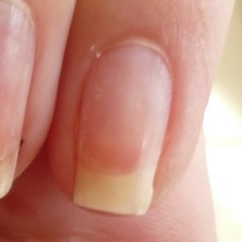 normal#1334 **Confidences:**normal = 79%; non-serious = 13%; warrants second opinion = 7%;   
The nail's condition is normal with confidence score of 79%.  
Otherwise it is non-serious with confidence score of 13%. [image source](http://localhost:8080/ai/onyx/images/korean/normalnail/semisuper_kor_259_1075_307_1573_831_P1020538.JPG)×

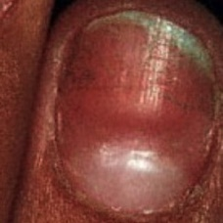 normal#1219 **Confidences:**normal = 82%; non-serious = 11%; warrants second opinion = 7%;   
The nail's condition is normal with confidence score of 82%.  
Otherwise it is non-serious with confidence score of 11%. [image source](http://localhost:8080/ai/onyx/images/korean/normalnail/semisuper_675_477_200_693_470_beaus1327988837804.jpg)×

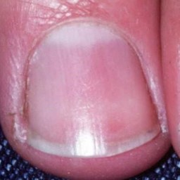 normal#1264 **Confidences:**normal = 83%; non-serious = 0%; warrants second opinion = 17%;   
The nail's condition is normal with confidence score of 83%.  
The confidence score for it warranting a second opinion is 17%. [image source](http://localhost:8080/ai/onyx/images/korean/normalnail/semisuper_936_421_438_848_866_026490HB.jpg)×

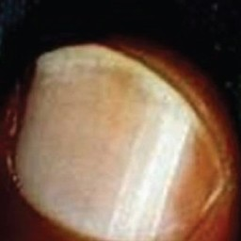 normal#1134 **Confidences:**normal = 84%; non-serious = 15%; warrants second opinion = 0%;   
The nail's condition is normal with confidence score of 84%.  
Otherwise it is non-serious with confidence score of 15%. [image source](http://localhost:8080/ai/onyx/images/korean/normalnail/semisuper_2331_17_26_329_341_ijdvl_2011_77_6_652_86473_f7.jpg)×

 normal#899 **Confidences:**normal = 86%; non-serious = 8%; warrants second opinion = 6%;   
The nail's condition is normal with confidence score of 86%.  
Otherwise it is non-serious with confidence score of 8%. [image source](http://localhost:8080/ai/onyx/images/korean/L_NAIL_5nail_5nail2014_1_normalnail.png#899)×

 normal#824 **Confidences:**normal = 87%; non-serious = 8%; warrants second opinion = 5%;   
The nail's condition is normal with confidence score of 87%.  
Otherwise it is non-serious with confidence score of 8%. [image source](http://localhost:8080/ai/onyx/images/korean/L_NAIL_5nail_5nail2014_1_normalnail.png#824)×

 normal#14 **Confidences:**normal = 88%; non-serious = 0%; warrants second opinion = 12%;   
The nail's condition is normal with confidence score of 88%.  
The confidence score for it warranting a second opinion is 12%. [image source](http://localhost:8080/ai/onyx/images/korean/L_NAIL_5nail_5nail2010_1_normalnail.png#14)×

 normal#444 **Confidences:**normal = 88%; non-serious = 2%; warrants second opinion = 11%;   
The nail's condition is normal with confidence score of 88%.  
The confidence score for it warranting a second opinion is 11%. [image source](http://localhost:8080/ai/onyx/images/korean/L_NAIL_5nail_5nail2010_1_normalnail.png#444)×

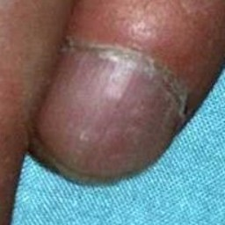 normal#1224 **Confidences:**normal = 88%; non-serious = 12%; warrants second opinion = 0%;   
The nail's condition is normal with confidence score of 88%.  
Otherwise it is non-serious with confidence score of 12%. [image source](http://localhost:8080/ai/onyx/images/korean/normalnail/semisuper_716_1315_438_1522_644_029779HB.jpg)×

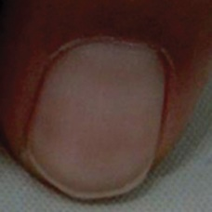 normal#1174 **Confidences:**normal = 89%; non-serious = 2%; warrants second opinion = 9%;   
The nail's condition is normal with confidence score of 89%.  
The confidence score for it warranting a second opinion is 9%. [image source](http://localhost:8080/ai/onyx/images/korean/normalnail/semisuper_354_1099_129_1342_372_fig_13j(6).jpg)×

 normal#504 **Confidences:**normal = 89%; non-serious = 11%; warrants second opinion = 0%;   
The nail's condition is normal with confidence score of 89%.  
Otherwise it is non-serious with confidence score of 11%. [image source](http://localhost:8080/ai/onyx/images/korean/L_NAIL_5nail_5nail2014_1_normalnail.png#504)×

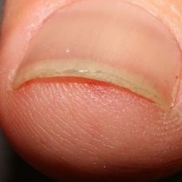 normal#1044 **Confidences:**normal = 89%; non-serious = 5%; warrants second opinion = 6%;   
The nail's condition is normal with confidence score of 89%.  
The confidence score for it warranting a second opinion is 6%. [image source](http://localhost:8080/ai/onyx/images/korean/normalnail/semisuper_1331_865_417_1195_747_Onychomycosis2thumbs1.jpg)×

 normal#224 **Confidences:**normal = 89%; non-serious = 11%; warrants second opinion = 0%;   
The nail's condition is normal with confidence score of 89%.  
Otherwise it is non-serious with confidence score of 11%. [image source](http://localhost:8080/ai/onyx/images/korean/L_NAIL_5nail_5nail2010_1_normalnail.png#224)×

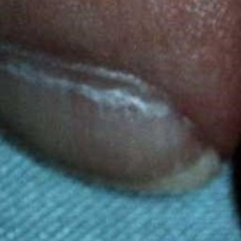 normal#1114 **Confidences:**normal = 89%; non-serious = 10%; warrants second opinion = 1%;   
The nail's condition is normal with confidence score of 89%.  
Otherwise it is non-serious with confidence score of 10%. [image source](http://localhost:8080/ai/onyx/images/korean/normalnail/semisuper_217_72_394_291_612_036256HB.jpg)×

 normal#789 **Confidences:**normal = 90%; non-serious = 1%; warrants second opinion = 9%;   
The nail's condition is normal with confidence score of 90%.  
The confidence score for it warranting a second opinion is 9%. [image source](http://localhost:8080/ai/onyx/images/korean/L_NAIL_5nail_5nail2014_1_normalnail.png#789)×

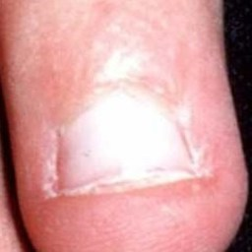 normal#1119 **Confidences:**normal = 90%; non-serious = 10%; warrants second opinion = 0%;   
The nail's condition is normal with confidence score of 90%.  
Otherwise it is non-serious with confidence score of 10%. [image source](http://localhost:8080/ai/onyx/images/korean/normalnail/semisuper_2207_878_721_1120_963_026170HB.JPG)×

 normal#244 **Confidences:**normal = 91%; non-serious = 7%; warrants second opinion = 2%;   
The nail's condition is normal with confidence score of 91%.  
Otherwise it is non-serious with confidence score of 7%. [image source](http://localhost:8080/ai/onyx/images/korean/L_NAIL_5nail_5nail2010_1_normalnail.png#244)×

 normal#974 **Confidences:**normal = 91%; non-serious = 2%; warrants second opinion = 6%;   
The nail's condition is normal with confidence score of 91%.  
The confidence score for it warranting a second opinion is 6%. [image source](http://localhost:8080/ai/onyx/images/korean/L_NAIL_5nail_5nail2014_1_normalnail.png#974)×

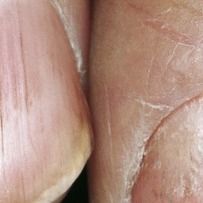 normal#1239 **Confidences:**normal = 91%; non-serious = 9%; warrants second opinion = 0%;   
The nail's condition is normal with confidence score of 91%.  
Otherwise it is non-serious with confidence score of 9%. [image source](http://localhost:8080/ai/onyx/images/korean/normalnail/semisuper_826_40_67_767_1286_1468603.jpg)×

 normal#69 **Confidences:**normal = 91%; non-serious = 9%; warrants second opinion = 0%;   
The nail's condition is normal with confidence score of 91%.  
Otherwise it is non-serious with confidence score of 9%. [image source](http://localhost:8080/ai/onyx/images/korean/L_NAIL_5nail_5nail2010_1_normalnail.png#69)×

 normal#34 **Confidences:**normal = 91%; non-serious = 8%; warrants second opinion = 0%;   
The nail's condition is normal with confidence score of 91%.  
Otherwise it is non-serious with confidence score of 8%. [image source](http://localhost:8080/ai/onyx/images/korean/L_NAIL_5nail_5nail2010_1_normalnail.png#34)×

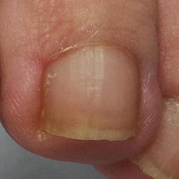 normal#1124 **Confidences:**normal = 92%; non-serious = 7%; warrants second opinion = 1%;   
The nail's condition is normal with confidence score of 92%.  
Otherwise it is non-serious with confidence score of 7%. [image source](http://localhost:8080/ai/onyx/images/korean/normalnail/semisuper_2262_1673_1027_2094_1448_melanonychia-_-tmavy-pas-na-nechte-sposobeny-melaninom.jpg)×

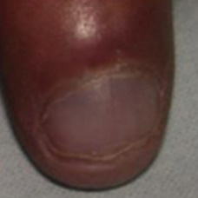 normal#1229 **Confidences:**normal = 92%; non-serious = 0%; warrants second opinion = 8%;   
The nail's condition is normal with confidence score of 92%.  
The confidence score for it warranting a second opinion is 8%. [image source](http://localhost:8080/ai/onyx/images/korean/normalnail/semisuper_761_718_398_913_593_fig_24j.jpg)×

 normal#709 **Confidences:**normal = 92%; non-serious = 6%; warrants second opinion = 2%;   
The nail's condition is normal with confidence score of 92%.  
Otherwise it is non-serious with confidence score of 6%. [image source](http://localhost:8080/ai/onyx/images/korean/L_NAIL_5nail_5nail2014_1_normalnail.png#709)×

 normal#939 **Confidences:**normal = 92%; non-serious = 0%; warrants second opinion = 8%;   
The nail's condition is normal with confidence score of 92%.  
The confidence score for it warranting a second opinion is 8%. [image source](http://localhost:8080/ai/onyx/images/korean/L_NAIL_5nail_5nail2014_1_normalnail.png#939)×

 normal#309 **Confidences:**normal = 92%; non-serious = 0%; warrants second opinion = 8%;   
The nail's condition is normal with confidence score of 92%.  
The confidence score for it warranting a second opinion is 8%. [image source](http://localhost:8080/ai/onyx/images/korean/L_NAIL_5nail_5nail2010_1_normalnail.png#309)×

 normal#204 **Confidences:**normal = 92%; non-serious = 7%; warrants second opinion = 1%;   
The nail's condition is normal with confidence score of 92%.  
Otherwise it is non-serious with confidence score of 7%. [image source](http://localhost:8080/ai/onyx/images/korean/L_NAIL_5nail_5nail2010_1_normalnail.png#204)×

 normal#869 **Confidences:**normal = 92%; non-serious = 0%; warrants second opinion = 7%;   
The nail's condition is normal with confidence score of 92%.  
The confidence score for it warranting a second opinion is 7%. [image source](http://localhost:8080/ai/onyx/images/korean/L_NAIL_5nail_5nail2014_1_normalnail.png#869)×

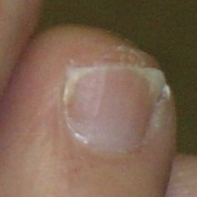 normal#1144 **Confidences:**normal = 93%; non-serious = 7%; warrants second opinion = 0%;   
The nail's condition is normal with confidence score of 93%.  
Otherwise it is non-serious with confidence score of 7%. [image source](http://localhost:8080/ai/onyx/images/korean/normalnail/semisuper_2427_985_648_1197_861_pt0906ce1.jpg)×

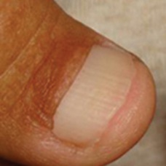 normal#1014 **Confidences:**normal = 93%; non-serious = 7%; warrants second opinion = 0%;   
The nail's condition is normal with confidence score of 93%.  
Otherwise it is non-serious with confidence score of 7%. [image source](http://localhost:8080/ai/onyx/images/korean/normalnail/semisuper_1074_321_527_519_726_fig_14j(4).jpg)×

 normal#149 **Confidences:**normal = 93%; non-serious = 5%; warrants second opinion = 1%;   
The nail's condition is normal with confidence score of 93%.  
Otherwise it is non-serious with confidence score of 5%. [image source](http://localhost:8080/ai/onyx/images/korean/L_NAIL_5nail_5nail2010_1_normalnail.png#149)×

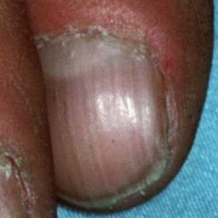 normal#1214 **Confidences:**normal = 93%; non-serious = 1%; warrants second opinion = 6%;   
The nail's condition is normal with confidence score of 93%.  
The confidence score for it warranting a second opinion is 6%. [image source](http://localhost:8080/ai/onyx/images/korean/normalnail/semisuper_608_1010_392_1340_723_029777HB.jpg)×

 normal#344 **Confidences:**normal = 94%; non-serious = 6%; warrants second opinion = 0%;   
The nail's condition is normal with confidence score of 94%.  
Otherwise it is non-serious with confidence score of 6%. [image source](http://localhost:8080/ai/onyx/images/korean/L_NAIL_5nail_5nail2010_1_normalnail.png#344)×

 normal#189 **Confidences:**normal = 94%; non-serious = 0%; warrants second opinion = 6%;   
The nail's condition is normal with confidence score of 94%.  
The confidence score for it warranting a second opinion is 6%. [image source](http://localhost:8080/ai/onyx/images/korean/L_NAIL_5nail_5nail2010_1_normalnail.png#189)×

 normal#919 **Confidences:**normal = 94%; non-serious = 0%; warrants second opinion = 6%;   
The nail's condition is normal with confidence score of 94%.  
The confidence score for it warranting a second opinion is 6%. [image source](http://localhost:8080/ai/onyx/images/korean/L_NAIL_5nail_5nail2014_1_normalnail.png#919)×

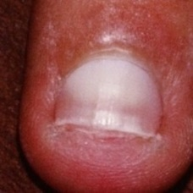 normal#1254 **Confidences:**normal = 94%; non-serious = 2%; warrants second opinion = 4%;   
The nail's condition is normal with confidence score of 94%.  
The confidence score for it warranting a second opinion is 4%. [image source](http://localhost:8080/ai/onyx/images/korean/normalnail/semisuper_871_1231_202_1450_421_leukonychia.jpg)×

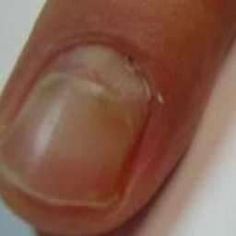 normal#1259 **Confidences:**normal = 94%; non-serious = 0%; warrants second opinion = 6%;   
The nail's condition is normal with confidence score of 94%.  
The confidence score for it warranting a second opinion is 6%. [image source](http://localhost:8080/ai/onyx/images/korean/normalnail/semisuper_913_9_244_182_441_403v105n05-90327714fig1.jpg)×

 normal#184 **Confidences:**normal = 94%; non-serious = 5%; warrants second opinion = 1%;   
The nail's condition is normal with confidence score of 94%.  
Otherwise it is non-serious with confidence score of 5%. [image source](http://localhost:8080/ai/onyx/images/korean/L_NAIL_5nail_5nail2010_1_normalnail.png#184)×

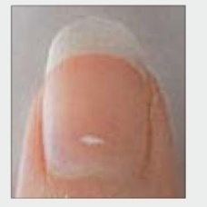 normal#1349 **Confidences:**normal = 94%; non-serious = 1%; warrants second opinion = 5%;   
The nail's condition is normal with confidence score of 94%.  
The confidence score for it warranting a second opinion is 5%. [image source](http://localhost:8080/ai/onyx/images/korean/normalnail/semisuper_kor_682_232_13_476_257_20161107000326585.jpg)×

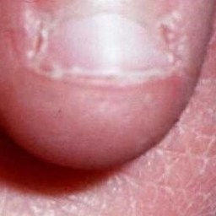 normal#1019 **Confidences:**normal = 94%; non-serious = 4%; warrants second opinion = 1%;   
The nail's condition is normal with confidence score of 94%.  
Otherwise it is non-serious with confidence score of 4%. [image source](http://localhost:8080/ai/onyx/images/korean/normalnail/semisuper_1084_1263_15_1620_295_026167HB.jpg)×

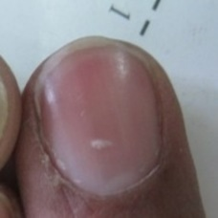 normal#1084 **Confidences:**normal = 95%; non-serious = 0%; warrants second opinion = 5%;   
The nail's condition is normal with confidence score of 95%.  
The confidence score for it warranting a second opinion is 5%. [image source](http://localhost:8080/ai/onyx/images/korean/normalnail/semisuper_192_356_18_568_231_LEUKONYCHIA-OF-NAILS.jpg)×

 normal#769 **Confidences:**normal = 95%; non-serious = 5%; warrants second opinion = 1%;   
The nail's condition is normal with confidence score of 95%.  
Otherwise it is non-serious with confidence score of 5%. [image source](http://localhost:8080/ai/onyx/images/korean/L_NAIL_5nail_5nail2014_1_normalnail.png#769)×

 normal#469 **Confidences:**normal = 95%; non-serious = 2%; warrants second opinion = 3%;   
The nail's condition is normal with confidence score of 95%.  
The confidence score for it warranting a second opinion is 3%. [image source](http://localhost:8080/ai/onyx/images/korean/L_NAIL_5nail_5nail2010_1_normalnail.png#469)×

 normal#474 **Confidences:**normal = 95%; non-serious = 4%; warrants second opinion = 1%;   
The nail's condition is normal with confidence score of 95%.  
Otherwise it is non-serious with confidence score of 4%. [image source](http://localhost:8080/ai/onyx/images/korean/L_NAIL_5nail_5nail2010_1_normalnail.png#474)×

 normal#29 **Confidences:**normal = 95%; non-serious = 2%; warrants second opinion = 2%;   
The nail's condition is normal with confidence score of 95%.  
Otherwise it is non-serious with confidence score of 2%. [image source](http://localhost:8080/ai/onyx/images/korean/L_NAIL_5nail_5nail2010_1_normalnail.png#29)×

 normal#524 **Confidences:**normal = 96%; non-serious = 3%; warrants second opinion = 2%;   
The nail's condition is normal with confidence score of 96%.  
Otherwise it is non-serious with confidence score of 3%. [image source](http://localhost:8080/ai/onyx/images/korean/L_NAIL_5nail_5nail2014_1_normalnail.png#524)×

 normal#239 **Confidences:**normal = 96%; non-serious = 0%; warrants second opinion = 4%;   
The nail's condition is normal with confidence score of 96%.  
The confidence score for it warranting a second opinion is 4%. [image source](http://localhost:8080/ai/onyx/images/korean/L_NAIL_5nail_5nail2010_1_normalnail.png#239)×

 normal#174 **Confidences:**normal = 96%; non-serious = 0%; warrants second opinion = 4%;   
The nail's condition is normal with confidence score of 96%.  
The confidence score for it warranting a second opinion is 4%. [image source](http://localhost:8080/ai/onyx/images/korean/L_NAIL_5nail_5nail2010_1_normalnail.png#174)×

 normal#124 **Confidences:**normal = 96%; non-serious = 0%; warrants second opinion = 4%;   
The nail's condition is normal with confidence score of 96%.  
The confidence score for it warranting a second opinion is 4%. [image source](http://localhost:8080/ai/onyx/images/korean/L_NAIL_5nail_5nail2010_1_normalnail.png#124)×

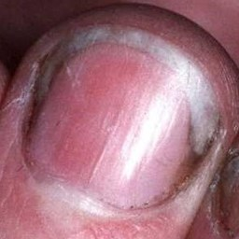 normal#1069 **Confidences:**normal = 96%; non-serious = 1%; warrants second opinion = 3%;   
The nail's condition is normal with confidence score of 96%.  
The confidence score for it warranting a second opinion is 3%. [image source](http://localhost:8080/ai/onyx/images/korean/normalnail/semisuper_1642_414_370_711_668_036923HB.JPG)×

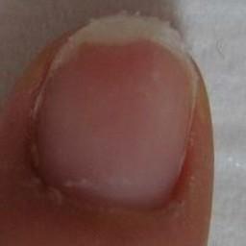 normal#1164 **Confidences:**normal = 96%; non-serious = 1%; warrants second opinion = 3%;   
The nail's condition is normal with confidence score of 96%.  
The confidence score for it warranting a second opinion is 3%. [image source](http://localhost:8080/ai/onyx/images/korean/normalnail/semisuper_333_570_64_840_340_beforeandafternail.jpg)×

 normal#619 **Confidences:**normal = 96%; non-serious = 1%; warrants second opinion = 3%;   
The nail's condition is normal with confidence score of 96%.  
The confidence score for it warranting a second opinion is 3%. [image source](http://localhost:8080/ai/onyx/images/korean/L_NAIL_5nail_5nail2014_1_normalnail.png#619)×

 normal#774 **Confidences:**normal = 96%; non-serious = 0%; warrants second opinion = 4%;   
The nail's condition is normal with confidence score of 96%.  
The confidence score for it warranting a second opinion is 4%. [image source](http://localhost:8080/ai/onyx/images/korean/L_NAIL_5nail_5nail2014_1_normalnail.png#774)×

 normal#454 **Confidences:**normal = 96%; non-serious = 3%; warrants second opinion = 1%;   
The nail's condition is normal with confidence score of 96%.  
Otherwise it is non-serious with confidence score of 3%. [image source](http://localhost:8080/ai/onyx/images/korean/L_NAIL_5nail_5nail2010_1_normalnail.png#454)×

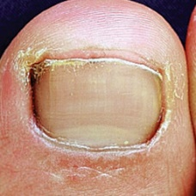 normal#1179 **Confidences:**normal = 96%; non-serious = 2%; warrants second opinion = 2%;   
The nail's condition is normal with confidence score of 96%.  
Otherwise it is non-serious with confidence score of 2%. [image source](http://localhost:8080/ai/onyx/images/korean/normalnail/semisuper_389_569_52_877_359_dlv80056f1.jpg)×

 normal#694 **Confidences:**normal = 96%; non-serious = 0%; warrants second opinion = 4%;   
The nail's condition is normal with confidence score of 96%.  
The confidence score for it warranting a second opinion is 4%. [image source](http://localhost:8080/ai/onyx/images/korean/L_NAIL_5nail_5nail2014_1_normalnail.png#694)×

 normal#154 **Confidences:**normal = 96%; non-serious = 3%; warrants second opinion = 0%;   
The nail's condition is normal with confidence score of 96%.  
Otherwise it is non-serious with confidence score of 3%. [image source](http://localhost:8080/ai/onyx/images/korean/L_NAIL_5nail_5nail2010_1_normalnail.png#154)×

 normal#989 **Confidences:**normal = 96%; non-serious = 0%; warrants second opinion = 4%;   
The nail's condition is normal with confidence score of 96%.  
The confidence score for it warranting a second opinion is 4%. [image source](http://localhost:8080/ai/onyx/images/korean/L_NAIL_5nail_5nail2014_1_normalnail.png#989)×

 normal#334 **Confidences:**normal = 96%; non-serious = 0%; warrants second opinion = 4%;   
The nail's condition is normal with confidence score of 96%.  
The confidence score for it warranting a second opinion is 4%. [image source](http://localhost:8080/ai/onyx/images/korean/L_NAIL_5nail_5nail2010_1_normalnail.png#334)×

 normal#794 **Confidences:**normal = 97%; non-serious = 3%; warrants second opinion = 0%;   
The nail's condition is normal with confidence score of 97%.  
Otherwise it is non-serious with confidence score of 3%. [image source](http://localhost:8080/ai/onyx/images/korean/L_NAIL_5nail_5nail2014_1_normalnail.png#794)×

 normal#254 **Confidences:**normal = 97%; non-serious = 2%; warrants second opinion = 1%;   
The nail's condition is normal with confidence score of 97%.  
Otherwise it is non-serious with confidence score of 2%. [image source](http://localhost:8080/ai/onyx/images/korean/L_NAIL_5nail_5nail2010_1_normalnail.png#254)×

 normal#429 **Confidences:**normal = 97%; non-serious = 3%; warrants second opinion = 1%;   
The nail's condition is normal with confidence score of 97%.  
Otherwise it is non-serious with confidence score of 3%. [image source](http://localhost:8080/ai/onyx/images/korean/L_NAIL_5nail_5nail2010_1_normalnail.png#429)×

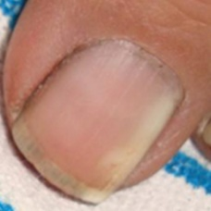 normal#1244 **Confidences:**normal = 97%; non-serious = 1%; warrants second opinion = 2%;   
The nail's condition is normal with confidence score of 97%.  
The confidence score for it warranting a second opinion is 2%. [image source](http://localhost:8080/ai/onyx/images/korean/normalnail/semisuper_846_539_363_774_597_fig_5j(16).jpg)×

 normal#179 **Confidences:**normal = 97%; non-serious = 0%; warrants second opinion = 3%;   
The nail's condition is normal with confidence score of 97%.  
The confidence score for it warranting a second opinion is 3%. [image source](http://localhost:8080/ai/onyx/images/korean/L_NAIL_5nail_5nail2010_1_normalnail.png#179)×

 normal#264 **Confidences:**normal = 97%; non-serious = 0%; warrants second opinion = 3%;   
The nail's condition is normal with confidence score of 97%.  
The confidence score for it warranting a second opinion is 3%. [image source](http://localhost:8080/ai/onyx/images/korean/L_NAIL_5nail_5nail2010_1_normalnail.png#264)×

 normal#669 **Confidences:**normal = 97%; non-serious = 0%; warrants second opinion = 3%;   
The nail's condition is normal with confidence score of 97%.  
The confidence score for it warranting a second opinion is 3%. [image source](http://localhost:8080/ai/onyx/images/korean/L_NAIL_5nail_5nail2014_1_normalnail.png#669)×

 normal#294 **Confidences:**normal = 97%; non-serious = 0%; warrants second opinion = 3%;   
The nail's condition is normal with confidence score of 97%.  
The confidence score for it warranting a second opinion is 3%. [image source](http://localhost:8080/ai/onyx/images/korean/L_NAIL_5nail_5nail2010_1_normalnail.png#294)×

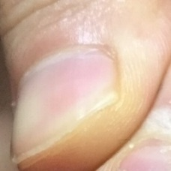 normal#1359 **Confidences:**normal = 97%; non-serious = 1%; warrants second opinion = 2%;   
The nail's condition is normal with confidence score of 97%.  
The confidence score for it warranting a second opinion is 2%. [image source](http://localhost:8080/ai/onyx/images/korean/normalnail/semisuper_kor_777_14_221_278_505_494.JPG)×

 normal#319 **Confidences:**normal = 97%; non-serious = 0%; warrants second opinion = 3%;   
The nail's condition is normal with confidence score of 97%.  
The confidence score for it warranting a second opinion is 3%. [image source](http://localhost:8080/ai/onyx/images/korean/L_NAIL_5nail_5nail2010_1_normalnail.png#319)×

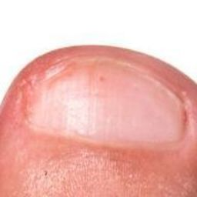 normal#1129 **Confidences:**normal = 97%; non-serious = 2%; warrants second opinion = 1%;   
The nail's condition is normal with confidence score of 97%.  
Otherwise it is non-serious with confidence score of 2%. [image source](http://localhost:8080/ai/onyx/images/korean/normalnail/semisuper_2291_502_386_694_578_ingrown-nail-56ce64c03df78cfb37a9c277.jpg)×

 normal#74 **Confidences:**normal = 97%; non-serious = 2%; warrants second opinion = 0%;   
The nail's condition is normal with confidence score of 97%.  
Otherwise it is non-serious with confidence score of 2%. [image source](http://localhost:8080/ai/onyx/images/korean/L_NAIL_5nail_5nail2010_1_normalnail.png#74)×

 normal#289 **Confidences:**normal = 98%; non-serious = 1%; warrants second opinion = 1%;   
The nail's condition is normal with confidence score of 98%.  
Otherwise it is non-serious with confidence score of 1%. [image source](http://localhost:8080/ai/onyx/images/korean/L_NAIL_5nail_5nail2010_1_normalnail.png#289)×

 normal#84 **Confidences:**normal = 98%; non-serious = 2%; warrants second opinion = 1%;   
The nail's condition is normal with confidence score of 98%.  
Otherwise it is non-serious with confidence score of 2%. [image source](http://localhost:8080/ai/onyx/images/korean/L_NAIL_5nail_5nail2010_1_normalnail.png#84)×

 normal#109 **Confidences:**normal = 98%; non-serious = 2%; warrants second opinion = 0%;   
The nail's condition is normal with confidence score of 98%.  
Otherwise it is non-serious with confidence score of 2%. [image source](http://localhost:8080/ai/onyx/images/korean/L_NAIL_5nail_5nail2010_1_normalnail.png#109)×

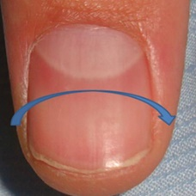 normal#1249 **Confidences:**normal = 98%; non-serious = 0%; warrants second opinion = 2%;   
The nail's condition is normal with confidence score of 98%.  
The confidence score for it warranting a second opinion is 2%. [image source](http://localhost:8080/ai/onyx/images/korean/normalnail/semisuper_853_27_59_515_560_fig_2j(35).jpg)×

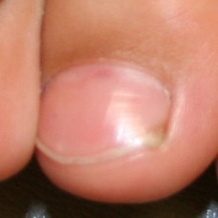 normal#1149 **Confidences:**normal = 98%; non-serious = 0%; warrants second opinion = 2%;   
The nail's condition is normal with confidence score of 98%.  
The confidence score for it warranting a second opinion is 2%. [image source](http://localhost:8080/ai/onyx/images/korean/normalnail/semisuper_2479_528_1023_790_1285_all-nails.jpg)×

 normal#724 **Confidences:**normal = 98%; non-serious = 1%; warrants second opinion = 1%;   
The nail's condition is normal with confidence score of 98%.  
Otherwise it is non-serious with confidence score of 1%. [image source](http://localhost:8080/ai/onyx/images/korean/L_NAIL_5nail_5nail2014_1_normalnail.png#724)×

 normal#404 **Confidences:**normal = 98%; non-serious = 2%; warrants second opinion = 0%;   
The nail's condition is normal with confidence score of 98%.  
Otherwise it is non-serious with confidence score of 2%. [image source](http://localhost:8080/ai/onyx/images/korean/L_NAIL_5nail_5nail2010_1_normalnail.png#404)×

 normal#664 **Confidences:**normal = 98%; non-serious = 1%; warrants second opinion = 1%;   
The nail's condition is normal with confidence score of 98%.  
Otherwise it is non-serious with confidence score of 1%. [image source](http://localhost:8080/ai/onyx/images/korean/L_NAIL_5nail_5nail2014_1_normalnail.png#664)×

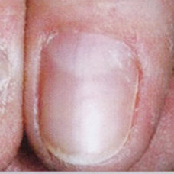 normal#1364 **Confidences:**normal = 98%; non-serious = 2%; warrants second opinion = 0%;   
The nail's condition is normal with confidence score of 98%.  
Otherwise it is non-serious with confidence score of 2%. [image source](http://localhost:8080/ai/onyx/images/korean/normalnail/semisuper_kor_939_1031_93_1231_293_Anwhawhdfb.jpg)×

 normal#64 **Confidences:**normal = 98%; non-serious = 1%; warrants second opinion = 1%;   
The nail's condition is normal with confidence score of 98%.  
Otherwise it is non-serious with confidence score of 1%. [image source](http://localhost:8080/ai/onyx/images/korean/L_NAIL_5nail_5nail2010_1_normalnail.png#64)×

 normal#324 **Confidences:**normal = 98%; non-serious = 2%; warrants second opinion = 0%;   
The nail's condition is normal with confidence score of 98%.  
Otherwise it is non-serious with confidence score of 2%. [image source](http://localhost:8080/ai/onyx/images/korean/L_NAIL_5nail_5nail2010_1_normalnail.png#324)×

 normal#419 **Confidences:**normal = 98%; non-serious = 2%; warrants second opinion = 0%;   
The nail's condition is normal with confidence score of 98%.  
Otherwise it is non-serious with confidence score of 2%. [image source](http://localhost:8080/ai/onyx/images/korean/L_NAIL_5nail_5nail2010_1_normalnail.png#419)×

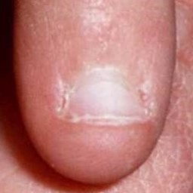 normal#1269 **Confidences:**normal = 98%; non-serious = 2%; warrants second opinion = 0%;   
The nail's condition is normal with confidence score of 98%.  
Otherwise it is non-serious with confidence score of 2%. [image source](http://localhost:8080/ai/onyx/images/korean/normalnail/semisuper_977_1077_193_1329_445_026166HB.jpg)×

 normal#529 **Confidences:**normal = 98%; non-serious = 0%; warrants second opinion = 2%;   
The nail's condition is normal with confidence score of 98%.  
The confidence score for it warranting a second opinion is 2%. [image source](http://localhost:8080/ai/onyx/images/korean/L_NAIL_5nail_5nail2014_1_normalnail.png#529)×

 normal#964 **Confidences:**normal = 98%; non-serious = 2%; warrants second opinion = 0%;   
The nail's condition is normal with confidence score of 98%.  
Otherwise it is non-serious with confidence score of 2%. [image source](http://localhost:8080/ai/onyx/images/korean/L_NAIL_5nail_5nail2014_1_normalnail.png#964)×

 normal#934 **Confidences:**normal = 98%; non-serious = 0%; warrants second opinion = 2%;   
The nail's condition is normal with confidence score of 98%.  
The confidence score for it warranting a second opinion is 2%. [image source](http://localhost:8080/ai/onyx/images/korean/L_NAIL_5nail_5nail2014_1_normalnail.png#934)×

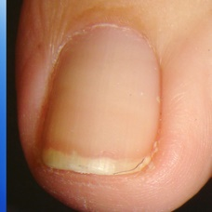 normal#1059 **Confidences:**normal = 98%; non-serious = 0%; warrants second opinion = 1%;   
The nail's condition is normal with confidence score of 98%.  
The confidence score for it warranting a second opinion is 1%. [image source](http://localhost:8080/ai/onyx/images/korean/normalnail/semisuper_1581_617_277_1118_779_0_toenailbanda.jpg)×

 normal#24 **Confidences:**normal = 98%; non-serious = 1%; warrants second opinion = 1%;   
The nail's condition is normal with confidence score of 98%.  
Otherwise it is non-serious with confidence score of 1%. [image source](http://localhost:8080/ai/onyx/images/korean/L_NAIL_5nail_5nail2010_1_normalnail.png#24)×

 normal#314 **Confidences:**normal = 98%; non-serious = 0%; warrants second opinion = 2%;   
The nail's condition is normal with confidence score of 98%.  
The confidence score for it warranting a second opinion is 2%. [image source](http://localhost:8080/ai/onyx/images/korean/L_NAIL_5nail_5nail2010_1_normalnail.png#314)×

 normal#114 **Confidences:**normal = 98%; non-serious = 1%; warrants second opinion = 1%;   
The nail's condition is normal with confidence score of 98%.  
Otherwise it is non-serious with confidence score of 1%. [image source](http://localhost:8080/ai/onyx/images/korean/L_NAIL_5nail_5nail2010_1_normalnail.png#114)×

 normal#99 **Confidences:**normal = 98%; non-serious = 0%; warrants second opinion = 1%;   
The nail's condition is normal with confidence score of 98%.  
The confidence score for it warranting a second opinion is 1%. [image source](http://localhost:8080/ai/onyx/images/korean/L_NAIL_5nail_5nail2010_1_normalnail.png#99)×

 normal#809 **Confidences:**normal = 98%; non-serious = 0%; warrants second opinion = 2%;   
The nail's condition is normal with confidence score of 98%.  
The confidence score for it warranting a second opinion is 2%. [image source](http://localhost:8080/ai/onyx/images/korean/L_NAIL_5nail_5nail2014_1_normalnail.png#809)×

 normal#369 **Confidences:**normal = 98%; non-serious = 0%; warrants second opinion = 1%;   
The nail's condition is normal with confidence score of 98%.  
The confidence score for it warranting a second opinion is 1%. [image source](http://localhost:8080/ai/onyx/images/korean/L_NAIL_5nail_5nail2010_1_normalnail.png#369)×

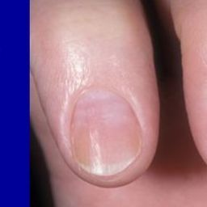 normal#1159 **Confidences:**normal = 98%; non-serious = 1%; warrants second opinion = 1%;   
The nail's condition is normal with confidence score of 98%.  
Otherwise it is non-serious with confidence score of 1%. [image source](http://localhost:8080/ai/onyx/images/korean/normalnail/semisuper_291_348_181_599_432_slide_19.jpg)×

 normal#569 **Confidences:**normal = 98%; non-serious = 0%; warrants second opinion = 2%;   
The nail's condition is normal with confidence score of 98%.  
The confidence score for it warranting a second opinion is 2%. [image source](http://localhost:8080/ai/onyx/images/korean/L_NAIL_5nail_5nail2014_1_normalnail.png#569)×

 normal#359 **Confidences:**normal = 98%; non-serious = 1%; warrants second opinion = 1%;   
The nail's condition is normal with confidence score of 98%.  
Otherwise it is non-serious with confidence score of 1%. [image source](http://localhost:8080/ai/onyx/images/korean/L_NAIL_5nail_5nail2010_1_normalnail.png#359)×

 normal#279 **Confidences:**normal = 98%; non-serious = 0%; warrants second opinion = 2%;   
The nail's condition is normal with confidence score of 98%.  
The confidence score for it warranting a second opinion is 2%. [image source](http://localhost:8080/ai/onyx/images/korean/L_NAIL_5nail_5nail2010_1_normalnail.png#279)×

 normal#439 **Confidences:**normal = 98%; non-serious = 1%; warrants second opinion = 1%;   
The nail's condition is normal with confidence score of 98%.  
Otherwise it is non-serious with confidence score of 1%. [image source](http://localhost:8080/ai/onyx/images/korean/L_NAIL_5nail_5nail2010_1_normalnail.png#439)×

 normal#424 **Confidences:**normal = 98%; non-serious = 2%; warrants second opinion = 0%;   
The nail's condition is normal with confidence score of 98%.  
Otherwise it is non-serious with confidence score of 2%. [image source](http://localhost:8080/ai/onyx/images/korean/L_NAIL_5nail_5nail2010_1_normalnail.png#424)×

 normal#654 **Confidences:**normal = 98%; non-serious = 1%; warrants second opinion = 1%;   
The nail's condition is normal with confidence score of 98%.  
Otherwise it is non-serious with confidence score of 1%. [image source](http://localhost:8080/ai/onyx/images/korean/L_NAIL_5nail_5nail2014_1_normalnail.png#654)×

 normal#884 **Confidences:**normal = 98%; non-serious = 1%; warrants second opinion = 1%;   
The nail's condition is normal with confidence score of 98%.  
Otherwise it is non-serious with confidence score of 1%. [image source](http://localhost:8080/ai/onyx/images/korean/L_NAIL_5nail_5nail2014_1_normalnail.png#884)×

 normal#89 **Confidences:**normal = 98%; non-serious = 0%; warrants second opinion = 1%;   
The nail's condition is normal with confidence score of 98%.  
The confidence score for it warranting a second opinion is 1%. [image source](http://localhost:8080/ai/onyx/images/korean/L_NAIL_5nail_5nail2010_1_normalnail.png#89)×

 normal#489 **Confidences:**normal = 98%; non-serious = 0%; warrants second opinion = 1%;   
The nail's condition is normal with confidence score of 98%.  
The confidence score for it warranting a second opinion is 1%. [image source](http://localhost:8080/ai/onyx/images/korean/L_NAIL_5nail_5nail2010_1_normalnail.png#489)×

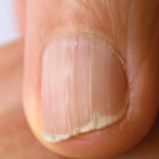 normal#1089 **Confidences:**normal = 98%; non-serious = 0%; warrants second opinion = 1%;   
The nail's condition is normal with confidence score of 98%.  
The confidence score for it warranting a second opinion is 1%. [image source](http://localhost:8080/ai/onyx/images/korean/normalnail/semisuper_1938_186_70_389_274_Brittle-nails.jpg)×

 normal#849 **Confidences:**normal = 98%; non-serious = 2%; warrants second opinion = 0%;   
The nail's condition is normal with confidence score of 98%.  
Otherwise it is non-serious with confidence score of 2%. [image source](http://localhost:8080/ai/onyx/images/korean/L_NAIL_5nail_5nail2014_1_normalnail.png#849)×

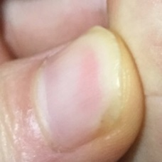 normal#1344 **Confidences:**normal = 99%; non-serious = 0%; warrants second opinion = 1%;   
The nail's condition is normal with confidence score of 99%.  
The confidence score for it warranting a second opinion is 1%. [image source](http://localhost:8080/ai/onyx/images/korean/normalnail/semisuper_kor_516_130_554_406_831_495.JPG)×

 normal#684 **Confidences:**normal = 99%; non-serious = 1%; warrants second opinion = 0%;   
The nail's condition is normal with confidence score of 99%.  
Otherwise it is non-serious with confidence score of 1%. [image source](http://localhost:8080/ai/onyx/images/korean/L_NAIL_5nail_5nail2014_1_normalnail.png#684)×

 normal#49 **Confidences:**normal = 99%; non-serious = 0%; warrants second opinion = 1%;   
The nail's condition is normal with confidence score of 99%.  
The confidence score for it warranting a second opinion is 1%. [image source](http://localhost:8080/ai/onyx/images/korean/L_NAIL_5nail_5nail2010_1_normalnail.png#49)×

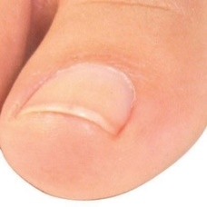 normal#1339 **Confidences:**normal = 99%; non-serious = 1%; warrants second opinion = 0%;   
The nail's condition is normal with confidence score of 99%.  
Otherwise it is non-serious with confidence score of 1%. [image source](http://localhost:8080/ai/onyx/images/korean/normalnail/semisuper_kor_45_539_1377_905_1719_PU01330064.jpg)×

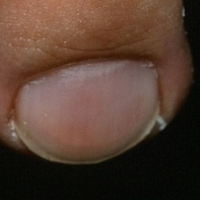 normal#1139 **Confidences:**normal = 99%; non-serious = 1%; warrants second opinion = 0%;   
The nail's condition is normal with confidence score of 99%.  
Otherwise it is non-serious with confidence score of 1%. [image source](http://localhost:8080/ai/onyx/images/korean/normalnail/semisuper_2363_1038_565_1382_909_MelanomaInSituMISNailD.jpg)×

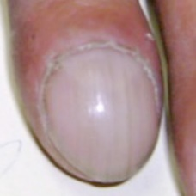 normal#1094 **Confidences:**normal = 99%; non-serious = 0%; warrants second opinion = 1%;   
The nail's condition is normal with confidence score of 99%.  
The confidence score for it warranting a second opinion is 1%. [image source](http://localhost:8080/ai/onyx/images/korean/normalnail/semisuper_1954_1155_885_1463_1194_Acopaquia.jpg)×

 normal#339 **Confidences:**normal = 99%; non-serious = 1%; warrants second opinion = 0%;   
The nail's condition is normal with confidence score of 99%.  
Otherwise it is non-serious with confidence score of 1%. [image source](http://localhost:8080/ai/onyx/images/korean/L_NAIL_5nail_5nail2010_1_normalnail.png#339)×

 normal#379 **Confidences:**normal = 99%; non-serious = 1%; warrants second opinion = 0%;   
The nail's condition is normal with confidence score of 99%.  
Otherwise it is non-serious with confidence score of 1%. [image source](http://localhost:8080/ai/onyx/images/korean/L_NAIL_5nail_5nail2010_1_normalnail.png#379)×

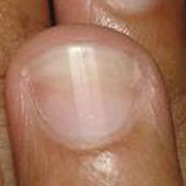 normal#1064 **Confidences:**normal = 99%; non-serious = 1%; warrants second opinion = 0%;   
The nail's condition is normal with confidence score of 99%.  
Otherwise it is non-serious with confidence score of 1%. [image source](http://localhost:8080/ai/onyx/images/korean/normalnail/semisuper_1611_596_340_932_676_2j.jpg)×

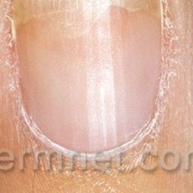 normal#1034 **Confidences:**normal = 99%; non-serious = 0%; warrants second opinion = 1%;   
The nail's condition is normal with confidence score of 99%.  
The confidence score for it warranting a second opinion is 1%. [image source](http://localhost:8080/ai/onyx/images/korean/normalnail/semisuper_1266_147_172_381_406_onycholysis-45.jpg)×

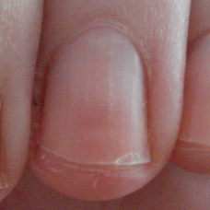 normal#1199 **Confidences:**normal = 99%; non-serious = 0%; warrants second opinion = 1%;   
The nail's condition is normal with confidence score of 99%.  
The confidence score for it warranting a second opinion is 1%. [image source](http://localhost:8080/ai/onyx/images/korean/normalnail/semisuper_530_523_179_814_470_nail%20health.jpg)×

 normal#629 **Confidences:**normal = 99%; non-serious = 0%; warrants second opinion = 1%;   
The nail's condition is normal with confidence score of 99%.  
The confidence score for it warranting a second opinion is 1%. [image source](http://localhost:8080/ai/onyx/images/korean/L_NAIL_5nail_5nail2014_1_normalnail.png#629)×

 normal#144 **Confidences:**normal = 99%; non-serious = 1%; warrants second opinion = 0%;   
The nail's condition is normal with confidence score of 99%.  
Otherwise it is non-serious with confidence score of 1%. [image source](http://localhost:8080/ai/onyx/images/korean/L_NAIL_5nail_5nail2010_1_normalnail.png#144)×

 normal#894 **Confidences:**normal = 99%; non-serious = 0%; warrants second opinion = 1%;   
The nail's condition is normal with confidence score of 99%.  
The confidence score for it warranting a second opinion is 1%. [image source](http://localhost:8080/ai/onyx/images/korean/L_NAIL_5nail_5nail2014_1_normalnail.png#894)×

 normal#509 **Confidences:**normal = 99%; non-serious = 1%; warrants second opinion = 0%;   
The nail's condition is normal with confidence score of 99%.  
Otherwise it is non-serious with confidence score of 1%. [image source](http://localhost:8080/ai/onyx/images/korean/L_NAIL_5nail_5nail2014_1_normalnail.png#509)×

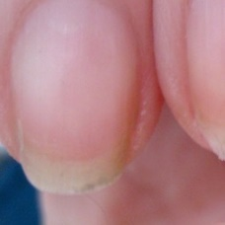 normal#1004 **Confidences:**normal = 99%; non-serious = 0%; warrants second opinion = 1%;   
The nail's condition is normal with confidence score of 99%.  
The confidence score for it warranting a second opinion is 1%. [image source](http://localhost:8080/ai/onyx/images/korean/normalnail/semisuper_1007_30_102_573_836_scary.jpg)×

 normal#119 **Confidences:**normal = 99%; non-serious = 0%; warrants second opinion = 1%;   
The nail's condition is normal with confidence score of 99%.  
The confidence score for it warranting a second opinion is 1%. [image source](http://localhost:8080/ai/onyx/images/korean/L_NAIL_5nail_5nail2010_1_normalnail.png#119)×

 normal#219 **Confidences:**normal = 99%; non-serious = 0%; warrants second opinion = 1%;   
The nail's condition is normal with confidence score of 99%.  
The confidence score for it warranting a second opinion is 1%. [image source](http://localhost:8080/ai/onyx/images/korean/L_NAIL_5nail_5nail2010_1_normalnail.png#219)×

 normal#194 **Confidences:**normal = 99%; non-serious = 0%; warrants second opinion = 1%;   
The nail's condition is normal with confidence score of 99%.  
The confidence score for it warranting a second opinion is 1%. [image source](http://localhost:8080/ai/onyx/images/korean/L_NAIL_5nail_5nail2010_1_normalnail.png#194)×

 normal#164 **Confidences:**normal = 99%; non-serious = 1%; warrants second opinion = 0%;   
The nail's condition is normal with confidence score of 99%.  
Otherwise it is non-serious with confidence score of 1%. [image source](http://localhost:8080/ai/onyx/images/korean/L_NAIL_5nail_5nail2010_1_normalnail.png#164)×

 normal#554 **Confidences:**normal = 99%; non-serious = 1%; warrants second opinion = 0%;   
The nail's condition is normal with confidence score of 99%.  
Otherwise it is non-serious with confidence score of 1%. [image source](http://localhost:8080/ai/onyx/images/korean/L_NAIL_5nail_5nail2014_1_normalnail.png#554)×

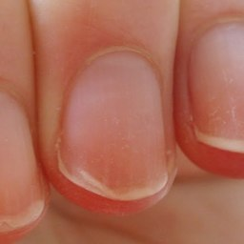 normal#1169 **Confidences:**normal = 99%; non-serious = 0%; warrants second opinion = 1%;   
The nail's condition is normal with confidence score of 99%.  
The confidence score for it warranting a second opinion is 1%. [image source](http://localhost:8080/ai/onyx/images/korean/normalnail/semisuper_345_662_239_1213_791_Peeling-Fingernails.jpg)×

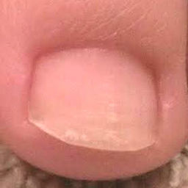 normal#1299 **Confidences:**normal = 99%; non-serious = 1%; warrants second opinion = 0%;   
The nail's condition is normal with confidence score of 99%.  
Otherwise it is non-serious with confidence score of 1%. [image source](http://localhost:8080/ai/onyx/images/korean/normalnail/semisuper_jpn_436_928_371_1206_648_tumekyu2.1.jpg)×

 normal#719 **Confidences:**normal = 99%; non-serious = 0%; warrants second opinion = 1%;   
The nail's condition is normal with confidence score of 99%.  
The confidence score for it warranting a second opinion is 1%. [image source](http://localhost:8080/ai/onyx/images/korean/L_NAIL_5nail_5nail2014_1_normalnail.png#719)×

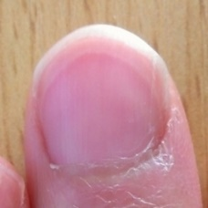 normal#1314 **Confidences:**normal = 99%; non-serious = 0%; warrants second opinion = 0%;   
The nail's condition is normal with confidence score of 99%. [image source](http://localhost:8080/ai/onyx/images/korean/normalnail/semisuper_jpn_66_211_38_442_270_sokohakuri_141215.jpg)×

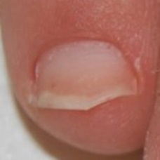 normal#1009 **Confidences:**normal = 99%; non-serious = 1%; warrants second opinion = 0%;   
The nail's condition is normal with confidence score of 99%.  
Otherwise it is non-serious with confidence score of 1%. [image source](http://localhost:8080/ai/onyx/images/korean/normalnail/semisuper_1067_216_345_400_530_jof-01-00030-g005-1024.jpg)×

 normal#1079 **Confidences:**normal = 99%; non-serious = 1%; warrants second opinion = 0%;   
The nail's condition is normal with confidence score of 99%.  
Otherwise it is non-serious with confidence score of 1%. [image source](http://localhost:8080/ai/onyx/images/korean/normalnail/semisuper_1801_216_345_400_530_jof-01-00030-g005-1024.jpg)×

 normal#459 **Confidences:**normal = 99%; non-serious = 0%; warrants second opinion = 1%;   
The nail's condition is normal with confidence score of 99%.  
The confidence score for it warranting a second opinion is 1%. [image source](http://localhost:8080/ai/onyx/images/korean/L_NAIL_5nail_5nail2010_1_normalnail.png#459)×

 normal#549 **Confidences:**normal = 99%; non-serious = 0%; warrants second opinion = 1%;   
The nail's condition is normal with confidence score of 99%.  
The confidence score for it warranting a second opinion is 1%. [image source](http://localhost:8080/ai/onyx/images/korean/L_NAIL_5nail_5nail2014_1_normalnail.png#549)×

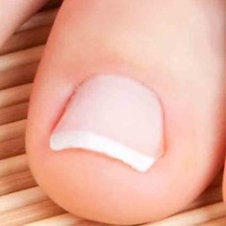 normal#1329 **Confidences:**normal = 99%; non-serious = 0%; warrants second opinion = 1%;   
The nail's condition is normal with confidence score of 99%.  
The confidence score for it warranting a second opinion is 1%. [image source](http://localhost:8080/ai/onyx/images/korean/normalnail/semisuper_kor_213_1447_2877_1994_3425_pedicure-m.jpg)×

 normal#834 **Confidences:**normal = 99%; non-serious = 0%; warrants second opinion = 1%;   
The nail's condition is normal with confidence score of 99%.  
The confidence score for it warranting a second opinion is 1%. [image source](http://localhost:8080/ai/onyx/images/korean/L_NAIL_5nail_5nail2014_1_normalnail.png#834)×

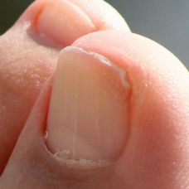 normal#1309 **Confidences:**normal = 99%; non-serious = 0%; warrants second opinion = 1%;   
The nail's condition is normal with confidence score of 99%.  
The confidence score for it warranting a second opinion is 1%. [image source](http://localhost:8080/ai/onyx/images/korean/normalnail/semisuper_jpn_564_1842_266_2268_691_529194_32885100.jpg)×

 normal#639 **Confidences:**normal = 99%; non-serious = 0%; warrants second opinion = 1%;   
The nail's condition is normal with confidence score of 99%.  
The confidence score for it warranting a second opinion is 1%. [image source](http://localhost:8080/ai/onyx/images/korean/L_NAIL_5nail_5nail2014_1_normalnail.png#639)×

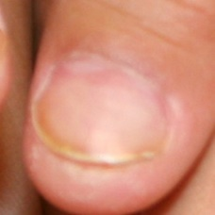 normal#1039 **Confidences:**normal = 99%; non-serious = 1%; warrants second opinion = 0%;   
The nail's condition is normal with confidence score of 99%.  
Otherwise it is non-serious with confidence score of 1%. [image source](http://localhost:8080/ai/onyx/images/korean/normalnail/semisuper_1289_766_241_978_454_all-nails.jpg)×

 normal#1204 **Confidences:**normal = 99%; non-serious = 1%; warrants second opinion = 0%;   
The nail's condition is normal with confidence score of 99%.  
Otherwise it is non-serious with confidence score of 1%. [image source](http://localhost:8080/ai/onyx/images/korean/normalnail/semisuper_564_766_241_978_454_all-nails.jpg)×

 normal#584 **Confidences:**normal = 99%; non-serious = 0%; warrants second opinion = 1%;   
The nail's condition is normal with confidence score of 99%.  
The confidence score for it warranting a second opinion is 1%. [image source](http://localhost:8080/ai/onyx/images/korean/L_NAIL_5nail_5nail2014_1_normalnail.png#584)×

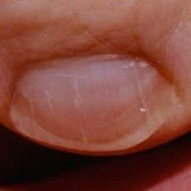 normal#1274 **Confidences:**normal = 99%; non-serious = 1%; warrants second opinion = 0%;   
The nail's condition is normal with confidence score of 99%.  
Otherwise it is non-serious with confidence score of 1%. [image source](http://localhost:8080/ai/onyx/images/korean/normalnail/semisuper_991_29_762_408_1140_ProximalSubungualonycho.jpg)×

 normal#559 **Confidences:**normal = 99%; non-serious = 0%; warrants second opinion = 1%;   
The nail's condition is normal with confidence score of 99%.  
The confidence score for it warranting a second opinion is 1%. [image source](http://localhost:8080/ai/onyx/images/korean/L_NAIL_5nail_5nail2014_1_normalnail.png#559)×

 normal#779 **Confidences:**normal = 99%; non-serious = 0%; warrants second opinion = 1%;   
The nail's condition is normal with confidence score of 99%.  
The confidence score for it warranting a second opinion is 1%. [image source](http://localhost:8080/ai/onyx/images/korean/L_NAIL_5nail_5nail2014_1_normalnail.png#779)×

 normal#984 **Confidences:**normal = 99%; non-serious = 0%; warrants second opinion = 0%;   
The nail's condition is normal with confidence score of 99%. [image source](http://localhost:8080/ai/onyx/images/korean/L_NAIL_5nail_5nail2014_1_normalnail.png#984)×

 normal#394 **Confidences:**normal = 99%; non-serious = 0%; warrants second opinion = 0%;   
The nail's condition is normal with confidence score of 99%. [image source](http://localhost:8080/ai/onyx/images/korean/L_NAIL_5nail_5nail2010_1_normalnail.png#394)×

 normal#104 **Confidences:**normal = 99%; non-serious = 0%; warrants second opinion = 0%;   
The nail's condition is normal with confidence score of 99%. [image source](http://localhost:8080/ai/onyx/images/korean/L_NAIL_5nail_5nail2010_1_normalnail.png#104)×

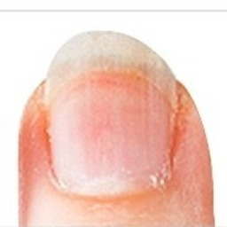 normal#1354 **Confidences:**normal = 99%; non-serious = 1%; warrants second opinion = 0%;   
The nail's condition is normal with confidence score of 99%.  
Otherwise it is non-serious with confidence score of 1%. [image source](http://localhost:8080/ai/onyx/images/korean/normalnail/semisuper_kor_704_547_214_731_399_th_272A8D4954D04D27052708.jpg)×

 normal#879 **Confidences:**normal = 99%; non-serious = 0%; warrants second opinion = 0%;   
The nail's condition is normal with confidence score of 99%. [image source](http://localhost:8080/ai/onyx/images/korean/L_NAIL_5nail_5nail2014_1_normalnail.png#879)×

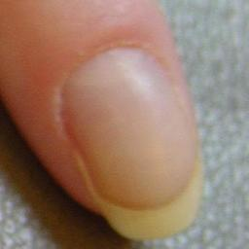 normal#1024 **Confidences:**normal = 99%; non-serious = 0%; warrants second opinion = 1%;   
The nail's condition is normal with confidence score of 99%.  
The confidence score for it warranting a second opinion is 1%. [image source](http://localhost:8080/ai/onyx/images/korean/normalnail/semisuper_111_2009_592_2532_1119_naillifting(onycholysis)-14B0D1C2C211E6D0CB1.jpg)×

 normal#284 **Confidences:**normal = 99%; non-serious = 0%; warrants second opinion = 0%;   
The nail's condition is normal with confidence score of 99%. [image source](http://localhost:8080/ai/onyx/images/korean/L_NAIL_5nail_5nail2010_1_normalnail.png#284)×

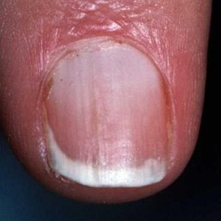 normal#1189 **Confidences:**normal = 99%; non-serious = 0%; warrants second opinion = 1%;   
The nail's condition is normal with confidence score of 99%.  
The confidence score for it warranting a second opinion is 1%. [image source](http://localhost:8080/ai/onyx/images/korean/normalnail/semisuper_468_101_163_535_598_026557HB.jpg)×

 normal#929 **Confidences:**normal = 99%; non-serious = 0%; warrants second opinion = 1%;   
The nail's condition is normal with confidence score of 99%.  
The confidence score for it warranting a second opinion is 1%. [image source](http://localhost:8080/ai/onyx/images/korean/L_NAIL_5nail_5nail2014_1_normalnail.png#929)×

 normal#409 **Confidences:**normal = 99%; non-serious = 0%; warrants second opinion = 1%;   
The nail's condition is normal with confidence score of 99%.  
The confidence score for it warranting a second opinion is 1%. [image source](http://localhost:8080/ai/onyx/images/korean/L_NAIL_5nail_5nail2010_1_normalnail.png#409)×

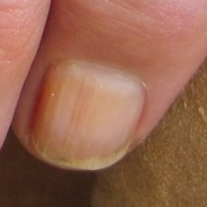 normal#1099 **Confidences:**normal = 99%; non-serious = 0%; warrants second opinion = 0%;   
The nail's condition is normal with confidence score of 99%. [image source](http://localhost:8080/ai/onyx/images/korean/normalnail/semisuper_1972_996_971_1192_1168_fold_hand_finger1.jpg)×

 normal#959 **Confidences:**normal = 99%; non-serious = 0%; warrants second opinion = 0%;   
The nail's condition is normal with confidence score of 99%. [image source](http://localhost:8080/ai/onyx/images/korean/L_NAIL_5nail_5nail2014_1_normalnail.png#959)×

 normal#434 **Confidences:**normal = 99%; non-serious = 0%; warrants second opinion = 1%;   
The nail's condition is normal with confidence score of 99%.  
The confidence score for it warranting a second opinion is 1%. [image source](http://localhost:8080/ai/onyx/images/korean/L_NAIL_5nail_5nail2010_1_normalnail.png#434)×

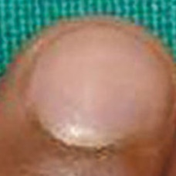 normal#1104 **Confidences:**normal = 99%; non-serious = 0%; warrants second opinion = 0%;   
The nail's condition is normal with confidence score of 99%. [image source](http://localhost:8080/ai/onyx/images/korean/normalnail/semisuper_2063_336_171_591_427_4j.jpg)×

 normal#234 **Confidences:**normal = 100%; non-serious = 0%; warrants second opinion = 0%;   
The nail's condition is normal with confidence score of 100%. [image source](http://localhost:8080/ai/onyx/images/korean/L_NAIL_5nail_5nail2010_1_normalnail.png#234)×

 normal#39 **Confidences:**normal = 100%; non-serious = 0%; warrants second opinion = 0%;   
The nail's condition is normal with confidence score of 100%. [image source](http://localhost:8080/ai/onyx/images/korean/L_NAIL_5nail_5nail2010_1_normalnail.png#39)×

 normal#839 **Confidences:**normal = 100%; non-serious = 0%; warrants second opinion = 0%;   
The nail's condition is normal with confidence score of 100%. [image source](http://localhost:8080/ai/onyx/images/korean/L_NAIL_5nail_5nail2014_1_normalnail.png#839)×

 normal#679 **Confidences:**normal = 100%; non-serious = 0%; warrants second opinion = 0%;   
The nail's condition is normal with confidence score of 100%. [image source](http://localhost:8080/ai/onyx/images/korean/L_NAIL_5nail_5nail2014_1_normalnail.png#679)×

 normal#969 **Confidences:**normal = 100%; non-serious = 0%; warrants second opinion = 0%;   
The nail's condition is normal with confidence score of 100%. [image source](http://localhost:8080/ai/onyx/images/korean/L_NAIL_5nail_5nail2014_1_normalnail.png#969)×

 normal#414 **Confidences:**normal = 100%; non-serious = 0%; warrants second opinion = 0%;   
The nail's condition is normal with confidence score of 100%. [image source](http://localhost:8080/ai/onyx/images/korean/L_NAIL_5nail_5nail2010_1_normalnail.png#414)×

 normal#134 **Confidences:**normal = 100%; non-serious = 0%; warrants second opinion = 0%;   
The nail's condition is normal with confidence score of 100%. [image source](http://localhost:8080/ai/onyx/images/korean/L_NAIL_5nail_5nail2010_1_normalnail.png#134)×

 normal#299 **Confidences:**normal = 100%; non-serious = 0%; warrants second opinion = 0%;   
The nail's condition is normal with confidence score of 100%. [image source](http://localhost:8080/ai/onyx/images/korean/L_NAIL_5nail_5nail2010_1_normalnail.png#299)×

 normal#534 **Confidences:**normal = 100%; non-serious = 0%; warrants second opinion = 0%;   
The nail's condition is normal with confidence score of 100%. [image source](http://localhost:8080/ai/onyx/images/korean/L_NAIL_5nail_5nail2014_1_normalnail.png#534)×

 normal#399 **Confidences:**normal = 100%; non-serious = 0%; warrants second opinion = 0%;   
The nail's condition is normal with confidence score of 100%. [image source](http://localhost:8080/ai/onyx/images/korean/L_NAIL_5nail_5nail2010_1_normalnail.png#399)×

 normal#604 **Confidences:**normal = 100%; non-serious = 0%; warrants second opinion = 0%;   
The nail's condition is normal with confidence score of 100%. [image source](http://localhost:8080/ai/onyx/images/korean/L_NAIL_5nail_5nail2014_1_normalnail.png#604)×

 normal#514 **Confidences:**normal = 100%; non-serious = 0%; warrants second opinion = 0%;   
The nail's condition is normal with confidence score of 100%. [image source](http://localhost:8080/ai/onyx/images/korean/L_NAIL_5nail_5nail2014_1_normalnail.png#514)×

 normal#944 **Confidences:**normal = 100%; non-serious = 0%; warrants second opinion = 0%;   
The nail's condition is normal with confidence score of 100%. [image source](http://localhost:8080/ai/onyx/images/korean/L_NAIL_5nail_5nail2014_1_normalnail.png#944)×

 normal#364 **Confidences:**normal = 100%; non-serious = 0%; warrants second opinion = 0%;   
The nail's condition is normal with confidence score of 100%. [image source](http://localhost:8080/ai/onyx/images/korean/L_NAIL_5nail_5nail2010_1_normalnail.png#364)×

 normal#214 **Confidences:**normal = 100%; non-serious = 0%; warrants second opinion = 0%;   
The nail's condition is normal with confidence score of 100%. [image source](http://localhost:8080/ai/onyx/images/korean/L_NAIL_5nail_5nail2010_1_normalnail.png#214)×

 normal#799 **Confidences:**normal = 100%; non-serious = 0%; warrants second opinion = 0%;   
The nail's condition is normal with confidence score of 100%. [image source](http://localhost:8080/ai/onyx/images/korean/L_NAIL_5nail_5nail2014_1_normalnail.png#799)×

 normal#689 **Confidences:**normal = 100%; non-serious = 0%; warrants second opinion = 0%;   
The nail's condition is normal with confidence score of 100%. [image source](http://localhost:8080/ai/onyx/images/korean/L_NAIL_5nail_5nail2014_1_normalnail.png#689)×

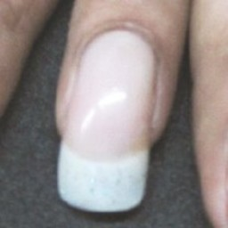 normal#1234 **Confidences:**normal = 100%; non-serious = 0%; warrants second opinion = 0%;   
The nail's condition is normal with confidence score of 100%. [image source](http://localhost:8080/ai/onyx/images/korean/normalnail/semisuper_789_191_389_399_597_ijdvl_2012_78_3_309_95445_f6.jpg)×

 normal#209 **Confidences:**normal = 100%; non-serious = 0%; warrants second opinion = 0%;   
The nail's condition is normal with confidence score of 100%. [image source](http://localhost:8080/ai/onyx/images/korean/L_NAIL_5nail_5nail2010_1_normalnail.png#209)×

 normal#169 **Confidences:**normal = 100%; non-serious = 0%; warrants second opinion = 0%;   
The nail's condition is normal with confidence score of 100%. [image source](http://localhost:8080/ai/onyx/images/korean/L_NAIL_5nail_5nail2010_1_normalnail.png#169)×

 normal#649 **Confidences:**normal = 100%; non-serious = 0%; warrants second opinion = 0%;   
The nail's condition is normal with confidence score of 100%. [image source](http://localhost:8080/ai/onyx/images/korean/L_NAIL_5nail_5nail2014_1_normalnail.png#649)×

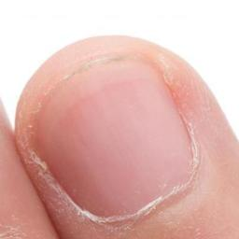 normal#1049 **Confidences:**normal = 100%; non-serious = 0%; warrants second opinion = 0%;   
The nail's condition is normal with confidence score of 100%. [image source](http://localhost:8080/ai/onyx/images/korean/normalnail/semisuper_1385_575_34_977_437_discolored-nail.jpg)×

 normal#1154 **Confidences:**normal = 100%; non-serious = 0%; warrants second opinion = 0%;   
The nail's condition is normal with confidence score of 100%. [image source](http://localhost:8080/ai/onyx/images/korean/normalnail/semisuper_2552_575_34_977_437_discolored-nail.jpg)×

 normal#954 **Confidences:**normal = 100%; non-serious = 0%; warrants second opinion = 0%;   
The nail's condition is normal with confidence score of 100%. [image source](http://localhost:8080/ai/onyx/images/korean/L_NAIL_5nail_5nail2014_1_normalnail.png#954)×

 normal#819 **Confidences:**normal = 100%; non-serious = 0%; warrants second opinion = 0%;   
The nail's condition is normal with confidence score of 100%. [image source](http://localhost:8080/ai/onyx/images/korean/L_NAIL_5nail_5nail2014_1_normalnail.png#819)×

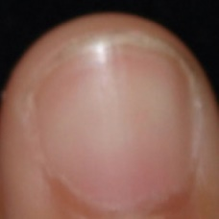 normal#1074 **Confidences:**normal = 100%; non-serious = 0%; warrants second opinion = 0%;   
The nail's condition is normal with confidence score of 100%. [image source](http://localhost:8080/ai/onyx/images/korean/normalnail/semisuper_1730_539_193_769_440_ijdvl_2015_81_4_390_157460_f1.jpg)×

 normal#304 **Confidences:**normal = 100%; non-serious = 0%; warrants second opinion = 0%;   
The nail's condition is normal with confidence score of 100%. [image source](http://localhost:8080/ai/onyx/images/korean/L_NAIL_5nail_5nail2010_1_normalnail.png#304)×

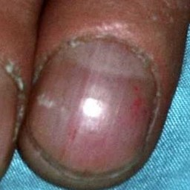 normal#1109 **Confidences:**normal = 100%; non-serious = 0%; warrants second opinion = 0%;   
The nail's condition is normal with confidence score of 100%. [image source](http://localhost:8080/ai/onyx/images/korean/normalnail/semisuper_212_1273_496_1585_808_029778HB.jpg)×

 normal#54 **Confidences:**normal = 100%; non-serious = 0%; warrants second opinion = 0%;   
The nail's condition is normal with confidence score of 100%. [image source](http://localhost:8080/ai/onyx/images/korean/L_NAIL_5nail_5nail2010_1_normalnail.png#54)×

 normal#199 **Confidences:**normal = 100%; non-serious = 0%; warrants second opinion = 0%;   
The nail's condition is normal with confidence score of 100%. [image source](http://localhost:8080/ai/onyx/images/korean/L_NAIL_5nail_5nail2010_1_normalnail.png#199)×

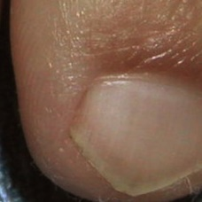 normal#1054 **Confidences:**normal = 100%; non-serious = 0%; warrants second opinion = 0%;   
The nail's condition is normal with confidence score of 100%. [image source](http://localhost:8080/ai/onyx/images/korean/normalnail/semisuper_1481_2149_983_2482_1333_onychomycosis1364420284545.jpg)×

 normal#914 **Confidences:**normal = 100%; non-serious = 0%; warrants second opinion = 0%;   
The nail's condition is normal with confidence score of 100%. [image source](http://localhost:8080/ai/onyx/images/korean/L_NAIL_5nail_5nail2014_1_normalnail.png#914)×

 normal#519 **Confidences:**normal = 100%; non-serious = 0%; warrants second opinion = 0%;   
The nail's condition is normal with confidence score of 100%. [image source](http://localhost:8080/ai/onyx/images/korean/L_NAIL_5nail_5nail2014_1_normalnail.png#519)×

 normal#574 **Confidences:**normal = 100%; non-serious = 0%; warrants second opinion = 0%;   
The nail's condition is normal with confidence score of 100%. [image source](http://localhost:8080/ai/onyx/images/korean/L_NAIL_5nail_5nail2014_1_normalnail.png#574)×

 normal#904 **Confidences:**normal = 100%; non-serious = 0%; warrants second opinion = 0%;   
The nail's condition is normal with confidence score of 100%. [image source](http://localhost:8080/ai/onyx/images/korean/L_NAIL_5nail_5nail2014_1_normalnail.png#904)×

 normal#729 **Confidences:**normal = 100%; non-serious = 0%; warrants second opinion = 0%;   
The nail's condition is normal with confidence score of 100%. [image source](http://localhost:8080/ai/onyx/images/korean/L_NAIL_5nail_5nail2014_1_normalnail.png#729)×

 normal#544 **Confidences:**normal = 100%; non-serious = 0%; warrants second opinion = 0%;   
The nail's condition is normal with confidence score of 100%. [image source](http://localhost:8080/ai/onyx/images/korean/L_NAIL_5nail_5nail2014_1_normalnail.png#544)×

 normal#609 **Confidences:**normal = 100%; non-serious = 0%; warrants second opinion = 0%;   
The nail's condition is normal with confidence score of 100%. [image source](http://localhost:8080/ai/onyx/images/korean/L_NAIL_5nail_5nail2014_1_normalnail.png#609)×

 normal#624 **Confidences:**normal = 100%; non-serious = 0%; warrants second opinion = 0%;   
The nail's condition is normal with confidence score of 100%. [image source](http://localhost:8080/ai/onyx/images/korean/L_NAIL_5nail_5nail2014_1_normalnail.png#624)×

 normal#864 **Confidences:**normal = 100%; non-serious = 0%; warrants second opinion = 0%;   
The nail's condition is normal with confidence score of 100%. [image source](http://localhost:8080/ai/onyx/images/korean/L_NAIL_5nail_5nail2014_1_normalnail.png#864)×

 normal#499 **Confidences:**normal = 100%; non-serious = 0%; warrants second opinion = 0%;   
The nail's condition is normal with confidence score of 100%. [image source](http://localhost:8080/ai/onyx/images/korean/L_NAIL_5nail_5nail2010_1_normalnail.png#499)×

 normal#9 **Confidences:**normal = 100%; non-serious = 0%; warrants second opinion = 0%;   
The nail's condition is normal with confidence score of 100%. [image source](http://localhost:8080/ai/onyx/images/korean/L_NAIL_5nail_5nail2010_1_normalnail.png#9)×

 normal#269 **Confidences:**normal = 100%; non-serious = 0%; warrants second opinion = 0%;   
The nail's condition is normal with confidence score of 100%. [image source](http://localhost:8080/ai/onyx/images/korean/L_NAIL_5nail_5nail2010_1_normalnail.png#269)×

 normal#999 **Confidences:**normal = 100%; non-serious = 0%; warrants second opinion = 0%;   
The nail's condition is normal with confidence score of 100%. [image source](http://localhost:8080/ai/onyx/images/korean/L_NAIL_5nail_5nail2014_1_normalnail.png#999)×

 normal#59 **Confidences:**normal = 100%; non-serious = 0%; warrants second opinion = 0%;   
The nail's condition is normal with confidence score of 100%. [image source](http://localhost:8080/ai/onyx/images/korean/L_NAIL_5nail_5nail2010_1_normalnail.png#59)×

 normal#464 **Confidences:**normal = 100%; non-serious = 0%; warrants second opinion = 0%;   
The nail's condition is normal with confidence score of 100%. [image source](http://localhost:8080/ai/onyx/images/korean/L_NAIL_5nail_5nail2010_1_normalnail.png#464)×

 normal#674 **Confidences:**normal = 100%; non-serious = 0%; warrants second opinion = 0%;   
The nail's condition is normal with confidence score of 100%. [image source](http://localhost:8080/ai/onyx/images/korean/L_NAIL_5nail_5nail2014_1_normalnail.png#674)×

 normal#739 **Confidences:**normal = 100%; non-serious = 0%; warrants second opinion = 0%;   
The nail's condition is normal with confidence score of 100%. [image source](http://localhost:8080/ai/onyx/images/korean/L_NAIL_5nail_5nail2014_1_normalnail.png#739)×

 normal#814 **Confidences:**normal = 100%; non-serious = 0%; warrants second opinion = 0%;   
The nail's condition is normal with confidence score of 100%. [image source](http://localhost:8080/ai/onyx/images/korean/L_NAIL_5nail_5nail2014_1_normalnail.png#814)×

 normal#479 **Confidences:**normal = 100%; non-serious = 0%; warrants second opinion = 0%;   
The nail's condition is normal with confidence score of 100%. [image source](http://localhost:8080/ai/onyx/images/korean/L_NAIL_5nail_5nail2010_1_normalnail.png#479)×

 normal#449 **Confidences:**normal = 100%; non-serious = 0%; warrants second opinion = 0%;   
The nail's condition is normal with confidence score of 100%. [image source](http://localhost:8080/ai/onyx/images/korean/L_NAIL_5nail_5nail2010_1_normalnail.png#449)×

 normal#859 **Confidences:**normal = 100%; non-serious = 0%; warrants second opinion = 0%;   
The nail's condition is normal with confidence score of 100%. [image source](http://localhost:8080/ai/onyx/images/korean/L_NAIL_5nail_5nail2014_1_normalnail.png#859)×

 normal#129 **Confidences:**normal = 100%; non-serious = 0%; warrants second opinion = 0%;   
The nail's condition is normal with confidence score of 100%. [image source](http://localhost:8080/ai/onyx/images/korean/L_NAIL_5nail_5nail2010_1_normalnail.png#129)×

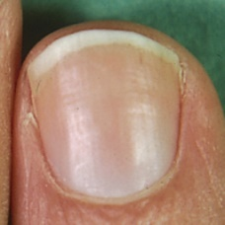 normal#1194 **Confidences:**normal = 100%; non-serious = 0%; warrants second opinion = 0%;   
The nail's condition is normal with confidence score of 100%. [image source](http://localhost:8080/ai/onyx/images/korean/normalnail/semisuper_522_586_181_786_382_skin_transverse_nail2.jpg)×

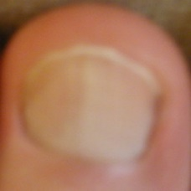 normal#1304 **Confidences:**normal = 100%; non-serious = 0%; warrants second opinion = 0%;   
The nail's condition is normal with confidence score of 100%. [image source](http://localhost:8080/ai/onyx/images/korean/normalnail/semisuper_jpn_519_1329_347_1756_774_0b8c4b3f.JPG)×

 normal#594 **Confidences:**normal = 100%; non-serious = 0%; warrants second opinion = 0%;   
The nail's condition is normal with confidence score of 100%. [image source](http://localhost:8080/ai/onyx/images/korean/L_NAIL_5nail_5nail2014_1_normalnail.png#594)×

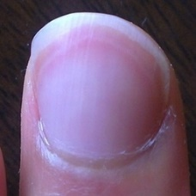 normal#1324 **Confidences:**normal = 100%; non-serious = 0%; warrants second opinion = 0%;   
The nail's condition is normal with confidence score of 100%. [image source](http://localhost:8080/ai/onyx/images/korean/normalnail/semisuper_jpn_87_273_15_555_298_sokohakuri_150319.jpg)×

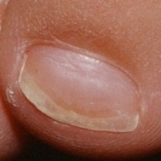 normal#1029 **Confidences:**normal = 100%; non-serious = 0%; warrants second opinion = 0%;   
The nail's condition is normal with confidence score of 100%. [image source](http://localhost:8080/ai/onyx/images/korean/normalnail/semisuper_1206_380_584_586_790_OnychomycosisE4.jpg)×

 normal#979 **Confidences:**normal = 100%; non-serious = 0%; warrants second opinion = 0%;   
The nail's condition is normal with confidence score of 100%. [image source](http://localhost:8080/ai/onyx/images/korean/L_NAIL_5nail_5nail2014_1_normalnail.png#979)×

 normal#759 **Confidences:**normal = 100%; non-serious = 0%; warrants second opinion = 0%;   
The nail's condition is normal with confidence score of 100%. [image source](http://localhost:8080/ai/onyx/images/korean/L_NAIL_5nail_5nail2014_1_normalnail.png#759)×

 normal#249 **Confidences:**normal = 100%; non-serious = 0%; warrants second opinion = 0%;   
The nail's condition is normal with confidence score of 100%. [image source](http://localhost:8080/ai/onyx/images/korean/L_NAIL_5nail_5nail2010_1_normalnail.png#249)×

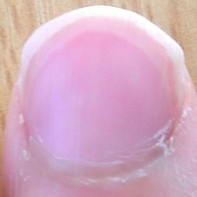 normal#1284 **Confidences:**normal = 100%; non-serious = 0%; warrants second opinion = 0%;   
The nail's condition is normal with confidence score of 100%. [image source](http://localhost:8080/ai/onyx/images/korean/normalnail/semisuper_jpn_127_412_17_720_325_sokohakuri_150206_2.jpg)×

 normal#734 **Confidences:**normal = 100%; non-serious = 0%; warrants second opinion = 0%;   
The nail's condition is normal with confidence score of 100%. [image source](http://localhost:8080/ai/onyx/images/korean/L_NAIL_5nail_5nail2014_1_normalnail.png#734)×

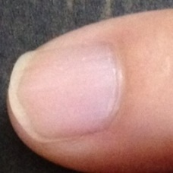 normal#1319 **Confidences:**normal = 100%; non-serious = 0%; warrants second opinion = 0%;   
The nail's condition is normal with confidence score of 100%. [image source](http://localhost:8080/ai/onyx/images/korean/normalnail/semisuper_jpn_75_702_12_941_229_tsume7.jpg)×

 normal#564 **Confidences:**normal = 100%; non-serious = 0%; warrants second opinion = 0%;   
The nail's condition is normal with confidence score of 100%. [image source](http://localhost:8080/ai/onyx/images/korean/L_NAIL_5nail_5nail2014_1_normalnail.png#564)×

 normal#754 **Confidences:**normal = 100%; non-serious = 0%; warrants second opinion = 0%;   
The nail's condition is normal with confidence score of 100%. [image source](http://localhost:8080/ai/onyx/images/korean/L_NAIL_5nail_5nail2014_1_normalnail.png#754)×

 normal#784 **Confidences:**normal = 100%; non-serious = 0%; warrants second opinion = 0%;   
The nail's condition is normal with confidence score of 100%. [image source](http://localhost:8080/ai/onyx/images/korean/L_NAIL_5nail_5nail2014_1_normalnail.png#784)×

 normal#389 **Confidences:**normal = 100%; non-serious = 0%; warrants second opinion = 0%;   
The nail's condition is normal with confidence score of 100%. [image source](http://localhost:8080/ai/onyx/images/korean/L_NAIL_5nail_5nail2010_1_normalnail.png#389)×

 normal#259 **Confidences:**normal = 100%; non-serious = 0%; warrants second opinion = 0%;   
The nail's condition is normal with confidence score of 100%. [image source](http://localhost:8080/ai/onyx/images/korean/L_NAIL_5nail_5nail2010_1_normalnail.png#259)×

 normal#374 **Confidences:**normal = 100%; non-serious = 0%; warrants second opinion = 0%;   
The nail's condition is normal with confidence score of 100%. [image source](http://localhost:8080/ai/onyx/images/korean/L_NAIL_5nail_5nail2010_1_normalnail.png#374)×

 normal#744 **Confidences:**normal = 100%; non-serious = 0%; warrants second opinion = 0%;   
The nail's condition is normal with confidence score of 100%. [image source](http://localhost:8080/ai/onyx/images/korean/L_NAIL_5nail_5nail2014_1_normalnail.png#744)×

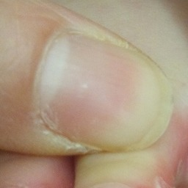 normal#1289 **Confidences:**normal = 100%; non-serious = 0%; warrants second opinion = 0%;   
The nail's condition is normal with confidence score of 100%. [image source](http://localhost:8080/ai/onyx/images/korean/normalnail/semisuper_jpn_144_76_351_441_715_mizumusiasinoyubi2.jpg)×

 normal#749 **Confidences:**normal = 100%; non-serious = 0%; warrants second opinion = 0%;   
The nail's condition is normal with confidence score of 100%. [image source](http://localhost:8080/ai/onyx/images/korean/L_NAIL_5nail_5nail2014_1_normalnail.png#749)×

 normal#804 **Confidences:**normal = 100%; non-serious = 0%; warrants second opinion = 0%;   
The nail's condition is normal with confidence score of 100%. [image source](http://localhost:8080/ai/onyx/images/korean/L_NAIL_5nail_5nail2014_1_normalnail.png#804)×

 normal#79 **Confidences:**normal = 100%; non-serious = 0%; warrants second opinion = 0%;   
The nail's condition is normal with confidence score of 100%. [image source](http://localhost:8080/ai/onyx/images/korean/L_NAIL_5nail_5nail2010_1_normalnail.png#79)×

 normal#159 **Confidences:**normal = 100%; non-serious = 0%; warrants second opinion = 0%;   
The nail's condition is normal with confidence score of 100%. [image source](http://localhost:8080/ai/onyx/images/korean/L_NAIL_5nail_5nail2010_1_normalnail.png#159)×

 normal#644 **Confidences:**normal = 100%; non-serious = 0%; warrants second opinion = 0%;   
The nail's condition is normal with confidence score of 100%. [image source](http://localhost:8080/ai/onyx/images/korean/L_NAIL_5nail_5nail2014_1_normalnail.png#644)×

 normal#274 **Confidences:**normal = 100%; non-serious = 0%; warrants second opinion = 0%;   
The nail's condition is normal with confidence score of 100%. [image source](http://localhost:8080/ai/onyx/images/korean/L_NAIL_5nail_5nail2010_1_normalnail.png#274)×

 normal#329 **Confidences:**normal = 100%; non-serious = 0%; warrants second opinion = 0%;   
The nail's condition is normal with confidence score of 100%. [image source](http://localhost:8080/ai/onyx/images/korean/L_NAIL_5nail_5nail2010_1_normalnail.png#329)×

 normal#484 **Confidences:**normal = 100%; non-serious = 0%; warrants second opinion = 0%;   
The nail's condition is normal with confidence score of 100%. [image source](http://localhost:8080/ai/onyx/images/korean/L_NAIL_5nail_5nail2010_1_normalnail.png#484)×

 normal#659 **Confidences:**normal = 100%; non-serious = 0%; warrants second opinion = 0%;   
The nail's condition is normal with confidence score of 100%. [image source](http://localhost:8080/ai/onyx/images/korean/L_NAIL_5nail_5nail2014_1_normalnail.png#659)×

 normal#599 **Confidences:**normal = 100%; non-serious = 0%; warrants second opinion = 0%;   
The nail's condition is normal with confidence score of 100%. [image source](http://localhost:8080/ai/onyx/images/korean/L_NAIL_5nail_5nail2014_1_normalnail.png#599)×

 normal#634 **Confidences:**normal = 100%; non-serious = 0%; warrants second opinion = 0%;   
The nail's condition is normal with confidence score of 100%. [image source](http://localhost:8080/ai/onyx/images/korean/L_NAIL_5nail_5nail2014_1_normalnail.png#634)×

 normal#44 **Confidences:**normal = 100%; non-serious = 0%; warrants second opinion = 0%;   
The nail's condition is normal with confidence score of 100%. [image source](http://localhost:8080/ai/onyx/images/korean/L_NAIL_5nail_5nail2010_1_normalnail.png#44)×

 normal#94 **Confidences:**normal = 100%; non-serious = 0%; warrants second opinion = 0%;   
The nail's condition is normal with confidence score of 100%. [image source](http://localhost:8080/ai/onyx/images/korean/L_NAIL_5nail_5nail2010_1_normalnail.png#94)×

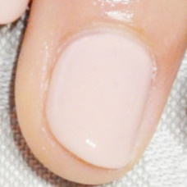 normal#1294 **Confidences:**normal = 100%; non-serious = 0%; warrants second opinion = 0%;   
The nail's condition is normal with confidence score of 100%. [image source](http://localhost:8080/ai/onyx/images/korean/normalnail/semisuper_jpn_276_177_520_412_755_20140215_1001886.jpg)×

 normal#889 **Confidences:**normal = 100%; non-serious = 0%; warrants second opinion = 0%;   
The nail's condition is normal with confidence score of 100%. [image source](http://localhost:8080/ai/onyx/images/korean/L_NAIL_5nail_5nail2014_1_normalnail.png#889)×

 normal#874 **Confidences:**normal = 100%; non-serious = 0%; warrants second opinion = 0%;   
The nail's condition is normal with confidence score of 100%. [image source](http://localhost:8080/ai/onyx/images/korean/L_NAIL_5nail_5nail2014_1_normalnail.png#874)×

 normal#354 **Confidences:**normal = 100%; non-serious = 0%; warrants second opinion = 0%;   
The nail's condition is normal with confidence score of 100%. [image source](http://localhost:8080/ai/onyx/images/korean/L_NAIL_5nail_5nail2010_1_normalnail.png#354)×

 normal#909 **Confidences:**normal = 100%; non-serious = 0%; warrants second opinion = 0%;   
The nail's condition is normal with confidence score of 100%. [image source](http://localhost:8080/ai/onyx/images/korean/L_NAIL_5nail_5nail2014_1_normalnail.png#909)×

 normal#714 **Confidences:**normal = 100%; non-serious = 0%; warrants second opinion = 0%;   
The nail's condition is normal with confidence score of 100%. [image source](http://localhost:8080/ai/onyx/images/korean/L_NAIL_5nail_5nail2014_1_normalnail.png#714)×

 normal#924 **Confidences:**normal = 100%; non-serious = 0%; warrants second opinion = 0%;   
The nail's condition is normal with confidence score of 100%. [image source](http://localhost:8080/ai/onyx/images/korean/L_NAIL_5nail_5nail2014_1_normalnail.png#924)×

 normal#994 **Confidences:**normal = 100%; non-serious = 0%; warrants second opinion = 0%;   
The nail's condition is normal with confidence score of 100%. [image source](http://localhost:8080/ai/onyx/images/korean/L_NAIL_5nail_5nail2014_1_normalnail.png#994)×

 normal#19 **Confidences:**normal = 100%; non-serious = 0%; warrants second opinion = 0%;   
The nail's condition is normal with confidence score of 100%. [image source](http://localhost:8080/ai/onyx/images/korean/L_NAIL_5nail_5nail2010_1_normalnail.png#19)×

 normal#589 **Confidences:**normal = 100%; non-serious = 0%; warrants second opinion = 0%;   
The nail's condition is normal with confidence score of 100%. [image source](http://localhost:8080/ai/onyx/images/korean/L_NAIL_5nail_5nail2014_1_normalnail.png#589)×

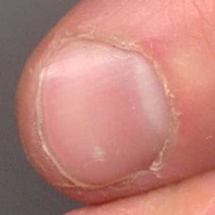 normal#1209 **Confidences:**normal = 100%; non-serious = 0%; warrants second opinion = 0%;   
The nail's condition is normal with confidence score of 100%. [image source](http://localhost:8080/ai/onyx/images/korean/normalnail/semisuper_583_160_10_353_200_Screen%20Shot%202013-08-13%20at%202.54.22%20PM.jpg)×

 normal#139 **Confidences:**normal = 100%; non-serious = 0%; warrants second opinion = 0%;   
The nail's condition is normal with confidence score of 100%. [image source](http://localhost:8080/ai/onyx/images/korean/L_NAIL_5nail_5nail2010_1_normalnail.png#139)×

 normal#539 **Confidences:**normal = 100%; non-serious = 0%; warrants second opinion = 0%;   
The nail's condition is normal with confidence score of 100%. [image source](http://localhost:8080/ai/onyx/images/korean/L_NAIL_5nail_5nail2014_1_normalnail.png#539)×

 normal#579 **Confidences:**normal = 100%; non-serious = 0%; warrants second opinion = 0%;   
The nail's condition is normal with confidence score of 100%. [image source](http://localhost:8080/ai/onyx/images/korean/L_NAIL_5nail_5nail2014_1_normalnail.png#579)×

 normal#699 **Confidences:**normal = 100%; non-serious = 0%; warrants second opinion = 0%;   
The nail's condition is normal with confidence score of 100%. [image source](http://localhost:8080/ai/onyx/images/korean/L_NAIL_5nail_5nail2014_1_normalnail.png#699)×

 normal#614 **Confidences:**normal = 100%; non-serious = 0%; warrants second opinion = 0%;   
The nail's condition is normal with confidence score of 100%. [image source](http://localhost:8080/ai/onyx/images/korean/L_NAIL_5nail_5nail2014_1_normalnail.png#614)×

 normal#229 **Confidences:**normal = 100%; non-serious = 0%; warrants second opinion = 0%;   
The nail's condition is normal with confidence score of 100%. [image source](http://localhost:8080/ai/onyx/images/korean/L_NAIL_5nail_5nail2010_1_normalnail.png#229)×

 normal#494 **Confidences:**normal = 100%; non-serious = 0%; warrants second opinion = 0%;   
The nail's condition is normal with confidence score of 100%. [image source](http://localhost:8080/ai/onyx/images/korean/L_NAIL_5nail_5nail2010_1_normalnail.png#494)×

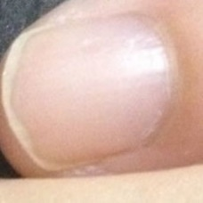 normal#1279 **Confidences:**normal = 100%; non-serious = 0%; warrants second opinion = 0%;   
The nail's condition is normal with confidence score of 100%. [image source](http://localhost:8080/ai/onyx/images/korean/normalnail/semisuper_jpn_104_684_12_953_241_tsume2.jpg)×

 normal#349 **Confidences:**normal = 100%; non-serious = 0%; warrants second opinion = 0%;   
The nail's condition is normal with confidence score of 100%. [image source](http://localhost:8080/ai/onyx/images/korean/L_NAIL_5nail_5nail2010_1_normalnail.png#349)×

 normal#829 **Confidences:**normal = 100%; non-serious = 0%; warrants second opinion = 0%;   
The nail's condition is normal with confidence score of 100%. [image source](http://localhost:8080/ai/onyx/images/korean/L_NAIL_5nail_5nail2014_1_normalnail.png#829)×

 normal#704 **Confidences:**normal = 100%; non-serious = 0%; warrants second opinion = 0%;   
The nail's condition is normal with confidence score of 100%. [image source](http://localhost:8080/ai/onyx/images/korean/L_NAIL_5nail_5nail2014_1_normalnail.png#704)×

 normal#764 **Confidences:**normal = 100%; non-serious = 0%; warrants second opinion = 0%;   
The nail's condition is normal with confidence score of 100%. [image source](http://localhost:8080/ai/onyx/images/korean/L_NAIL_5nail_5nail2014_1_normalnail.png#764)×

 normal#844 **Confidences:**normal = 100%; non-serious = 0%; warrants second opinion = 0%;   
The nail's condition is normal with confidence score of 100%. [image source](http://localhost:8080/ai/onyx/images/korean/L_NAIL_5nail_5nail2014_1_normalnail.png#844)×

 normal#854 **Confidences:**normal = 100%; non-serious = 0%; warrants second opinion = 0%;   
The nail's condition is normal with confidence score of 100%. [image source](http://localhost:8080/ai/onyx/images/korean/L_NAIL_5nail_5nail2014_1_normalnail.png#854)×

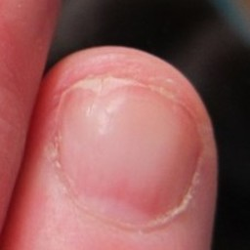 normal#1184 **Confidences:**normal = 100%; non-serious = 0%; warrants second opinion = 0%;   
The nail's condition is normal with confidence score of 100%. [image source](http://localhost:8080/ai/onyx/images/korean/normalnail/semisuper_405_624_331_851_559_IMG_0772-940x705.jpg)×

 non-serious#887 **Confidences:**normal = 0%; non-serious = 50%; warrants second opinion = 50%;   
Not very sure whether the nail is OK or not. Sorry. [image source](http://localhost:8080/ai/onyx/images/korean/L_NAIL_5nail_5nail2005_2_onychomycosis.png#887)×

 non-serious#62 **Confidences:**normal = 17%; non-serious = 74%; warrants second opinion = 9%;   
The nail's condition is non-serious with confidence score of 74%.  
Otherwise it is normal with confidence score of 17%. [image source](http://localhost:8080/ai/onyx/images/korean/L_NAIL_5nailA2_lesion_onychomycosis_onychomycosis.png#62)×

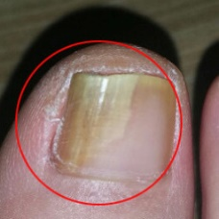 non-serious#1572 **Confidences:**normal = 12%; non-serious = 77%; warrants second opinion = 11%;   
The nail's condition is non-serious with confidence score of 77%.  
Otherwise it is normal with confidence score of 12%. [image source](http://localhost:8080/ai/onyx/images/korean/onychomycosis/semisuper_kor_424_107_35_362_291_th_2458DA3557922A95036C8B.jpg)×

 non-serious#217 **Confidences:**normal = 18%; non-serious = 81%; warrants second opinion = 1%;   
The nail's condition is non-serious with confidence score of 81%.  
Otherwise it is normal with confidence score of 18%. [image source](http://localhost:8080/ai/onyx/images/korean/L_NAIL_5nailA2_lesion_onychomycosis_onychomycosis.png#217)×

 non-serious#722 **Confidences:**normal = 8%; non-serious = 89%; warrants second opinion = 3%;   
The nail's condition is non-serious with confidence score of 89%.  
Otherwise it is normal with confidence score of 8%. [image source](http://localhost:8080/ai/onyx/images/korean/L_NAIL_5nail_5nail2006_onychomycosis_onychomycosis.png#722)×

 non-serious#337 **Confidences:**normal = 4%; non-serious = 89%; warrants second opinion = 7%;   
The nail's condition is non-serious with confidence score of 89%.  
The confidence score for it warranting a second opinion is 7%. [image source](http://localhost:8080/ai/onyx/images/korean/L_NAIL_5nailA2_scio_onychomycosis.png#337)×

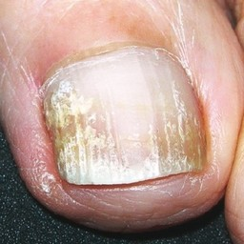 non-serious#1477 **Confidences:**normal = 8%; non-serious = 89%; warrants second opinion = 3%;   
The nail's condition is non-serious with confidence score of 89%.  
Otherwise it is normal with confidence score of 8%. [image source](http://localhost:8080/ai/onyx/images/korean/onychomycosis/semisuper_964_123_192_535_604_ijdvl_2012_78_3_309_95445_f9.jpg)×

 non-serious#987 **Confidences:**normal = 0%; non-serious = 89%; warrants second opinion = 11%;   
The nail's condition is non-serious with confidence score of 89%.  
The confidence score for it warranting a second opinion is 11%. [image source](http://localhost:8080/ai/onyx/images/korean/L_NAIL_5nail_5nail2005_2_onychomycosis.png#987)×

 non-serious#232 **Confidences:**normal = 10%; non-serious = 90%; warrants second opinion = 0%;   
The nail's condition is non-serious with confidence score of 90%.  
Otherwise it is normal with confidence score of 10%. [image source](http://localhost:8080/ai/onyx/images/korean/L_NAIL_5nailA2_lesion_onychomycosis_onychomycosis.png#232)×

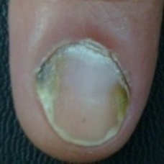 non-serious#1312 **Confidences:**normal = 8%; non-serious = 90%; warrants second opinion = 2%;   
The nail's condition is non-serious with confidence score of 90%.  
Otherwise it is normal with confidence score of 8%. [image source](http://localhost:8080/ai/onyx/images/korean/onychomycosis/semisuper_306_60_409_258_607_DSC05450.jpg)×

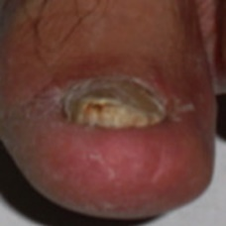 non-serious#1182 **Confidences:**normal = 0%; non-serious = 90%; warrants second opinion = 10%;   
The nail's condition is non-serious with confidence score of 90%.  
The confidence score for it warranting a second opinion is 10%. [image source](http://localhost:8080/ai/onyx/images/korean/onychomycosis/semisuper_1714_543_528_713_698_JBO_18_11_116005_f002.jpg)×

 non-serious#792 **Confidences:**normal = 9%; non-serious = 91%; warrants second opinion = 0%;   
The nail's condition is non-serious with confidence score of 91%.  
Otherwise it is normal with confidence score of 9%. [image source](http://localhost:8080/ai/onyx/images/korean/L_NAIL_5nail_5nail2006_onychomycosis_onychomycosis.png#792)×

 non-serious#407 **Confidences:**normal = 8%; non-serious = 91%; warrants second opinion = 1%;   
The nail's condition is non-serious with confidence score of 91%.  
Otherwise it is normal with confidence score of 8%. [image source](http://localhost:8080/ai/onyx/images/korean/L_NAIL_5nailA2_scio_onychomycosis.png#407)×

 non-serious#172 **Confidences:**normal = 4%; non-serious = 91%; warrants second opinion = 5%;   
The nail's condition is non-serious with confidence score of 91%.  
The confidence score for it warranting a second opinion is 5%. [image source](http://localhost:8080/ai/onyx/images/korean/L_NAIL_5nailA2_lesion_onychomycosis_onychomycosis.png#172)×

 non-serious#192 **Confidences:**normal = 0%; non-serious = 92%; warrants second opinion = 8%;   
The nail's condition is non-serious with confidence score of 92%.  
The confidence score for it warranting a second opinion is 8%. [image source](http://localhost:8080/ai/onyx/images/korean/L_NAIL_5nailA2_lesion_onychomycosis_onychomycosis.png#192)×

 non-serious#2 **Confidences:**normal = 8%; non-serious = 92%; warrants second opinion = 0%;   
The nail's condition is non-serious with confidence score of 92%.  
Otherwise it is normal with confidence score of 8%. [image source](http://localhost:8080/ai/onyx/images/korean/L_NAIL_5nailA2_lesion_onychomycosis_onychomycosis.png#2)×

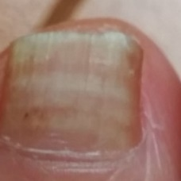 non-serious#1512 **Confidences:**normal = 0%; non-serious = 92%; warrants second opinion = 8%;   
The nail's condition is non-serious with confidence score of 92%.  
The confidence score for it warranting a second opinion is 8%. [image source](http://localhost:8080/ai/onyx/images/korean/onychomycosis/semisuper_jpn_465_170_50_429_309_20140526125837a53.jpg)×

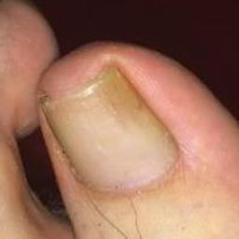 non-serious#1232 **Confidences:**normal = 7%; non-serious = 92%; warrants second opinion = 1%;   
The nail's condition is non-serious with confidence score of 92%.  
Otherwise it is normal with confidence score of 7%. [image source](http://localhost:8080/ai/onyx/images/korean/onychomycosis/semisuper_1943_370_171_569_370_pt06derm2.jpeg)×

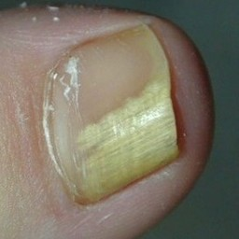 non-serious#1367 **Confidences:**normal = 3%; non-serious = 93%; warrants second opinion = 5%;   
The nail's condition is non-serious with confidence score of 93%.  
The confidence score for it warranting a second opinion is 5%. [image source](http://localhost:8080/ai/onyx/images/korean/onychomycosis/semisuper_588_288_89_561_361_funghi-allalluce.jpg)×

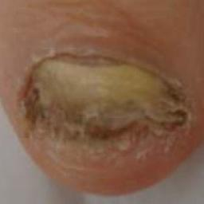 non-serious#1102 **Confidences:**normal = 7%; non-serious = 93%; warrants second opinion = 1%;   
The nail's condition is non-serious with confidence score of 93%.  
Otherwise it is normal with confidence score of 7%. [image source](http://localhost:8080/ai/onyx/images/korean/onychomycosis/semisuper_1536_95_1135_806_1807_0365-0596-abd-89-01-0184-gf01.jpg)×

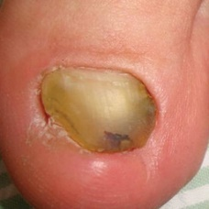 non-serious#1422 **Confidences:**normal = 6%; non-serious = 93%; warrants second opinion = 1%;   
The nail's condition is non-serious with confidence score of 93%.  
Otherwise it is normal with confidence score of 6%. [image source](http://localhost:8080/ai/onyx/images/korean/onychomycosis/semisuper_771_774_1330_1263_1818_fig_5a-dj.jpg)×

 non-serious#37 **Confidences:**normal = 3%; non-serious = 93%; warrants second opinion = 4%;   
The nail's condition is non-serious with confidence score of 93%.  
The confidence score for it warranting a second opinion is 4%. [image source](http://localhost:8080/ai/onyx/images/korean/L_NAIL_5nailA2_lesion_onychomycosis_onychomycosis.png#37)×

 non-serious#547 **Confidences:**normal = 3%; non-serious = 93%; warrants second opinion = 4%;   
The nail's condition is non-serious with confidence score of 93%.  
The confidence score for it warranting a second opinion is 4%. [image source](http://localhost:8080/ai/onyx/images/korean/L_NAIL_5nail_5nail2004_2_onychomycosis.png#547)×

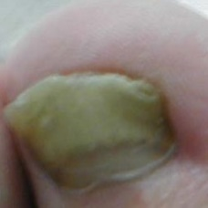 non-serious#1462 **Confidences:**normal = 6%; non-serious = 93%; warrants second opinion = 1%;   
The nail's condition is non-serious with confidence score of 93%.  
Otherwise it is normal with confidence score of 6%. [image source](http://localhost:8080/ai/onyx/images/korean/onychomycosis/semisuper_89_215_14_469_268_Extremities_onychomycosis2.jpg)×

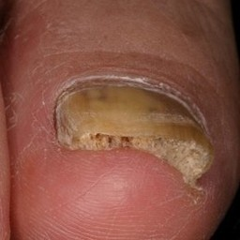 non-serious#1507 **Confidences:**normal = 6%; non-serious = 94%; warrants second opinion = 1%;   
The nail's condition is non-serious with confidence score of 94%.  
Otherwise it is normal with confidence score of 6%. [image source](http://localhost:8080/ai/onyx/images/korean/onychomycosis/semisuper_jpn_452_403_83_696_376_content.jpg)×

 non-serious#672 **Confidences:**normal = 6%; non-serious = 94%; warrants second opinion = 1%;   
The nail's condition is non-serious with confidence score of 94%.  
Otherwise it is normal with confidence score of 6%. [image source](http://localhost:8080/ai/onyx/images/korean/L_NAIL_5nail_5nail2006_onychomycosis_onychomycosis.png#672)×

 non-serious#297 **Confidences:**normal = 0%; non-serious = 94%; warrants second opinion = 6%;   
The nail's condition is non-serious with confidence score of 94%.  
The confidence score for it warranting a second opinion is 6%. [image source](http://localhost:8080/ai/onyx/images/korean/L_NAIL_5nailA2_scio_onychomycosis.png#297)×

 non-serious#852 **Confidences:**normal = 2%; non-serious = 94%; warrants second opinion = 3%;   
The nail's condition is non-serious with confidence score of 94%.  
The confidence score for it warranting a second opinion is 3%. [image source](http://localhost:8080/ai/onyx/images/korean/L_NAIL_5nail_5nail2005_2_onychomycosis.png#852)×

 non-serious#312 **Confidences:**normal = 5%; non-serious = 95%; warrants second opinion = 0%;   
The nail's condition is non-serious with confidence score of 95%.  
Otherwise it is normal with confidence score of 5%. [image source](http://localhost:8080/ai/onyx/images/korean/L_NAIL_5nailA2_scio_onychomycosis.png#312)×

 non-serious#132 **Confidences:**normal = 2%; non-serious = 95%; warrants second opinion = 4%;   
The nail's condition is non-serious with confidence score of 95%.  
The confidence score for it warranting a second opinion is 4%. [image source](http://localhost:8080/ai/onyx/images/korean/L_NAIL_5nailA2_lesion_onychomycosis_onychomycosis.png#132)×

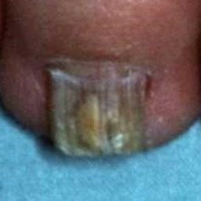 non-serious#1212 **Confidences:**normal = 4%; non-serious = 95%; warrants second opinion = 1%;   
The nail's condition is non-serious with confidence score of 95%.  
Otherwise it is normal with confidence score of 4%. [image source](http://localhost:8080/ai/onyx/images/korean/onychomycosis/semisuper_1791_150_749_360_959_036049HB.JPG)×

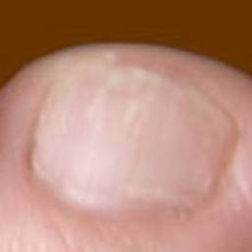 non-serious#1082 **Confidences:**normal = 5%; non-serious = 95%; warrants second opinion = 0%;   
The nail's condition is non-serious with confidence score of 95%.  
Otherwise it is normal with confidence score of 5%. [image source](http://localhost:8080/ai/onyx/images/korean/onychomycosis/semisuper_1476_627_94_857_323_4526565_orig.jpg)×

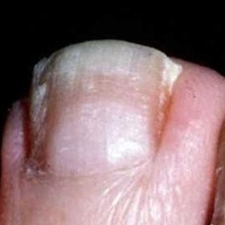 non-serious#1387 **Confidences:**normal = 2%; non-serious = 95%; warrants second opinion = 3%;   
The nail's condition is non-serious with confidence score of 95%.  
The confidence score for it warranting a second opinion is 3%. [image source](http://localhost:8080/ai/onyx/images/korean/onychomycosis/semisuper_668_569_15_852_287_036641HB.jpg)×

 non-serious#397 **Confidences:**normal = 0%; non-serious = 95%; warrants second opinion = 5%;   
The nail's condition is non-serious with confidence score of 95%.  
The confidence score for it warranting a second opinion is 5%. [image source](http://localhost:8080/ai/onyx/images/korean/L_NAIL_5nailA2_scio_onychomycosis.png#397)×

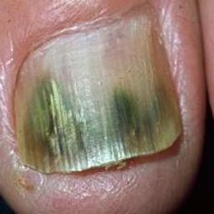 non-serious#1497 **Confidences:**normal = 0%; non-serious = 95%; warrants second opinion = 5%;   
The nail's condition is non-serious with confidence score of 95%.  
The confidence score for it warranting a second opinion is 5%. [image source](http://localhost:8080/ai/onyx/images/korean/onychomycosis/semisuper_jpn_241_54_62_285_293_img0104.jpg)×

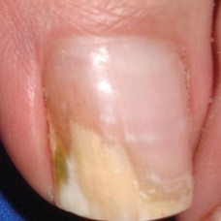 non-serious#1042 **Confidences:**normal = 1%; non-serious = 95%; warrants second opinion = 3%;   
The nail's condition is non-serious with confidence score of 95%.  
The confidence score for it warranting a second opinion is 3%. [image source](http://localhost:8080/ai/onyx/images/korean/onychomycosis/semisuper_1333_628_151_1041_584_fig_10j(9).jpg)×

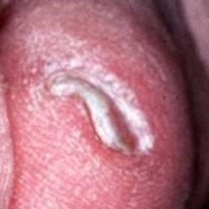 non-serious#1007 **Confidences:**normal = 2%; non-serious = 95%; warrants second opinion = 3%;   
The nail's condition is non-serious with confidence score of 95%.  
The confidence score for it warranting a second opinion is 3%. [image source](http://localhost:8080/ai/onyx/images/korean/onychomycosis/semisuper_1015_1230_400_1443_613_036963HB.jpg)×

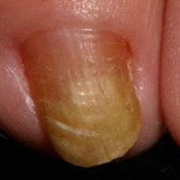 non-serious#1067 **Confidences:**normal = 4%; non-serious = 95%; warrants second opinion = 0%;   
The nail's condition is non-serious with confidence score of 95%.  
Otherwise it is normal with confidence score of 4%. [image source](http://localhost:8080/ai/onyx/images/korean/onychomycosis/semisuper_1446_75_656_412_993_Onycho5yearold2_2.jpg)×

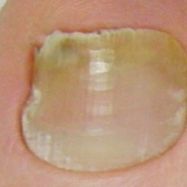 non-serious#1402 **Confidences:**normal = 0%; non-serious = 95%; warrants second opinion = 4%;   
The nail's condition is non-serious with confidence score of 95%.  
The confidence score for it warranting a second opinion is 4%. [image source](http://localhost:8080/ai/onyx/images/korean/onychomycosis/semisuper_701_613_75_1010_472_toe-nail1.jpg)×

 non-serious#777 **Confidences:**normal = 0%; non-serious = 96%; warrants second opinion = 4%;   
The nail's condition is non-serious with confidence score of 96%.  
The confidence score for it warranting a second opinion is 4%. [image source](http://localhost:8080/ai/onyx/images/korean/L_NAIL_5nail_5nail2006_onychomycosis_onychomycosis.png#777)×

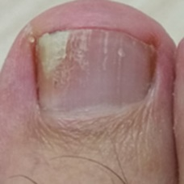 non-serious#1517 **Confidences:**normal = 3%; non-serious = 96%; warrants second opinion = 1%;   
The nail's condition is non-serious with confidence score of 96%.  
Otherwise it is normal with confidence score of 3%. [image source](http://localhost:8080/ai/onyx/images/korean/onychomycosis/semisuper_jpn_473_223_10_439_199_160924222344630689.jpg)×

 non-serious#362 **Confidences:**normal = 4%; non-serious = 96%; warrants second opinion = 0%;   
The nail's condition is non-serious with confidence score of 96%.  
Otherwise it is normal with confidence score of 4%. [image source](http://localhost:8080/ai/onyx/images/korean/L_NAIL_5nailA2_scio_onychomycosis.png#362)×

 non-serious#432 **Confidences:**normal = 3%; non-serious = 96%; warrants second opinion = 1%;   
The nail's condition is non-serious with confidence score of 96%.  
Otherwise it is normal with confidence score of 3%. [image source](http://localhost:8080/ai/onyx/images/korean/L_NAIL_5nailA2_scio_onychomycosis.png#432)×

 non-serious#87 **Confidences:**normal = 3%; non-serious = 96%; warrants second opinion = 0%;   
The nail's condition is non-serious with confidence score of 96%.  
Otherwise it is normal with confidence score of 3%. [image source](http://localhost:8080/ai/onyx/images/korean/L_NAIL_5nailA2_lesion_onychomycosis_onychomycosis.png#87)×

 non-serious#612 **Confidences:**normal = 2%; non-serious = 97%; warrants second opinion = 1%;   
The nail's condition is non-serious with confidence score of 97%.  
Otherwise it is normal with confidence score of 2%. [image source](http://localhost:8080/ai/onyx/images/korean/L_NAIL_5nail_5nail2004_2_onychomycosis.png#612)×

 non-serious#537 **Confidences:**normal = 0%; non-serious = 97%; warrants second opinion = 3%;   
The nail's condition is non-serious with confidence score of 97%.  
The confidence score for it warranting a second opinion is 3%. [image source](http://localhost:8080/ai/onyx/images/korean/L_NAIL_5nail_5nail2004_2_onychomycosis.png#537)×

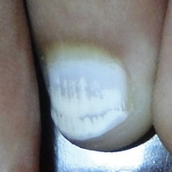 non-serious#1247 **Confidences:**normal = 3%; non-serious = 97%; warrants second opinion = 0%;   
The nail's condition is non-serious with confidence score of 97%.  
Otherwise it is normal with confidence score of 3%. [image source](http://localhost:8080/ai/onyx/images/korean/onychomycosis/semisuper_2025_1122_1944_1557_2379_white%20nail-3-.JPG)×

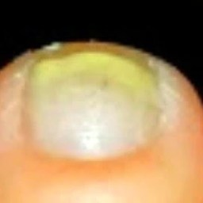 non-serious#1522 **Confidences:**normal = 3%; non-serious = 97%; warrants second opinion = 1%;   
The nail's condition is non-serious with confidence score of 97%.  
Otherwise it is normal with confidence score of 3%. [image source](http://localhost:8080/ai/onyx/images/korean/onychomycosis/semisuper_jpn_488_495_88_767_360_maxresdefault.jpg)×

 non-serious#762 **Confidences:**normal = 3%; non-serious = 97%; warrants second opinion = 0%;   
The nail's condition is non-serious with confidence score of 97%.  
Otherwise it is normal with confidence score of 3%. [image source](http://localhost:8080/ai/onyx/images/korean/L_NAIL_5nail_5nail2006_onychomycosis_onychomycosis.png#762)×

 non-serious#92 **Confidences:**normal = 1%; non-serious = 97%; warrants second opinion = 2%;   
The nail's condition is non-serious with confidence score of 97%.  
The confidence score for it warranting a second opinion is 2%. [image source](http://localhost:8080/ai/onyx/images/korean/L_NAIL_5nailA2_lesion_onychomycosis_onychomycosis.png#92)×

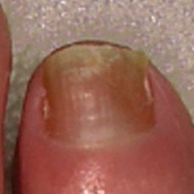 non-serious#1172 **Confidences:**normal = 2%; non-serious = 97%; warrants second opinion = 1%;   
The nail's condition is non-serious with confidence score of 97%.  
Otherwise it is normal with confidence score of 2%. [image source](http://localhost:8080/ai/onyx/images/korean/onychomycosis/semisuper_1700_682_73_942_333_dce70004f1.jpg)×

 non-serious#347 **Confidences:**normal = 2%; non-serious = 97%; warrants second opinion = 1%;   
The nail's condition is non-serious with confidence score of 97%.  
Otherwise it is normal with confidence score of 2%. [image source](http://localhost:8080/ai/onyx/images/korean/L_NAIL_5nailA2_scio_onychomycosis.png#347)×

 non-serious#7 **Confidences:**normal = 3%; non-serious = 97%; warrants second opinion = 0%;   
The nail's condition is non-serious with confidence score of 97%.  
Otherwise it is normal with confidence score of 3%. [image source](http://localhost:8080/ai/onyx/images/korean/L_NAIL_5nailA2_lesion_onychomycosis_onychomycosis.png#7)×

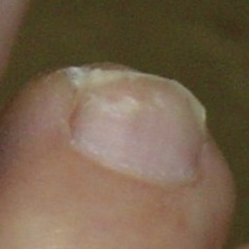 non-serious#1027 **Confidences:**normal = 3%; non-serious = 97%; warrants second opinion = 0%;   
The nail's condition is non-serious with confidence score of 97%.  
Otherwise it is normal with confidence score of 3%. [image source](http://localhost:8080/ai/onyx/images/korean/onychomycosis/semisuper_1211_811_445_1047_681_pt0906ce1.jpg)×

 non-serious#602 **Confidences:**normal = 0%; non-serious = 97%; warrants second opinion = 3%;   
The nail's condition is non-serious with confidence score of 97%.  
The confidence score for it warranting a second opinion is 3%. [image source](http://localhost:8080/ai/onyx/images/korean/L_NAIL_5nail_5nail2004_2_onychomycosis.png#602)×

 non-serious#437 **Confidences:**normal = 1%; non-serious = 97%; warrants second opinion = 1%;   
The nail's condition is non-serious with confidence score of 97%.  
Otherwise it is normal with confidence score of 1%. [image source](http://localhost:8080/ai/onyx/images/korean/L_NAIL_5nailA2_scio_onychomycosis.png#437)×

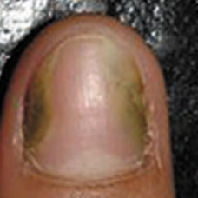 non-serious#1242 **Confidences:**normal = 2%; non-serious = 97%; warrants second opinion = 0%;   
The nail's condition is non-serious with confidence score of 97%.  
Otherwise it is normal with confidence score of 2%. [image source](http://localhost:8080/ai/onyx/images/korean/onychomycosis/semisuper_2006_627_237_1033_643_1j.jpg)×

 non-serious#1372 **Confidences:**normal = 2%; non-serious = 97%; warrants second opinion = 0%;   
The nail's condition is non-serious with confidence score of 97%.  
Otherwise it is normal with confidence score of 2%. [image source](http://localhost:8080/ai/onyx/images/korean/onychomycosis/semisuper_61_627_237_1033_643_1j.jpg)×

 non-serious#577 **Confidences:**normal = 2%; non-serious = 97%; warrants second opinion = 0%;   
The nail's condition is non-serious with confidence score of 97%.  
Otherwise it is normal with confidence score of 2%. [image source](http://localhost:8080/ai/onyx/images/korean/L_NAIL_5nail_5nail2004_2_onychomycosis.png#577)×

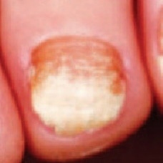 non-serious#1137 **Confidences:**normal = 2%; non-serious = 97%; warrants second opinion = 0%;   
The nail's condition is non-serious with confidence score of 97%.  
Otherwise it is normal with confidence score of 2%. [image source](http://localhost:8080/ai/onyx/images/korean/onychomycosis/semisuper_1615_493_219_685_411_f7a2a3d03ca5e2626b873b655c6988ee.jpg)×

 non-serious#997 **Confidences:**normal = 1%; non-serious = 98%; warrants second opinion = 2%;   
The nail's condition is non-serious with confidence score of 98%.  
The confidence score for it warranting a second opinion is 2%. [image source](http://localhost:8080/ai/onyx/images/korean/L_NAIL_5nail_5nail2005_2_onychomycosis.png#997)×

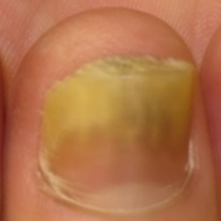 non-serious#1542 **Confidences:**normal = 2%; non-serious = 98%; warrants second opinion = 0%;   
The nail's condition is non-serious with confidence score of 98%.  
Otherwise it is normal with confidence score of 2%. [image source](http://localhost:8080/ai/onyx/images/korean/onychomycosis/semisuper_jpn_92_102_83_342_324.jpg)×

 non-serious#827 **Confidences:**normal = 2%; non-serious = 98%; warrants second opinion = 0%;   
The nail's condition is non-serious with confidence score of 98%.  
Otherwise it is normal with confidence score of 2%. [image source](http://localhost:8080/ai/onyx/images/korean/L_NAIL_5nail_5nail2005_2_onychomycosis.png#827)×

 non-serious#442 **Confidences:**normal = 0%; non-serious = 98%; warrants second opinion = 2%;   
The nail's condition is non-serious with confidence score of 98%.  
The confidence score for it warranting a second opinion is 2%. [image source](http://localhost:8080/ai/onyx/images/korean/L_NAIL_5nailA2_scio_onychomycosis.png#442)×

 non-serious#867 **Confidences:**normal = 0%; non-serious = 98%; warrants second opinion = 2%;   
The nail's condition is non-serious with confidence score of 98%.  
The confidence score for it warranting a second opinion is 2%. [image source](http://localhost:8080/ai/onyx/images/korean/L_NAIL_5nail_5nail2005_2_onychomycosis.png#867)×

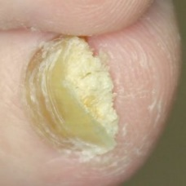 non-serious#1357 **Confidences:**normal = 2%; non-serious = 98%; warrants second opinion = 0%;   
The nail's condition is non-serious with confidence score of 98%.  
Otherwise it is normal with confidence score of 2%. [image source](http://localhost:8080/ai/onyx/images/korean/onychomycosis/semisuper_53_1851_950_2646_1744_Onychomycosis-web.jpg)×

 non-serious#557 **Confidences:**normal = 0%; non-serious = 98%; warrants second opinion = 2%;   
The nail's condition is non-serious with confidence score of 98%.  
The confidence score for it warranting a second opinion is 2%. [image source](http://localhost:8080/ai/onyx/images/korean/L_NAIL_5nail_5nail2004_2_onychomycosis.png#557)×

 non-serious#597 **Confidences:**normal = 0%; non-serious = 98%; warrants second opinion = 2%;   
The nail's condition is non-serious with confidence score of 98%.  
The confidence score for it warranting a second opinion is 2%. [image source](http://localhost:8080/ai/onyx/images/korean/L_NAIL_5nail_5nail2004_2_onychomycosis.png#597)×

 non-serious#247 **Confidences:**normal = 1%; non-serious = 98%; warrants second opinion = 0%;   
The nail's condition is non-serious with confidence score of 98%.  
Otherwise it is normal with confidence score of 1%. [image source](http://localhost:8080/ai/onyx/images/korean/L_NAIL_5nailA2_lesion_onychomycosis_onychomycosis.png#247)×

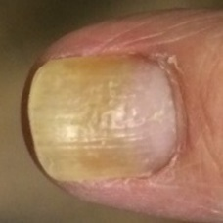 non-serious#1272 **Confidences:**normal = 2%; non-serious = 98%; warrants second opinion = 0%;   
The nail's condition is non-serious with confidence score of 98%.  
Otherwise it is normal with confidence score of 2%. [image source](http://localhost:8080/ai/onyx/images/korean/onychomycosis/semisuper_2210_114_754_310_951_20140620-183207-66727012.jpg)×

 non-serious#97 **Confidences:**normal = 1%; non-serious = 98%; warrants second opinion = 1%;   
The nail's condition is non-serious with confidence score of 98%.  
Otherwise it is normal with confidence score of 1%. [image source](http://localhost:8080/ai/onyx/images/korean/L_NAIL_5nailA2_lesion_onychomycosis_onychomycosis.png#97)×

 non-serious#502 **Confidences:**normal = 2%; non-serious = 98%; warrants second opinion = 0%;   
The nail's condition is non-serious with confidence score of 98%.  
Otherwise it is normal with confidence score of 2%. [image source](http://localhost:8080/ai/onyx/images/korean/L_NAIL_5nail_5nail2004_2_onychomycosis.png#502)×

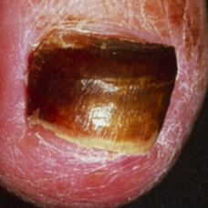 non-serious#1482 **Confidences:**normal = 0%; non-serious = 98%; warrants second opinion = 1%;   
The nail's condition is non-serious with confidence score of 98%.  
The confidence score for it warranting a second opinion is 1%. [image source](http://localhost:8080/ai/onyx/images/korean/onychomycosis/semisuper_985_371_169_566_365_ca_ss_sk0208_121565.jpg)×

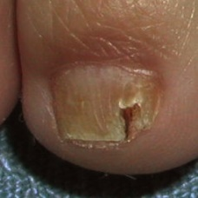 non-serious#1307 **Confidences:**normal = 2%; non-serious = 98%; warrants second opinion = 0%;   
The nail's condition is non-serious with confidence score of 98%.  
Otherwise it is normal with confidence score of 2%. [image source](http://localhost:8080/ai/onyx/images/korean/onychomycosis/semisuper_27_150_1017_525_1391_onychomycosis1364420284545.jpg)×

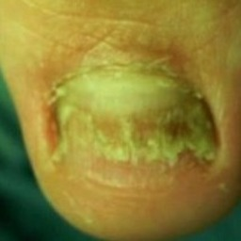 non-serious#1567 **Confidences:**normal = 0%; non-serious = 98%; warrants second opinion = 1%;   
The nail's condition is non-serious with confidence score of 98%.  
The confidence score for it warranting a second opinion is 1%. [image source](http://localhost:8080/ai/onyx/images/korean/onychomycosis/semisuper_kor_387_361_286_573_497_th_1861A03E4D3922FF162748.jpg)×

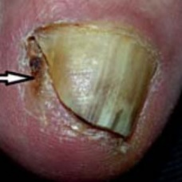 non-serious#1282 **Confidences:**normal = 1%; non-serious = 98%; warrants second opinion = 1%;   
The nail's condition is non-serious with confidence score of 98%.  
Otherwise it is normal with confidence score of 1%. [image source](http://localhost:8080/ai/onyx/images/korean/onychomycosis/semisuper_2414_181_166_467_453_PMC4148282_abd-89-04-0649-g01.jpg)×

 non-serious#907 **Confidences:**normal = 1%; non-serious = 98%; warrants second opinion = 1%;   
The nail's condition is non-serious with confidence score of 98%.  
Otherwise it is normal with confidence score of 1%. [image source](http://localhost:8080/ai/onyx/images/korean/L_NAIL_5nail_5nail2005_2_onychomycosis.png#907)×

 non-serious#107 **Confidences:**normal = 1%; non-serious = 98%; warrants second opinion = 1%;   
The nail's condition is non-serious with confidence score of 98%.  
Otherwise it is normal with confidence score of 1%. [image source](http://localhost:8080/ai/onyx/images/korean/L_NAIL_5nailA2_lesion_onychomycosis_onychomycosis.png#107)×

 non-serious#582 **Confidences:**normal = 2%; non-serious = 98%; warrants second opinion = 0%;   
The nail's condition is non-serious with confidence score of 98%.  
Otherwise it is normal with confidence score of 2%. [image source](http://localhost:8080/ai/onyx/images/korean/L_NAIL_5nail_5nail2004_2_onychomycosis.png#582)×

 non-serious#532 **Confidences:**normal = 1%; non-serious = 98%; warrants second opinion = 0%;   
The nail's condition is non-serious with confidence score of 98%.  
Otherwise it is normal with confidence score of 1%. [image source](http://localhost:8080/ai/onyx/images/korean/L_NAIL_5nail_5nail2004_2_onychomycosis.png#532)×

 non-serious#282 **Confidences:**normal = 1%; non-serious = 98%; warrants second opinion = 1%;   
The nail's condition is non-serious with confidence score of 98%.  
Otherwise it is normal with confidence score of 1%. [image source](http://localhost:8080/ai/onyx/images/korean/L_NAIL_5nailA2_scio_onychomycosis.png#282)×

 non-serious#742 **Confidences:**normal = 1%; non-serious = 98%; warrants second opinion = 0%;   
The nail's condition is non-serious with confidence score of 98%.  
Otherwise it is normal with confidence score of 1%. [image source](http://localhost:8080/ai/onyx/images/korean/L_NAIL_5nail_5nail2006_onychomycosis_onychomycosis.png#742)×

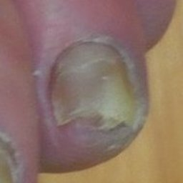 non-serious#1347 **Confidences:**normal = 0%; non-serious = 99%; warrants second opinion = 1%;   
The nail's condition is non-serious with confidence score of 99%.  
The confidence score for it warranting a second opinion is 1%. [image source](http://localhost:8080/ai/onyx/images/korean/onychomycosis/semisuper_475_799_355_989_551_DSCN0049_lxSl8MZ.max-1000x800.jpg)×

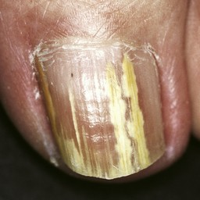 non-serious#1337 **Confidences:**normal = 0%; non-serious = 99%; warrants second opinion = 1%;   
The nail's condition is non-serious with confidence score of 99%.  
The confidence score for it warranting a second opinion is 1%. [image source](http://localhost:8080/ai/onyx/images/korean/onychomycosis/semisuper_432_206_864_1168_1826_0396907.jpg)×

 non-serious#627 **Confidences:**normal = 0%; non-serious = 99%; warrants second opinion = 1%;   
The nail's condition is non-serious with confidence score of 99%.  
The confidence score for it warranting a second opinion is 1%. [image source](http://localhost:8080/ai/onyx/images/korean/L_NAIL_5nail_5nail2004_2_onychomycosis.png#627)×

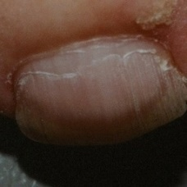 non-serious#1142 **Confidences:**normal = 1%; non-serious = 99%; warrants second opinion = 0%;   
The nail's condition is non-serious with confidence score of 99%.  
Otherwise it is normal with confidence score of 1%. [image source](http://localhost:8080/ai/onyx/images/korean/onychomycosis/semisuper_1629_921_528_1221_828_Superficial_Onychomycosis_E1.jpg)×

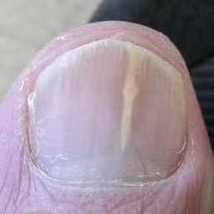 non-serious#1492 **Confidences:**normal = 0%; non-serious = 99%; warrants second opinion = 1%;   
The nail's condition is non-serious with confidence score of 99%.  
The confidence score for it warranting a second opinion is 1%. [image source](http://localhost:8080/ai/onyx/images/korean/onychomycosis/semisuper_jpn_174_273_145_515_387_11230003.jpg)×

 non-serious#327 **Confidences:**normal = 0%; non-serious = 99%; warrants second opinion = 1%;   
The nail's condition is non-serious with confidence score of 99%.  
The confidence score for it warranting a second opinion is 1%. [image source](http://localhost:8080/ai/onyx/images/korean/L_NAIL_5nailA2_scio_onychomycosis.png#327)×

 non-serious#82 **Confidences:**normal = 1%; non-serious = 99%; warrants second opinion = 0%;   
The nail's condition is non-serious with confidence score of 99%.  
Otherwise it is normal with confidence score of 1%. [image source](http://localhost:8080/ai/onyx/images/korean/L_NAIL_5nailA2_lesion_onychomycosis_onychomycosis.png#82)×

 non-serious#707 **Confidences:**normal = 0%; non-serious = 99%; warrants second opinion = 1%;   
The nail's condition is non-serious with confidence score of 99%.  
The confidence score for it warranting a second opinion is 1%. [image source](http://localhost:8080/ai/onyx/images/korean/L_NAIL_5nail_5nail2006_onychomycosis_onychomycosis.png#707)×

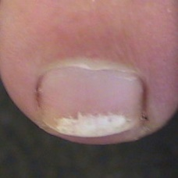 non-serious#1332 **Confidences:**normal = 1%; non-serious = 99%; warrants second opinion = 0%;   
The nail's condition is non-serious with confidence score of 99%.  
Otherwise it is normal with confidence score of 1%. [image source](http://localhost:8080/ai/onyx/images/korean/onychomycosis/semisuper_412_650_856_943_1150_3073104374e470f4e44ae2.jpg)×

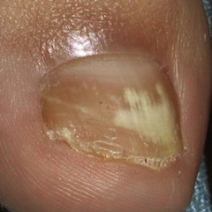 non-serious#1302 **Confidences:**normal = 1%; non-serious = 99%; warrants second opinion = 0%;   
The nail's condition is non-serious with confidence score of 99%.  
Otherwise it is normal with confidence score of 1%. [image source](http://localhost:8080/ai/onyx/images/korean/onychomycosis/semisuper_25_1612_736_2154_1279_onychomycosis1364420284545.jpg)×

 non-serious#822 **Confidences:**normal = 1%; non-serious = 99%; warrants second opinion = 0%;   
The nail's condition is non-serious with confidence score of 99%.  
Otherwise it is normal with confidence score of 1%. [image source](http://localhost:8080/ai/onyx/images/korean/L_NAIL_5nail_5nail2006_onychomycosis_onychomycosis.png#822)×

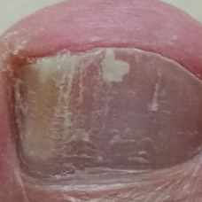 non-serious#1502 **Confidences:**normal = 0%; non-serious = 99%; warrants second opinion = 1%;   
The nail's condition is non-serious with confidence score of 99%.  
The confidence score for it warranting a second opinion is 1%. [image source](http://localhost:8080/ai/onyx/images/korean/onychomycosis/semisuper_jpn_445_123_64_819_759_160807135541776994.jpg)×

 non-serious#182 **Confidences:**normal = 0%; non-serious = 99%; warrants second opinion = 1%;   
The nail's condition is non-serious with confidence score of 99%.  
The confidence score for it warranting a second opinion is 1%. [image source](http://localhost:8080/ai/onyx/images/korean/L_NAIL_5nailA2_lesion_onychomycosis_onychomycosis.png#182)×

 non-serious#552 **Confidences:**normal = 0%; non-serious = 99%; warrants second opinion = 1%;   
The nail's condition is non-serious with confidence score of 99%.  
The confidence score for it warranting a second opinion is 1%. [image source](http://localhost:8080/ai/onyx/images/korean/L_NAIL_5nail_5nail2004_2_onychomycosis.png#552)×

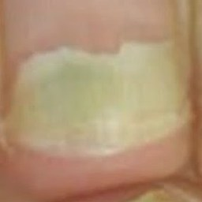 non-serious#1597 **Confidences:**normal = 1%; non-serious = 99%; warrants second opinion = 0%;   
The nail's condition is non-serious with confidence score of 99%.  
Otherwise it is normal with confidence score of 1%. [image source](http://localhost:8080/ai/onyx/images/korean/onychomycosis/semisuper_kor_761_279_121_568_409_maxresdefault.jpg)×

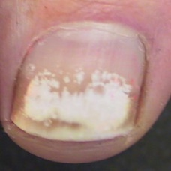 non-serious#1092 **Confidences:**normal = 1%; non-serious = 99%; warrants second opinion = 0%;   
The nail's condition is non-serious with confidence score of 99%.  
Otherwise it is normal with confidence score of 1%. [image source](http://localhost:8080/ai/onyx/images/korean/onychomycosis/semisuper_1514_964_670_1387_1092_3073104374e470f4e44ae2.jpg)×

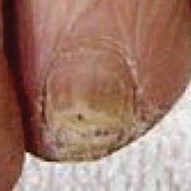 non-serious#1127 **Confidences:**normal = 0%; non-serious = 99%; warrants second opinion = 1%;   
The nail's condition is non-serious with confidence score of 99%.  
The confidence score for it warranting a second opinion is 1%. [image source](http://localhost:8080/ai/onyx/images/korean/onychomycosis/semisuper_1588_304_290_605_591_ClearSteps-Laser-Onychomycosis-nail-infection-before-after-photots.jpg)×

 non-serious#257 **Confidences:**normal = 0%; non-serious = 99%; warrants second opinion = 1%;   
The nail's condition is non-serious with confidence score of 99%.  
The confidence score for it warranting a second opinion is 1%. [image source](http://localhost:8080/ai/onyx/images/korean/L_NAIL_5nailA2_scio_onychomycosis.png#257)×

 non-serious#57 **Confidences:**normal = 1%; non-serious = 99%; warrants second opinion = 0%;   
The nail's condition is non-serious with confidence score of 99%.  
Otherwise it is normal with confidence score of 1%. [image source](http://localhost:8080/ai/onyx/images/korean/L_NAIL_5nailA2_lesion_onychomycosis_onychomycosis.png#57)×

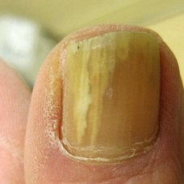 non-serious#1362 **Confidences:**normal = 0%; non-serious = 99%; warrants second opinion = 1%;   
The nail's condition is non-serious with confidence score of 99%.  
The confidence score for it warranting a second opinion is 1%. [image source](http://localhost:8080/ai/onyx/images/korean/onychomycosis/semisuper_55_266_491_1998_2223_Fungal-toenail.jpg)×

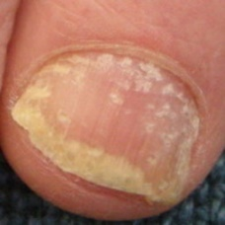 non-serious#1257 **Confidences:**normal = 1%; non-serious = 99%; warrants second opinion = 0%;   
The nail's condition is non-serious with confidence score of 99%.  
Otherwise it is normal with confidence score of 1%. [image source](http://localhost:8080/ai/onyx/images/korean/onychomycosis/semisuper_2068_432_175_628_370_nail-psoriasis1.jpg)×

 non-serious#727 **Confidences:**normal = 0%; non-serious = 99%; warrants second opinion = 1%;   
The nail's condition is non-serious with confidence score of 99%.  
The confidence score for it warranting a second opinion is 1%. [image source](http://localhost:8080/ai/onyx/images/korean/L_NAIL_5nail_5nail2006_onychomycosis_onychomycosis.png#727)×

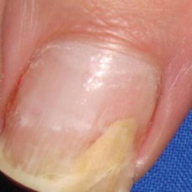 non-serious#1297 **Confidences:**normal = 1%; non-serious = 99%; warrants second opinion = 0%;   
The nail's condition is non-serious with confidence score of 99%.  
Otherwise it is normal with confidence score of 1%. [image source](http://localhost:8080/ai/onyx/images/korean/onychomycosis/semisuper_2515_56_109_479_533_fig_10j(9).jpg)×

 non-serious#897 **Confidences:**normal = 0%; non-serious = 99%; warrants second opinion = 1%;   
The nail's condition is non-serious with confidence score of 99%.  
The confidence score for it warranting a second opinion is 1%. [image source](http://localhost:8080/ai/onyx/images/korean/L_NAIL_5nail_5nail2005_2_onychomycosis.png#897)×

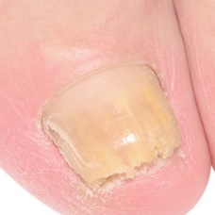 non-serious#1412 **Confidences:**normal = 1%; non-serious = 99%; warrants second opinion = 0%;   
The nail's condition is non-serious with confidence score of 99%.  
Otherwise it is normal with confidence score of 1%. [image source](http://localhost:8080/ai/onyx/images/korean/onychomycosis/semisuper_745_2596_1492_3194_2089_shutterstock_161804258.jpg)×

 non-serious#22 **Confidences:**normal = 0%; non-serious = 99%; warrants second opinion = 1%;   
The nail's condition is non-serious with confidence score of 99%.  
The confidence score for it warranting a second opinion is 1%. [image source](http://localhost:8080/ai/onyx/images/korean/L_NAIL_5nailA2_lesion_onychomycosis_onychomycosis.png#22)×

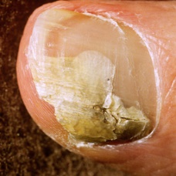 non-serious#1317 **Confidences:**normal = 0%; non-serious = 99%; warrants second opinion = 1%;   
The nail's condition is non-serious with confidence score of 99%.  
The confidence score for it warranting a second opinion is 1%. [image source](http://localhost:8080/ai/onyx/images/korean/onychomycosis/semisuper_322_26_142_430_547_8536670e4c.jpg)×

 non-serious#902 **Confidences:**normal = 0%; non-serious = 99%; warrants second opinion = 1%;   
The nail's condition is non-serious with confidence score of 99%.  
The confidence score for it warranting a second opinion is 1%. [image source](http://localhost:8080/ai/onyx/images/korean/L_NAIL_5nail_5nail2005_2_onychomycosis.png#902)×

 non-serious#962 **Confidences:**normal = 0%; non-serious = 99%; warrants second opinion = 1%;   
The nail's condition is non-serious with confidence score of 99%.  
The confidence score for it warranting a second opinion is 1%. [image source](http://localhost:8080/ai/onyx/images/korean/L_NAIL_5nail_5nail2005_2_onychomycosis.png#962)×

 non-serious#697 **Confidences:**normal = 1%; non-serious = 99%; warrants second opinion = 0%;   
The nail's condition is non-serious with confidence score of 99%.  
Otherwise it is normal with confidence score of 1%. [image source](http://localhost:8080/ai/onyx/images/korean/L_NAIL_5nail_5nail2006_onychomycosis_onychomycosis.png#697)×

 non-serious#212 **Confidences:**normal = 1%; non-serious = 99%; warrants second opinion = 0%;   
The nail's condition is non-serious with confidence score of 99%.  
Otherwise it is normal with confidence score of 1%. [image source](http://localhost:8080/ai/onyx/images/korean/L_NAIL_5nailA2_lesion_onychomycosis_onychomycosis.png#212)×

 non-serious#412 **Confidences:**normal = 0%; non-serious = 99%; warrants second opinion = 1%;   
The nail's condition is non-serious with confidence score of 99%.  
The confidence score for it warranting a second opinion is 1%. [image source](http://localhost:8080/ai/onyx/images/korean/L_NAIL_5nailA2_scio_onychomycosis.png#412)×

 non-serious#67 **Confidences:**normal = 0%; non-serious = 99%; warrants second opinion = 1%;   
The nail's condition is non-serious with confidence score of 99%.  
The confidence score for it warranting a second opinion is 1%. [image source](http://localhost:8080/ai/onyx/images/korean/L_NAIL_5nailA2_lesion_onychomycosis_onychomycosis.png#67)×

 non-serious#252 **Confidences:**normal = 0%; non-serious = 99%; warrants second opinion = 1%;   
The nail's condition is non-serious with confidence score of 99%.  
The confidence score for it warranting a second opinion is 1%. [image source](http://localhost:8080/ai/onyx/images/korean/L_NAIL_5nailA2_scio_onychomycosis.png#252)×

 non-serious#307 **Confidences:**normal = 1%; non-serious = 99%; warrants second opinion = 0%;   
The nail's condition is non-serious with confidence score of 99%.  
Otherwise it is normal with confidence score of 1%. [image source](http://localhost:8080/ai/onyx/images/korean/L_NAIL_5nailA2_scio_onychomycosis.png#307)×

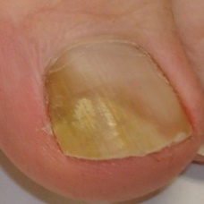 non-serious#1382 **Confidences:**normal = 0%; non-serious = 99%; warrants second opinion = 0%;   
The nail's condition is non-serious with confidence score of 99%. [image source](http://localhost:8080/ai/onyx/images/korean/onychomycosis/semisuper_663_1799_714_2338_1253_19_de_agosto_2008_003.jpg)×

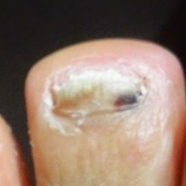 non-serious#1582 **Confidences:**normal = 1%; non-serious = 99%; warrants second opinion = 0%;   
The nail's condition is non-serious with confidence score of 99%.  
Otherwise it is normal with confidence score of 1%. [image source](http://localhost:8080/ai/onyx/images/korean/onychomycosis/semisuper_kor_507_849_31_1173_356_20140514_1400114.jpg)×

 non-serious#302 **Confidences:**normal = 0%; non-serious = 99%; warrants second opinion = 1%;   
The nail's condition is non-serious with confidence score of 99%.  
The confidence score for it warranting a second opinion is 1%. [image source](http://localhost:8080/ai/onyx/images/korean/L_NAIL_5nailA2_scio_onychomycosis.png#302)×

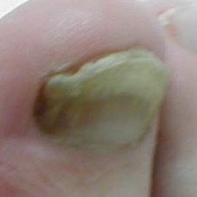 non-serious#1467 **Confidences:**normal = 0%; non-serious = 99%; warrants second opinion = 0%;   
The nail's condition is non-serious with confidence score of 99%. [image source](http://localhost:8080/ai/onyx/images/korean/onychomycosis/semisuper_90_723_83_1010_370_Extremities_onychomycosis2.jpg)×

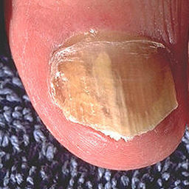 non-serious#1592 **Confidences:**normal = 0%; non-serious = 99%; warrants second opinion = 0%;   
The nail's condition is non-serious with confidence score of 99%. [image source](http://localhost:8080/ai/onyx/images/korean/onychomycosis/semisuper_kor_61_370_112_682_424_Onychomycosis.jpg)×

 non-serious#812 **Confidences:**normal = 0%; non-serious = 99%; warrants second opinion = 1%;   
The nail's condition is non-serious with confidence score of 99%.  
The confidence score for it warranting a second opinion is 1%. [image source](http://localhost:8080/ai/onyx/images/korean/L_NAIL_5nail_5nail2006_onychomycosis_onychomycosis.png#812)×

 non-serious#17 **Confidences:**normal = 0%; non-serious = 99%; warrants second opinion = 1%;   
The nail's condition is non-serious with confidence score of 99%.  
The confidence score for it warranting a second opinion is 1%. [image source](http://localhost:8080/ai/onyx/images/korean/L_NAIL_5nailA2_lesion_onychomycosis_onychomycosis.png#17)×

 non-serious#912 **Confidences:**normal = 0%; non-serious = 99%; warrants second opinion = 1%;   
The nail's condition is non-serious with confidence score of 99%.  
The confidence score for it warranting a second opinion is 1%. [image source](http://localhost:8080/ai/onyx/images/korean/L_NAIL_5nail_5nail2005_2_onychomycosis.png#912)×

 non-serious#42 **Confidences:**normal = 1%; non-serious = 99%; warrants second opinion = 0%;   
The nail's condition is non-serious with confidence score of 99%.  
Otherwise it is normal with confidence score of 1%. [image source](http://localhost:8080/ai/onyx/images/korean/L_NAIL_5nailA2_lesion_onychomycosis_onychomycosis.png#42)×

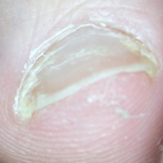 non-serious#1407 **Confidences:**normal = 1%; non-serious = 99%; warrants second opinion = 0%;   
The nail's condition is non-serious with confidence score of 99%.  
Otherwise it is normal with confidence score of 1%. [image source](http://localhost:8080/ai/onyx/images/korean/onychomycosis/semisuper_71_752_145_1231_633_Onychomycosis-Cropped.jpg)×

 non-serious#222 **Confidences:**normal = 0%; non-serious = 99%; warrants second opinion = 0%;   
The nail's condition is non-serious with confidence score of 99%. [image source](http://localhost:8080/ai/onyx/images/korean/L_NAIL_5nailA2_lesion_onychomycosis_onychomycosis.png#222)×

 non-serious#702 **Confidences:**normal = 0%; non-serious = 99%; warrants second opinion = 0%;   
The nail's condition is non-serious with confidence score of 99%. [image source](http://localhost:8080/ai/onyx/images/korean/L_NAIL_5nail_5nail2006_onychomycosis_onychomycosis.png#702)×

 non-serious#147 **Confidences:**normal = 0%; non-serious = 99%; warrants second opinion = 0%;   
The nail's condition is non-serious with confidence score of 99%. [image source](http://localhost:8080/ai/onyx/images/korean/L_NAIL_5nailA2_lesion_onychomycosis_onychomycosis.png#147)×

 non-serious#162 **Confidences:**normal = 0%; non-serious = 100%; warrants second opinion = 0%;   
The nail's condition is non-serious with confidence score of 100%. [image source](http://localhost:8080/ai/onyx/images/korean/L_NAIL_5nailA2_lesion_onychomycosis_onychomycosis.png#162)×

 non-serious#72 **Confidences:**normal = 0%; non-serious = 100%; warrants second opinion = 0%;   
The nail's condition is non-serious with confidence score of 100%. [image source](http://localhost:8080/ai/onyx/images/korean/L_NAIL_5nailA2_lesion_onychomycosis_onychomycosis.png#72)×

 non-serious#77 **Confidences:**normal = 0%; non-serious = 100%; warrants second opinion = 0%;   
The nail's condition is non-serious with confidence score of 100%. [image source](http://localhost:8080/ai/onyx/images/korean/L_NAIL_5nailA2_lesion_onychomycosis_onychomycosis.png#77)×

 non-serious#967 **Confidences:**normal = 0%; non-serious = 100%; warrants second opinion = 0%;   
The nail's condition is non-serious with confidence score of 100%. [image source](http://localhost:8080/ai/onyx/images/korean/L_NAIL_5nail_5nail2005_2_onychomycosis.png#967)×

 non-serious#592 **Confidences:**normal = 0%; non-serious = 100%; warrants second opinion = 0%;   
The nail's condition is non-serious with confidence score of 100%. [image source](http://localhost:8080/ai/onyx/images/korean/L_NAIL_5nail_5nail2004_2_onychomycosis.png#592)×

 non-serious#587 **Confidences:**normal = 0%; non-serious = 100%; warrants second opinion = 0%;   
The nail's condition is non-serious with confidence score of 100%. [image source](http://localhost:8080/ai/onyx/images/korean/L_NAIL_5nail_5nail2004_2_onychomycosis.png#587)×

 non-serious#422 **Confidences:**normal = 0%; non-serious = 100%; warrants second opinion = 0%;   
The nail's condition is non-serious with confidence score of 100%. [image source](http://localhost:8080/ai/onyx/images/korean/L_NAIL_5nailA2_scio_onychomycosis.png#422)×

 non-serious#122 **Confidences:**normal = 0%; non-serious = 100%; warrants second opinion = 0%;   
The nail's condition is non-serious with confidence score of 100%. [image source](http://localhost:8080/ai/onyx/images/korean/L_NAIL_5nailA2_lesion_onychomycosis_onychomycosis.png#122)×

 non-serious#267 **Confidences:**normal = 0%; non-serious = 100%; warrants second opinion = 0%;   
The nail's condition is non-serious with confidence score of 100%. [image source](http://localhost:8080/ai/onyx/images/korean/L_NAIL_5nailA2_scio_onychomycosis.png#267)×

 non-serious#112 **Confidences:**normal = 0%; non-serious = 100%; warrants second opinion = 0%;   
The nail's condition is non-serious with confidence score of 100%. [image source](http://localhost:8080/ai/onyx/images/korean/L_NAIL_5nailA2_lesion_onychomycosis_onychomycosis.png#112)×

 non-serious#32 **Confidences:**normal = 0%; non-serious = 100%; warrants second opinion = 0%;   
The nail's condition is non-serious with confidence score of 100%. [image source](http://localhost:8080/ai/onyx/images/korean/L_NAIL_5nailA2_lesion_onychomycosis_onychomycosis.png#32)×

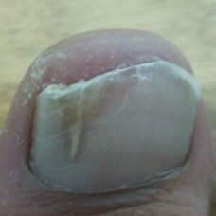 non-serious#1537 **Confidences:**normal = 0%; non-serious = 100%; warrants second opinion = 0%;   
The nail's condition is non-serious with confidence score of 100%. [image source](http://localhost:8080/ai/onyx/images/korean/onychomycosis/semisuper_jpn_556_473_91_910_527_DSC_0026.jpg)×

 non-serious#572 **Confidences:**normal = 0%; non-serious = 100%; warrants second opinion = 0%;   
The nail's condition is non-serious with confidence score of 100%. [image source](http://localhost:8080/ai/onyx/images/korean/L_NAIL_5nail_5nail2004_2_onychomycosis.png#572)×

 non-serious#332 **Confidences:**normal = 0%; non-serious = 100%; warrants second opinion = 0%;   
The nail's condition is non-serious with confidence score of 100%. [image source](http://localhost:8080/ai/onyx/images/korean/L_NAIL_5nailA2_scio_onychomycosis.png#332)×

 non-serious#342 **Confidences:**normal = 0%; non-serious = 100%; warrants second opinion = 0%;   
The nail's condition is non-serious with confidence score of 100%. [image source](http://localhost:8080/ai/onyx/images/korean/L_NAIL_5nailA2_scio_onychomycosis.png#342)×

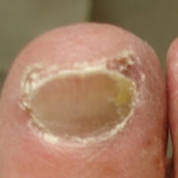 non-serious#1552 **Confidences:**normal = 0%; non-serious = 100%; warrants second opinion = 0%;   
The nail's condition is non-serious with confidence score of 100%. [image source](http://localhost:8080/ai/onyx/images/korean/onychomycosis/semisuper_kor_130_152_78_410_336_th_497bc116aa26f.jpg)×

 non-serious#377 **Confidences:**normal = 0%; non-serious = 100%; warrants second opinion = 0%;   
The nail's condition is non-serious with confidence score of 100%. [image source](http://localhost:8080/ai/onyx/images/korean/L_NAIL_5nailA2_scio_onychomycosis.png#377)×

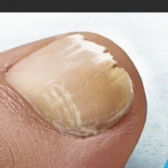 non-serious#1442 **Confidences:**normal = 0%; non-serious = 100%; warrants second opinion = 0%;   
The nail's condition is non-serious with confidence score of 100%. [image source](http://localhost:8080/ai/onyx/images/korean/onychomycosis/semisuper_814_229_86_419_276_fungailnail-2-1.jpg)×

 non-serious#227 **Confidences:**normal = 0%; non-serious = 100%; warrants second opinion = 0%;   
The nail's condition is non-serious with confidence score of 100%. [image source](http://localhost:8080/ai/onyx/images/korean/L_NAIL_5nailA2_lesion_onychomycosis_onychomycosis.png#227)×

 non-serious#27 **Confidences:**normal = 0%; non-serious = 100%; warrants second opinion = 0%;   
The nail's condition is non-serious with confidence score of 100%. [image source](http://localhost:8080/ai/onyx/images/korean/L_NAIL_5nailA2_lesion_onychomycosis_onychomycosis.png#27)×

 non-serious#802 **Confidences:**normal = 0%; non-serious = 100%; warrants second opinion = 0%;   
The nail's condition is non-serious with confidence score of 100%. [image source](http://localhost:8080/ai/onyx/images/korean/L_NAIL_5nail_5nail2006_onychomycosis_onychomycosis.png#802)×

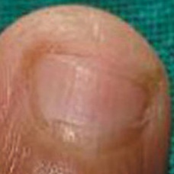 non-serious#1262 **Confidences:**normal = 0%; non-serious = 100%; warrants second opinion = 0%;   
The nail's condition is non-serious with confidence score of 100%. [image source](http://localhost:8080/ai/onyx/images/korean/onychomycosis/semisuper_2093_992_317_1274_598_3j.jpg)×

 non-serious#1472 **Confidences:**normal = 0%; non-serious = 100%; warrants second opinion = 0%;   
The nail's condition is non-serious with confidence score of 100%. [image source](http://localhost:8080/ai/onyx/images/korean/onychomycosis/semisuper_943_992_317_1274_598_3j.jpg)×

 non-serious#357 **Confidences:**normal = 0%; non-serious = 100%; warrants second opinion = 0%;   
The nail's condition is non-serious with confidence score of 100%. [image source](http://localhost:8080/ai/onyx/images/korean/L_NAIL_5nailA2_scio_onychomycosis.png#357)×

 non-serious#372 **Confidences:**normal = 0%; non-serious = 100%; warrants second opinion = 0%;   
The nail's condition is non-serious with confidence score of 100%. [image source](http://localhost:8080/ai/onyx/images/korean/L_NAIL_5nailA2_scio_onychomycosis.png#372)×

 non-serious#527 **Confidences:**normal = 0%; non-serious = 100%; warrants second opinion = 0%;   
The nail's condition is non-serious with confidence score of 100%. [image source](http://localhost:8080/ai/onyx/images/korean/L_NAIL_5nail_5nail2004_2_onychomycosis.png#527)×

 non-serious#732 **Confidences:**normal = 0%; non-serious = 100%; warrants second opinion = 0%;   
The nail's condition is non-serious with confidence score of 100%. [image source](http://localhost:8080/ai/onyx/images/korean/L_NAIL_5nail_5nail2006_onychomycosis_onychomycosis.png#732)×

 non-serious#882 **Confidences:**normal = 0%; non-serious = 100%; warrants second opinion = 0%;   
The nail's condition is non-serious with confidence score of 100%. [image source](http://localhost:8080/ai/onyx/images/korean/L_NAIL_5nail_5nail2005_2_onychomycosis.png#882)×

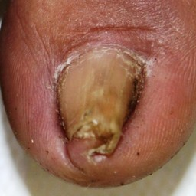 non-serious#1377 **Confidences:**normal = 0%; non-serious = 100%; warrants second opinion = 0%;   
The nail's condition is non-serious with confidence score of 100%. [image source](http://localhost:8080/ai/onyx/images/korean/onychomycosis/semisuper_639_2535_1486_3737_2688_10419-036%20(3).jpg)×

 non-serious#47 **Confidences:**normal = 0%; non-serious = 100%; warrants second opinion = 0%;   
The nail's condition is non-serious with confidence score of 100%. [image source](http://localhost:8080/ai/onyx/images/korean/L_NAIL_5nailA2_lesion_onychomycosis_onychomycosis.png#47)×

 non-serious#992 **Confidences:**normal = 0%; non-serious = 100%; warrants second opinion = 0%;   
The nail's condition is non-serious with confidence score of 100%. [image source](http://localhost:8080/ai/onyx/images/korean/L_NAIL_5nail_5nail2005_2_onychomycosis.png#992)×

 non-serious#982 **Confidences:**normal = 0%; non-serious = 100%; warrants second opinion = 0%;   
The nail's condition is non-serious with confidence score of 100%. [image source](http://localhost:8080/ai/onyx/images/korean/L_NAIL_5nail_5nail2005_2_onychomycosis.png#982)×

 non-serious#652 **Confidences:**normal = 0%; non-serious = 100%; warrants second opinion = 0%;   
The nail's condition is non-serious with confidence score of 100%. [image source](http://localhost:8080/ai/onyx/images/korean/L_NAIL_5nail_5nail2006_onychomycosis_onychomycosis.png#652)×

 non-serious#957 **Confidences:**normal = 0%; non-serious = 100%; warrants second opinion = 0%;   
The nail's condition is non-serious with confidence score of 100%. [image source](http://localhost:8080/ai/onyx/images/korean/L_NAIL_5nail_5nail2005_2_onychomycosis.png#957)×

 non-serious#842 **Confidences:**normal = 0%; non-serious = 100%; warrants second opinion = 0%;   
The nail's condition is non-serious with confidence score of 100%. [image source](http://localhost:8080/ai/onyx/images/korean/L_NAIL_5nail_5nail2005_2_onychomycosis.png#842)×

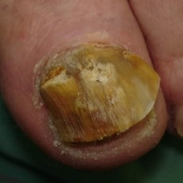 non-serious#1252 **Confidences:**normal = 0%; non-serious = 100%; warrants second opinion = 0%;   
The nail's condition is non-serious with confidence score of 100%. [image source](http://localhost:8080/ai/onyx/images/korean/onychomycosis/semisuper_2052_430_186_940_696_627_1.jpg)×

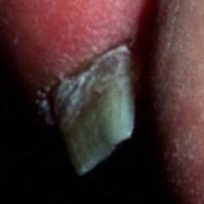 non-serious#1157 **Confidences:**normal = 0%; non-serious = 100%; warrants second opinion = 0%;   
The nail's condition is non-serious with confidence score of 100%. [image source](http://localhost:8080/ai/onyx/images/korean/onychomycosis/semisuper_1671_117_511_325_719_035580HB.JPG)×

 non-serious#1187 **Confidences:**normal = 0%; non-serious = 100%; warrants second opinion = 0%;   
The nail's condition is non-serious with confidence score of 100%. [image source](http://localhost:8080/ai/onyx/images/korean/onychomycosis/semisuper_171_117_511_325_719_035580HB.jpg)×

 non-serious#927 **Confidences:**normal = 0%; non-serious = 100%; warrants second opinion = 0%;   
The nail's condition is non-serious with confidence score of 100%. [image source](http://localhost:8080/ai/onyx/images/korean/L_NAIL_5nail_5nail2005_2_onychomycosis.png#927)×

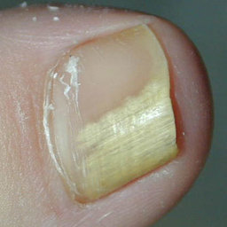 non-serious#1392 **Confidences:**normal = 0%; non-serious = 100%; warrants second opinion = 0%;   
The nail's condition is non-serious with confidence score of 100%. [image source](http://localhost:8080/ai/onyx/images/korean/onychomycosis/semisuper_676_368_114_702_447_micosi-.jpg)×

 non-serious#197 **Confidences:**normal = 0%; non-serious = 100%; warrants second opinion = 0%;   
The nail's condition is non-serious with confidence score of 100%. [image source](http://localhost:8080/ai/onyx/images/korean/L_NAIL_5nailA2_lesion_onychomycosis_onychomycosis.png#197)×

 non-serious#607 **Confidences:**normal = 0%; non-serious = 100%; warrants second opinion = 0%;   
The nail's condition is non-serious with confidence score of 100%. [image source](http://localhost:8080/ai/onyx/images/korean/L_NAIL_5nail_5nail2004_2_onychomycosis.png#607)×

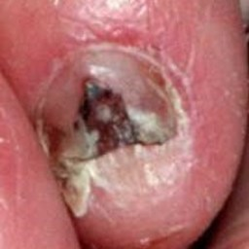 non-serious#1237 **Confidences:**normal = 0%; non-serious = 100%; warrants second opinion = 0%;   
The nail's condition is non-serious with confidence score of 100%. [image source](http://localhost:8080/ai/onyx/images/korean/onychomycosis/semisuper_1991_904_243_1118_457_026066HB.JPG)×

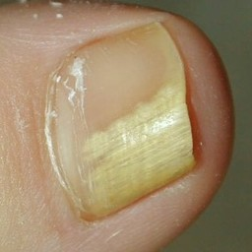 non-serious#1032 **Confidences:**normal = 0%; non-serious = 100%; warrants second opinion = 0%;   
The nail's condition is non-serious with confidence score of 100%. [image source](http://localhost:8080/ai/onyx/images/korean/onychomycosis/semisuper_1249_372_119_709_456_onycholysis-pictures-4.jpg)×

 non-serious#1287 **Confidences:**normal = 0%; non-serious = 100%; warrants second opinion = 0%;   
The nail's condition is non-serious with confidence score of 100%. [image source](http://localhost:8080/ai/onyx/images/korean/onychomycosis/semisuper_2457_372_119_709_456_onycholysis-pictures-4.jpg)×

 non-serious#142 **Confidences:**normal = 0%; non-serious = 100%; warrants second opinion = 0%;   
The nail's condition is non-serious with confidence score of 100%. [image source](http://localhost:8080/ai/onyx/images/korean/L_NAIL_5nailA2_lesion_onychomycosis_onychomycosis.png#142)×

 non-serious#127 **Confidences:**normal = 0%; non-serious = 100%; warrants second opinion = 0%;   
The nail's condition is non-serious with confidence score of 100%. [image source](http://localhost:8080/ai/onyx/images/korean/L_NAIL_5nailA2_lesion_onychomycosis_onychomycosis.png#127)×

 non-serious#667 **Confidences:**normal = 0%; non-serious = 100%; warrants second opinion = 0%;   
The nail's condition is non-serious with confidence score of 100%. [image source](http://localhost:8080/ai/onyx/images/korean/L_NAIL_5nail_5nail2006_onychomycosis_onychomycosis.png#667)×

 non-serious#692 **Confidences:**normal = 0%; non-serious = 100%; warrants second opinion = 0%;   
The nail's condition is non-serious with confidence score of 100%. [image source](http://localhost:8080/ai/onyx/images/korean/L_NAIL_5nail_5nail2006_onychomycosis_onychomycosis.png#692)×

 non-serious#542 **Confidences:**normal = 0%; non-serious = 100%; warrants second opinion = 0%;   
The nail's condition is non-serious with confidence score of 100%. [image source](http://localhost:8080/ai/onyx/images/korean/L_NAIL_5nail_5nail2004_2_onychomycosis.png#542)×

 non-serious#782 **Confidences:**normal = 0%; non-serious = 100%; warrants second opinion = 0%;   
The nail's condition is non-serious with confidence score of 100%. [image source](http://localhost:8080/ai/onyx/images/korean/L_NAIL_5nail_5nail2006_onychomycosis_onychomycosis.png#782)×

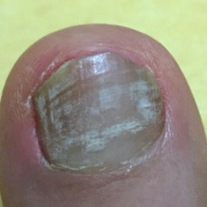 non-serious#1577 **Confidences:**normal = 0%; non-serious = 100%; warrants second opinion = 0%;   
The nail's condition is non-serious with confidence score of 100%. [image source](http://localhost:8080/ai/onyx/images/korean/onychomycosis/semisuper_kor_466_346_212_622_488_th_2533664657BEF6FD0424C4.jpg)×

 non-serious#117 **Confidences:**normal = 0%; non-serious = 100%; warrants second opinion = 0%;   
The nail's condition is non-serious with confidence score of 100%. [image source](http://localhost:8080/ai/onyx/images/korean/L_NAIL_5nailA2_lesion_onychomycosis_onychomycosis.png#117)×

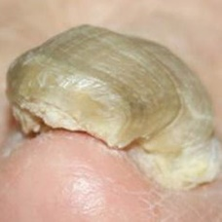 non-serious#1037 **Confidences:**normal = 0%; non-serious = 100%; warrants second opinion = 0%;   
The nail's condition is non-serious with confidence score of 100%. [image source](http://localhost:8080/ai/onyx/images/korean/onychomycosis/semisuper_1299_42_16_356_322_PMC4369658_kjfm-36-113-g008.jpg)×

 non-serious#1292 **Confidences:**normal = 0%; non-serious = 100%; warrants second opinion = 0%;   
The nail's condition is non-serious with confidence score of 100%. [image source](http://localhost:8080/ai/onyx/images/korean/onychomycosis/semisuper_2485_42_16_356_322_PMC4369658_kjfm-36-113-g008.jpg)×

 non-serious#277 **Confidences:**normal = 0%; non-serious = 100%; warrants second opinion = 0%;   
The nail's condition is non-serious with confidence score of 100%. [image source](http://localhost:8080/ai/onyx/images/korean/L_NAIL_5nailA2_scio_onychomycosis.png#277)×

 non-serious#462 **Confidences:**normal = 0%; non-serious = 100%; warrants second opinion = 0%;   
The nail's condition is non-serious with confidence score of 100%. [image source](http://localhost:8080/ai/onyx/images/korean/L_NAIL_5nailA2_scio_onychomycosis.png#462)×

 non-serious#262 **Confidences:**normal = 0%; non-serious = 100%; warrants second opinion = 0%;   
The nail's condition is non-serious with confidence score of 100%. [image source](http://localhost:8080/ai/onyx/images/korean/L_NAIL_5nailA2_scio_onychomycosis.png#262)×

 non-serious#492 **Confidences:**normal = 0%; non-serious = 100%; warrants second opinion = 0%;   
The nail's condition is non-serious with confidence score of 100%. [image source](http://localhost:8080/ai/onyx/images/korean/L_NAIL_5nailA2_scio_onychomycosis.png#492)×

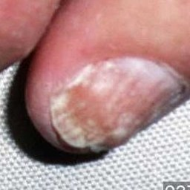 non-serious#1062 **Confidences:**normal = 0%; non-serious = 100%; warrants second opinion = 0%;   
The nail's condition is non-serious with confidence score of 100%. [image source](http://localhost:8080/ai/onyx/images/korean/onychomycosis/semisuper_1431_1300_794_1562_1056_037076HB.JPG)×

 non-serious#447 **Confidences:**normal = 0%; non-serious = 100%; warrants second opinion = 0%;   
The nail's condition is non-serious with confidence score of 100%. [image source](http://localhost:8080/ai/onyx/images/korean/L_NAIL_5nailA2_scio_onychomycosis.png#447)×

 non-serious#452 **Confidences:**normal = 0%; non-serious = 100%; warrants second opinion = 0%;   
The nail's condition is non-serious with confidence score of 100%. [image source](http://localhost:8080/ai/onyx/images/korean/L_NAIL_5nailA2_scio_onychomycosis.png#452)×

 non-serious#932 **Confidences:**normal = 0%; non-serious = 100%; warrants second opinion = 0%;   
The nail's condition is non-serious with confidence score of 100%. [image source](http://localhost:8080/ai/onyx/images/korean/L_NAIL_5nail_5nail2005_2_onychomycosis.png#932)×

 non-serious#922 **Confidences:**normal = 0%; non-serious = 100%; warrants second opinion = 0%;   
The nail's condition is non-serious with confidence score of 100%. [image source](http://localhost:8080/ai/onyx/images/korean/L_NAIL_5nail_5nail2005_2_onychomycosis.png#922)×

 non-serious#952 **Confidences:**normal = 0%; non-serious = 100%; warrants second opinion = 0%;   
The nail's condition is non-serious with confidence score of 100%. [image source](http://localhost:8080/ai/onyx/images/korean/L_NAIL_5nail_5nail2005_2_onychomycosis.png#952)×

 non-serious#367 **Confidences:**normal = 0%; non-serious = 100%; warrants second opinion = 0%;   
The nail's condition is non-serious with confidence score of 100%. [image source](http://localhost:8080/ai/onyx/images/korean/L_NAIL_5nailA2_scio_onychomycosis.png#367)×

 non-serious#497 **Confidences:**normal = 0%; non-serious = 100%; warrants second opinion = 0%;   
The nail's condition is non-serious with confidence score of 100%. [image source](http://localhost:8080/ai/onyx/images/korean/L_NAIL_5nailA2_scio_onychomycosis.png#497)×

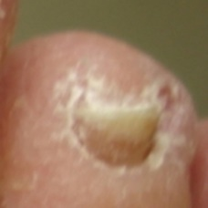 non-serious#1547 **Confidences:**normal = 0%; non-serious = 100%; warrants second opinion = 0%;   
The nail's condition is non-serious with confidence score of 100%. [image source](http://localhost:8080/ai/onyx/images/korean/onychomycosis/semisuper_kor_1025_796_220_987_412_th_497bc123ad77d.jpg)×

 non-serious#1562 **Confidences:**normal = 0%; non-serious = 100%; warrants second opinion = 0%;   
The nail's condition is non-serious with confidence score of 100%. [image source](http://localhost:8080/ai/onyx/images/korean/onychomycosis/semisuper_kor_274_796_220_987_412_th_497bc123ad77d.jpg)×

 non-serious#402 **Confidences:**normal = 0%; non-serious = 100%; warrants second opinion = 0%;   
The nail's condition is non-serious with confidence score of 100%. [image source](http://localhost:8080/ai/onyx/images/korean/L_NAIL_5nailA2_scio_onychomycosis.png#402)×

 non-serious#662 **Confidences:**normal = 0%; non-serious = 100%; warrants second opinion = 0%;   
The nail's condition is non-serious with confidence score of 100%. [image source](http://localhost:8080/ai/onyx/images/korean/L_NAIL_5nail_5nail2006_onychomycosis_onychomycosis.png#662)×

 non-serious#137 **Confidences:**normal = 0%; non-serious = 100%; warrants second opinion = 0%;   
The nail's condition is non-serious with confidence score of 100%. [image source](http://localhost:8080/ai/onyx/images/korean/L_NAIL_5nailA2_lesion_onychomycosis_onychomycosis.png#137)×

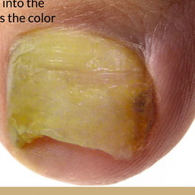 non-serious#1122 **Confidences:**normal = 0%; non-serious = 100%; warrants second opinion = 0%;   
The nail's condition is non-serious with confidence score of 100%. [image source](http://localhost:8080/ai/onyx/images/korean/onychomycosis/semisuper_1583_239_147_695_602_002_onychomycosis.jpg)×

 non-serious#817 **Confidences:**normal = 0%; non-serious = 100%; warrants second opinion = 0%;   
The nail's condition is non-serious with confidence score of 100%. [image source](http://localhost:8080/ai/onyx/images/korean/L_NAIL_5nail_5nail2006_onychomycosis_onychomycosis.png#817)×

 non-serious#512 **Confidences:**normal = 0%; non-serious = 100%; warrants second opinion = 0%;   
The nail's condition is non-serious with confidence score of 100%. [image source](http://localhost:8080/ai/onyx/images/korean/L_NAIL_5nail_5nail2004_2_onychomycosis.png#512)×

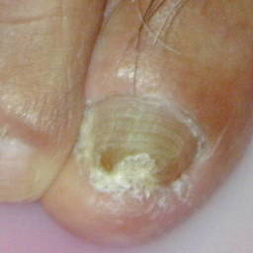 non-serious#1167 **Confidences:**normal = 0%; non-serious = 100%; warrants second opinion = 0%;   
The nail's condition is non-serious with confidence score of 100%. [image source](http://localhost:8080/ai/onyx/images/korean/onychomycosis/semisuper_1692_683_773_1160_1178_Dscn0083.jpg)×

 non-serious#617 **Confidences:**normal = 0%; non-serious = 100%; warrants second opinion = 0%;   
The nail's condition is non-serious with confidence score of 100%. [image source](http://localhost:8080/ai/onyx/images/korean/L_NAIL_5nail_5nail2004_2_onychomycosis.png#617)×

 non-serious#487 **Confidences:**normal = 0%; non-serious = 100%; warrants second opinion = 0%;   
The nail's condition is non-serious with confidence score of 100%. [image source](http://localhost:8080/ai/onyx/images/korean/L_NAIL_5nailA2_scio_onychomycosis.png#487)×

 non-serious#322 **Confidences:**normal = 0%; non-serious = 100%; warrants second opinion = 0%;   
The nail's condition is non-serious with confidence score of 100%. [image source](http://localhost:8080/ai/onyx/images/korean/L_NAIL_5nailA2_scio_onychomycosis.png#322)×

 non-serious#522 **Confidences:**normal = 0%; non-serious = 100%; warrants second opinion = 0%;   
The nail's condition is non-serious with confidence score of 100%. [image source](http://localhost:8080/ai/onyx/images/korean/L_NAIL_5nail_5nail2004_2_onychomycosis.png#522)×

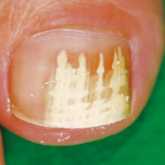 non-serious#1487 **Confidences:**normal = 0%; non-serious = 100%; warrants second opinion = 0%;   
The nail's condition is non-serious with confidence score of 100%. [image source](http://localhost:8080/ai/onyx/images/korean/onychomycosis/semisuper_jpn_11_87_199_858_970_06.jpg)×

 non-serious#772 **Confidences:**normal = 0%; non-serious = 100%; warrants second opinion = 0%;   
The nail's condition is non-serious with confidence score of 100%. [image source](http://localhost:8080/ai/onyx/images/korean/L_NAIL_5nail_5nail2006_onychomycosis_onychomycosis.png#772)×

 non-serious#862 **Confidences:**normal = 0%; non-serious = 100%; warrants second opinion = 0%;   
The nail's condition is non-serious with confidence score of 100%. [image source](http://localhost:8080/ai/onyx/images/korean/L_NAIL_5nail_5nail2005_2_onychomycosis.png#862)×

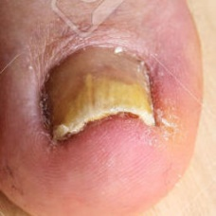 non-serious#1077 **Confidences:**normal = 0%; non-serious = 100%; warrants second opinion = 0%;   
The nail's condition is non-serious with confidence score of 100%. [image source](http://localhost:8080/ai/onyx/images/korean/onychomycosis/semisuper_1465_732_484_983_736_50417908-Pathological-changes-in-the-feet-nail-fungus-on-the-toenails-and-skin-spots-Stock-Photo.jpg)×

 non-serious#712 **Confidences:**normal = 0%; non-serious = 100%; warrants second opinion = 0%;   
The nail's condition is non-serious with confidence score of 100%. [image source](http://localhost:8080/ai/onyx/images/korean/L_NAIL_5nail_5nail2006_onychomycosis_onychomycosis.png#712)×

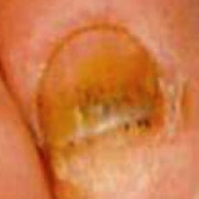 non-serious#1427 **Confidences:**normal = 0%; non-serious = 100%; warrants second opinion = 0%;   
The nail's condition is non-serious with confidence score of 100%. [image source](http://localhost:8080/ai/onyx/images/korean/onychomycosis/semisuper_782_492_88_654_277_oncyholysis-148AFBAC9CF686F35B8.jpg)×

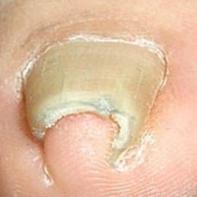 non-serious#1012 **Confidences:**normal = 0%; non-serious = 100%; warrants second opinion = 0%;   
The nail's condition is non-serious with confidence score of 100%. [image source](http://localhost:8080/ai/onyx/images/korean/onychomycosis/semisuper_1032_300_191_491_381_200706-fig1.jpg)×

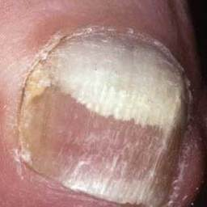 non-serious#1447 **Confidences:**normal = 0%; non-serious = 100%; warrants second opinion = 0%;   
The nail's condition is non-serious with confidence score of 100%. [image source](http://localhost:8080/ai/onyx/images/korean/onychomycosis/semisuper_832_720_141_1036_459_8-143-1.jpg)×

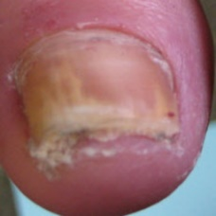 non-serious#1057 **Confidences:**normal = 0%; non-serious = 100%; warrants second opinion = 0%;   
The nail's condition is non-serious with confidence score of 100%. [image source](http://localhost:8080/ai/onyx/images/korean/onychomycosis/semisuper_1425_102_125_336_359_Onychomycosis-4.jpg)×

 non-serious#457 **Confidences:**normal = 0%; non-serious = 100%; warrants second opinion = 0%;   
The nail's condition is non-serious with confidence score of 100%. [image source](http://localhost:8080/ai/onyx/images/korean/L_NAIL_5nailA2_scio_onychomycosis.png#457)×

 non-serious#687 **Confidences:**normal = 0%; non-serious = 100%; warrants second opinion = 0%;   
The nail's condition is non-serious with confidence score of 100%. [image source](http://localhost:8080/ai/onyx/images/korean/L_NAIL_5nail_5nail2006_onychomycosis_onychomycosis.png#687)×

 non-serious#237 **Confidences:**normal = 0%; non-serious = 100%; warrants second opinion = 0%;   
The nail's condition is non-serious with confidence score of 100%. [image source](http://localhost:8080/ai/onyx/images/korean/L_NAIL_5nailA2_lesion_onychomycosis_onychomycosis.png#237)×

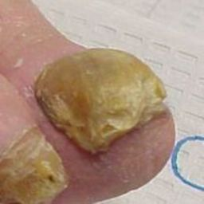 non-serious#1107 **Confidences:**normal = 0%; non-serious = 100%; warrants second opinion = 0%;   
The nail's condition is non-serious with confidence score of 100%. [image source](http://localhost:8080/ai/onyx/images/korean/onychomycosis/semisuper_1551_396_123_600_328_2011Onychomycosis1.jpg)×

 non-serious#477 **Confidences:**normal = 0%; non-serious = 100%; warrants second opinion = 0%;   
The nail's condition is non-serious with confidence score of 100%. [image source](http://localhost:8080/ai/onyx/images/korean/L_NAIL_5nailA2_scio_onychomycosis.png#477)×

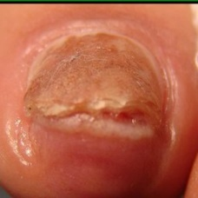 non-serious#1397 **Confidences:**normal = 0%; non-serious = 100%; warrants second opinion = 0%;   
The nail's condition is non-serious with confidence score of 100%. [image source](http://localhost:8080/ai/onyx/images/korean/onychomycosis/semisuper_681_464_167_1356_1060_nails-joggers-10062_0.jpg)×

 non-serious#152 **Confidences:**normal = 0%; non-serious = 100%; warrants second opinion = 0%;   
The nail's condition is non-serious with confidence score of 100%. [image source](http://localhost:8080/ai/onyx/images/korean/L_NAIL_5nailA2_lesion_onychomycosis_onychomycosis.png#152)×

 non-serious#847 **Confidences:**normal = 0%; non-serious = 100%; warrants second opinion = 0%;   
The nail's condition is non-serious with confidence score of 100%. [image source](http://localhost:8080/ai/onyx/images/korean/L_NAIL_5nail_5nail2005_2_onychomycosis.png#847)×

 non-serious#242 **Confidences:**normal = 0%; non-serious = 100%; warrants second opinion = 0%;   
The nail's condition is non-serious with confidence score of 100%. [image source](http://localhost:8080/ai/onyx/images/korean/L_NAIL_5nailA2_lesion_onychomycosis_onychomycosis.png#242)×

 non-serious#947 **Confidences:**normal = 0%; non-serious = 100%; warrants second opinion = 0%;   
The nail's condition is non-serious with confidence score of 100%. [image source](http://localhost:8080/ai/onyx/images/korean/L_NAIL_5nail_5nail2005_2_onychomycosis.png#947)×

 non-serious#857 **Confidences:**normal = 0%; non-serious = 100%; warrants second opinion = 0%;   
The nail's condition is non-serious with confidence score of 100%. [image source](http://localhost:8080/ai/onyx/images/korean/L_NAIL_5nail_5nail2005_2_onychomycosis.png#857)×

 non-serious#292 **Confidences:**normal = 0%; non-serious = 100%; warrants second opinion = 0%;   
The nail's condition is non-serious with confidence score of 100%. [image source](http://localhost:8080/ai/onyx/images/korean/L_NAIL_5nailA2_scio_onychomycosis.png#292)×

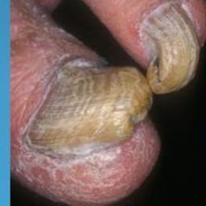 non-serious#1227 **Confidences:**normal = 0%; non-serious = 100%; warrants second opinion = 0%;   
The nail's condition is non-serious with confidence score of 100%. [image source](http://localhost:8080/ai/onyx/images/korean/onychomycosis/semisuper_1874_124_484_346_707_slide_23.jpg)×

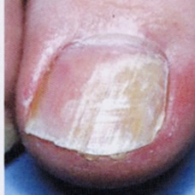 non-serious#1557 **Confidences:**normal = 0%; non-serious = 100%; warrants second opinion = 0%;   
The nail's condition is non-serious with confidence score of 100%. [image source](http://localhost:8080/ai/onyx/images/korean/onychomycosis/semisuper_kor_191_1307_201_1539_433_Anwhawhdfb.jpg)×

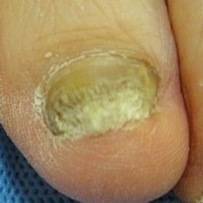 non-serious#1602 **Confidences:**normal = 0%; non-serious = 100%; warrants second opinion = 0%;   
The nail's condition is non-serious with confidence score of 100%. [image source](http://localhost:8080/ai/onyx/images/korean/onychomycosis/semisuper_kor_809_349_132_558_341_49.jpg)×

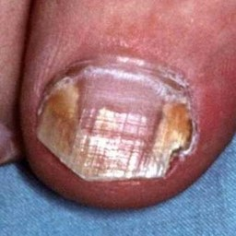 non-serious#1192 **Confidences:**normal = 0%; non-serious = 100%; warrants second opinion = 0%;   
The nail's condition is non-serious with confidence score of 100%. [image source](http://localhost:8080/ai/onyx/images/korean/onychomycosis/semisuper_1744_312_603_651_941_035907HB.JPG)×

 non-serious#567 **Confidences:**normal = 0%; non-serious = 100%; warrants second opinion = 0%;   
The nail's condition is non-serious with confidence score of 100%. [image source](http://localhost:8080/ai/onyx/images/korean/L_NAIL_5nail_5nail2004_2_onychomycosis.png#567)×

 non-serious#637 **Confidences:**normal = 0%; non-serious = 100%; warrants second opinion = 0%;   
The nail's condition is non-serious with confidence score of 100%. [image source](http://localhost:8080/ai/onyx/images/korean/L_NAIL_5nail_5nail2004_2_onychomycosis.png#637)×

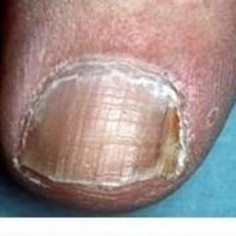 non-serious#1197 **Confidences:**normal = 0%; non-serious = 100%; warrants second opinion = 0%;   
The nail's condition is non-serious with confidence score of 100%. [image source](http://localhost:8080/ai/onyx/images/korean/onychomycosis/semisuper_1755_275_308_465_487_2-packs-toe-nail-fungus-cream-onychomycosis-paronychia-toe-nail-slits-infection-finger-ointment-ringworm-of-the-nails.jpg)×

 non-serious#517 **Confidences:**normal = 0%; non-serious = 100%; warrants second opinion = 0%;   
The nail's condition is non-serious with confidence score of 100%. [image source](http://localhost:8080/ai/onyx/images/korean/L_NAIL_5nail_5nail2004_2_onychomycosis.png#517)×

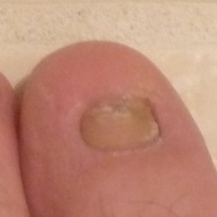 non-serious#1322 **Confidences:**normal = 0%; non-serious = 100%; warrants second opinion = 0%;   
The nail's condition is non-serious with confidence score of 100%. [image source](http://localhost:8080/ai/onyx/images/korean/onychomycosis/semisuper_368_1734_803_2170_1239_8567527128_69c7744b39_o.jpg)×

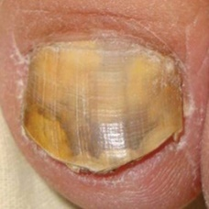 non-serious#1432 **Confidences:**normal = 0%; non-serious = 100%; warrants second opinion = 0%;   
The nail's condition is non-serious with confidence score of 100%. [image source](http://localhost:8080/ai/onyx/images/korean/onychomycosis/semisuper_790_993_127_1338_472_fig_22j.jpg)×

 non-serious#207 **Confidences:**normal = 0%; non-serious = 100%; warrants second opinion = 0%;   
The nail's condition is non-serious with confidence score of 100%. [image source](http://localhost:8080/ai/onyx/images/korean/L_NAIL_5nailA2_lesion_onychomycosis_onychomycosis.png#207)×

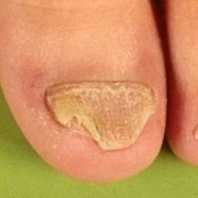 non-serious#1017 **Confidences:**normal = 0%; non-serious = 100%; warrants second opinion = 0%;   
The nail's condition is non-serious with confidence score of 100%. [image source](http://localhost:8080/ai/onyx/images/korean/onychomycosis/semisuper_1073_577_475_767_665_twenty-nail-syndrome-of-childhood-2.jpg)×

 non-serious#387 **Confidences:**normal = 0%; non-serious = 100%; warrants second opinion = 0%;   
The nail's condition is non-serious with confidence score of 100%. [image source](http://localhost:8080/ai/onyx/images/korean/L_NAIL_5nailA2_scio_onychomycosis.png#387)×

 non-serious#877 **Confidences:**normal = 0%; non-serious = 100%; warrants second opinion = 0%;   
The nail's condition is non-serious with confidence score of 100%. [image source](http://localhost:8080/ai/onyx/images/korean/L_NAIL_5nail_5nail2005_2_onychomycosis.png#877)×

 non-serious#382 **Confidences:**normal = 0%; non-serious = 100%; warrants second opinion = 0%;   
The nail's condition is non-serious with confidence score of 100%. [image source](http://localhost:8080/ai/onyx/images/korean/L_NAIL_5nailA2_scio_onychomycosis.png#382)×

 non-serious#202 **Confidences:**normal = 0%; non-serious = 100%; warrants second opinion = 0%;   
The nail's condition is non-serious with confidence score of 100%. [image source](http://localhost:8080/ai/onyx/images/korean/L_NAIL_5nailA2_lesion_onychomycosis_onychomycosis.png#202)×

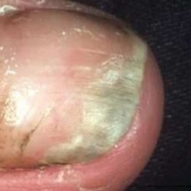 non-serious#1417 **Confidences:**normal = 0%; non-serious = 100%; warrants second opinion = 0%;   
The nail's condition is non-serious with confidence score of 100%. [image source](http://localhost:8080/ai/onyx/images/korean/onychomycosis/semisuper_755_215_42_566_393_Neglsopp.jpg)×

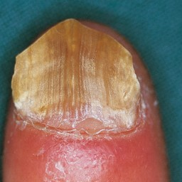 non-serious#1147 **Confidences:**normal = 0%; non-serious = 100%; warrants second opinion = 0%;   
The nail's condition is non-serious with confidence score of 100%. [image source](http://localhost:8080/ai/onyx/images/korean/onychomycosis/semisuper_1640_233_237_1368_1371_0396902.jpg)×

 non-serious#797 **Confidences:**normal = 0%; non-serious = 100%; warrants second opinion = 0%;   
The nail's condition is non-serious with confidence score of 100%. [image source](http://localhost:8080/ai/onyx/images/korean/L_NAIL_5nail_5nail2006_onychomycosis_onychomycosis.png#797)×

 non-serious#937 **Confidences:**normal = 0%; non-serious = 100%; warrants second opinion = 0%;   
The nail's condition is non-serious with confidence score of 100%. [image source](http://localhost:8080/ai/onyx/images/korean/L_NAIL_5nail_5nail2005_2_onychomycosis.png#937)×

 non-serious#177 **Confidences:**normal = 0%; non-serious = 100%; warrants second opinion = 0%;   
The nail's condition is non-serious with confidence score of 100%. [image source](http://localhost:8080/ai/onyx/images/korean/L_NAIL_5nailA2_lesion_onychomycosis_onychomycosis.png#177)×

 non-serious#352 **Confidences:**normal = 0%; non-serious = 100%; warrants second opinion = 0%;   
The nail's condition is non-serious with confidence score of 100%. [image source](http://localhost:8080/ai/onyx/images/korean/L_NAIL_5nailA2_scio_onychomycosis.png#352)×

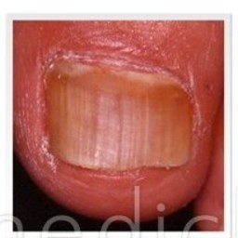 non-serious#1527 **Confidences:**normal = 0%; non-serious = 100%; warrants second opinion = 0%;   
The nail's condition is non-serious with confidence score of 100%. [image source](http://localhost:8080/ai/onyx/images/korean/onychomycosis/semisuper_jpn_50_218_48_424_253_th-hi-00002.jpg)×

 non-serious#622 **Confidences:**normal = 0%; non-serious = 100%; warrants second opinion = 0%;   
The nail's condition is non-serious with confidence score of 100%. [image source](http://localhost:8080/ai/onyx/images/korean/L_NAIL_5nail_5nail2004_2_onychomycosis.png#622)×

 non-serious#737 **Confidences:**normal = 0%; non-serious = 100%; warrants second opinion = 0%;   
The nail's condition is non-serious with confidence score of 100%. [image source](http://localhost:8080/ai/onyx/images/korean/L_NAIL_5nail_5nail2006_onychomycosis_onychomycosis.png#737)×

 non-serious#317 **Confidences:**normal = 0%; non-serious = 100%; warrants second opinion = 0%;   
The nail's condition is non-serious with confidence score of 100%. [image source](http://localhost:8080/ai/onyx/images/korean/L_NAIL_5nailA2_scio_onychomycosis.png#317)×

 non-serious#287 **Confidences:**normal = 0%; non-serious = 100%; warrants second opinion = 0%;   
The nail's condition is non-serious with confidence score of 100%. [image source](http://localhost:8080/ai/onyx/images/korean/L_NAIL_5nailA2_scio_onychomycosis.png#287)×

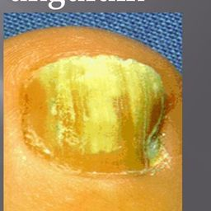 non-serious#1117 **Confidences:**normal = 0%; non-serious = 100%; warrants second opinion = 0%;   
The nail's condition is non-serious with confidence score of 100%. [image source](http://localhost:8080/ai/onyx/images/korean/onychomycosis/semisuper_1574_465_130_934_599_slide_6.jpg)×

 non-serious#102 **Confidences:**normal = 0%; non-serious = 100%; warrants second opinion = 0%;   
The nail's condition is non-serious with confidence score of 100%. [image source](http://localhost:8080/ai/onyx/images/korean/L_NAIL_5nailA2_lesion_onychomycosis_onychomycosis.png#102)×

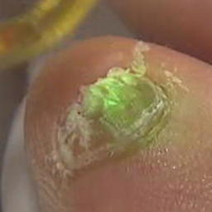 non-serious#1587 **Confidences:**normal = 0%; non-serious = 100%; warrants second opinion = 0%;   
The nail's condition is non-serious with confidence score of 100%. [image source](http://localhost:8080/ai/onyx/images/korean/onychomycosis/semisuper_kor_586_522_272_727_478_2654584_230.jpg)×

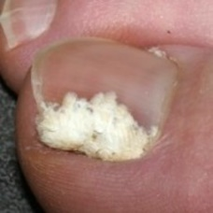 non-serious#1437 **Confidences:**normal = 0%; non-serious = 100%; warrants second opinion = 0%;   
The nail's condition is non-serious with confidence score of 100%. [image source](http://localhost:8080/ai/onyx/images/korean/onychomycosis/semisuper_79_61_115_247_302_Superficial_white_onychomycosis.jpg)×

 non-serious#187 **Confidences:**normal = 0%; non-serious = 100%; warrants second opinion = 0%;   
The nail's condition is non-serious with confidence score of 100%. [image source](http://localhost:8080/ai/onyx/images/korean/L_NAIL_5nailA2_lesion_onychomycosis_onychomycosis.png#187)×

 non-serious#392 **Confidences:**normal = 0%; non-serious = 100%; warrants second opinion = 0%;   
The nail's condition is non-serious with confidence score of 100%. [image source](http://localhost:8080/ai/onyx/images/korean/L_NAIL_5nailA2_scio_onychomycosis.png#392)×

 non-serious#482 **Confidences:**normal = 0%; non-serious = 100%; warrants second opinion = 0%;   
The nail's condition is non-serious with confidence score of 100%. [image source](http://localhost:8080/ai/onyx/images/korean/L_NAIL_5nailA2_scio_onychomycosis.png#482)×

 non-serious#272 **Confidences:**normal = 0%; non-serious = 100%; warrants second opinion = 0%;   
The nail's condition is non-serious with confidence score of 100%. [image source](http://localhost:8080/ai/onyx/images/korean/L_NAIL_5nailA2_scio_onychomycosis.png#272)×

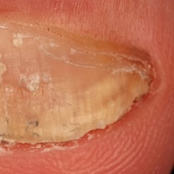 non-serious#1342 **Confidences:**normal = 0%; non-serious = 100%; warrants second opinion = 0%;   
The nail's condition is non-serious with confidence score of 100%. [image source](http://localhost:8080/ai/onyx/images/korean/onychomycosis/semisuper_455_1242_1965_2182_2905_0279703.jpg)×

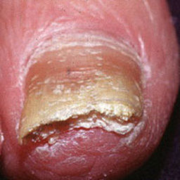 non-serious#1112 **Confidences:**normal = 0%; non-serious = 100%; warrants second opinion = 0%;   
The nail's condition is non-serious with confidence score of 100%. [image source](http://localhost:8080/ai/onyx/images/korean/onychomycosis/semisuper_1561_504_249_704_449_PsoriaticNail.jpg)×

 non-serious#12 **Confidences:**normal = 0%; non-serious = 100%; warrants second opinion = 0%;   
The nail's condition is non-serious with confidence score of 100%. [image source](http://localhost:8080/ai/onyx/images/korean/L_NAIL_5nailA2_lesion_onychomycosis_onychomycosis.png#12)×

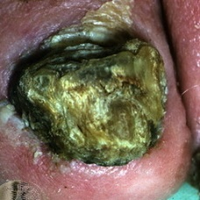 non-serious#1452 **Confidences:**normal = 0%; non-serious = 100%; warrants second opinion = 0%;   
The nail's condition is non-serious with confidence score of 100%. [image source](http://localhost:8080/ai/onyx/images/korean/onychomycosis/semisuper_840_18_98_359_439_gryphosis.jpg)×

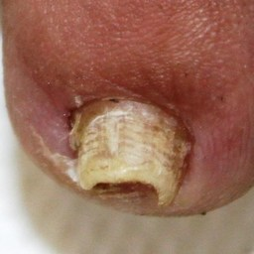 non-serious#1267 **Confidences:**normal = 0%; non-serious = 100%; warrants second opinion = 0%;   
The nail's condition is non-serious with confidence score of 100%. [image source](http://localhost:8080/ai/onyx/images/korean/onychomycosis/semisuper_2120_1664_2024_2342_2701_10419-036%20(3).JPG)×

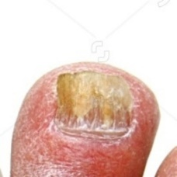 non-serious#1097 **Confidences:**normal = 0%; non-serious = 100%; warrants second opinion = 0%;   
The nail's condition is non-serious with confidence score of 100%. [image source](http://localhost:8080/ai/onyx/images/korean/onychomycosis/semisuper_1521_613_69_837_294_stock-photo-closeup-of-a-foot-with-arthritis-nail-fungus-and-athlete-s-foot-103386344.jpg)×

 non-serious#157 **Confidences:**normal = 0%; non-serious = 100%; warrants second opinion = 0%;   
The nail's condition is non-serious with confidence score of 100%. [image source](http://localhost:8080/ai/onyx/images/korean/L_NAIL_5nailA2_lesion_onychomycosis_onychomycosis.png#157)×

 non-serious#832 **Confidences:**normal = 0%; non-serious = 100%; warrants second opinion = 0%;   
The nail's condition is non-serious with confidence score of 100%. [image source](http://localhost:8080/ai/onyx/images/korean/L_NAIL_5nail_5nail2005_2_onychomycosis.png#832)×

 non-serious#972 **Confidences:**normal = 0%; non-serious = 100%; warrants second opinion = 0%;   
The nail's condition is non-serious with confidence score of 100%. [image source](http://localhost:8080/ai/onyx/images/korean/L_NAIL_5nail_5nail2005_2_onychomycosis.png#972)×

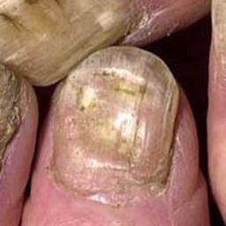 non-serious#1072 **Confidences:**normal = 0%; non-serious = 100%; warrants second opinion = 0%;   
The nail's condition is non-serious with confidence score of 100%. [image source](http://localhost:8080/ai/onyx/images/korean/onychomycosis/semisuper_1457_436_386_654_604_slide_24.jpg)×

 non-serious#892 **Confidences:**normal = 0%; non-serious = 100%; warrants second opinion = 0%;   
The nail's condition is non-serious with confidence score of 100%. [image source](http://localhost:8080/ai/onyx/images/korean/L_NAIL_5nail_5nail2005_2_onychomycosis.png#892)×

 non-serious#657 **Confidences:**normal = 0%; non-serious = 100%; warrants second opinion = 0%;   
The nail's condition is non-serious with confidence score of 100%. [image source](http://localhost:8080/ai/onyx/images/korean/L_NAIL_5nail_5nail2006_onychomycosis_onychomycosis.png#657)×

 non-serious#52 **Confidences:**normal = 0%; non-serious = 100%; warrants second opinion = 0%;   
The nail's condition is non-serious with confidence score of 100%. [image source](http://localhost:8080/ai/onyx/images/korean/L_NAIL_5nailA2_lesion_onychomycosis_onychomycosis.png#52)×

 non-serious#417 **Confidences:**normal = 0%; non-serious = 100%; warrants second opinion = 0%;   
The nail's condition is non-serious with confidence score of 100%. [image source](http://localhost:8080/ai/onyx/images/korean/L_NAIL_5nailA2_scio_onychomycosis.png#417)×

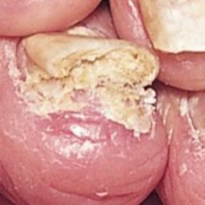 non-serious#1022 **Confidences:**normal = 0%; non-serious = 100%; warrants second opinion = 0%;   
The nail's condition is non-serious with confidence score of 100%. [image source](http://localhost:8080/ai/onyx/images/korean/onychomycosis/semisuper_1157_44_237_265_458_psoriasis01.jpg)×

 non-serious#167 **Confidences:**normal = 0%; non-serious = 100%; warrants second opinion = 0%;   
The nail's condition is non-serious with confidence score of 100%. [image source](http://localhost:8080/ai/onyx/images/korean/L_NAIL_5nailA2_lesion_onychomycosis_onychomycosis.png#167)×

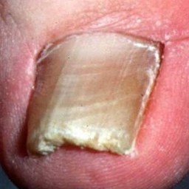 non-serious#1152 **Confidences:**normal = 0%; non-serious = 100%; warrants second opinion = 0%;   
The nail's condition is non-serious with confidence score of 100%. [image source](http://localhost:8080/ai/onyx/images/korean/onychomycosis/semisuper_1667_1150_584_1507_940_035580HB.JPG)×

 non-serious#1162 **Confidences:**normal = 0%; non-serious = 100%; warrants second opinion = 0%;   
The nail's condition is non-serious with confidence score of 100%. [image source](http://localhost:8080/ai/onyx/images/korean/onychomycosis/semisuper_167_1150_584_1507_940_035580HB.jpg)×

 non-serious#872 **Confidences:**normal = 0%; non-serious = 100%; warrants second opinion = 0%;   
The nail's condition is non-serious with confidence score of 100%. [image source](http://localhost:8080/ai/onyx/images/korean/L_NAIL_5nail_5nail2005_2_onychomycosis.png#872)×

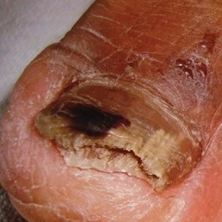 non-serious#1277 **Confidences:**normal = 0%; non-serious = 100%; warrants second opinion = 0%;   
The nail's condition is non-serious with confidence score of 100%. [image source](http://localhost:8080/ai/onyx/images/korean/onychomycosis/semisuper_2371_35_128_444_488_ArchMedHealthSci_2014_2_1_48_133811_f1.jpg)×

 non-serious#807 **Confidences:**normal = 0%; non-serious = 100%; warrants second opinion = 0%;   
The nail's condition is non-serious with confidence score of 100%. [image source](http://localhost:8080/ai/onyx/images/korean/L_NAIL_5nail_5nail2006_onychomycosis_onychomycosis.png#807)×

 non-serious#632 **Confidences:**normal = 0%; non-serious = 100%; warrants second opinion = 0%;   
The nail's condition is non-serious with confidence score of 100%. [image source](http://localhost:8080/ai/onyx/images/korean/L_NAIL_5nail_5nail2004_2_onychomycosis.png#632)×

 non-serious#752 **Confidences:**normal = 0%; non-serious = 100%; warrants second opinion = 0%;   
The nail's condition is non-serious with confidence score of 100%. [image source](http://localhost:8080/ai/onyx/images/korean/L_NAIL_5nail_5nail2006_onychomycosis_onychomycosis.png#752)×

 non-serious#977 **Confidences:**normal = 0%; non-serious = 100%; warrants second opinion = 0%;   
The nail's condition is non-serious with confidence score of 100%. [image source](http://localhost:8080/ai/onyx/images/korean/L_NAIL_5nail_5nail2005_2_onychomycosis.png#977)×

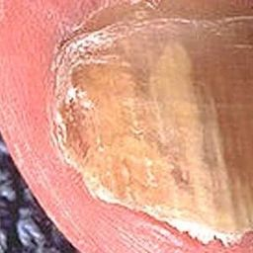 non-serious#1132 **Confidences:**normal = 0%; non-serious = 100%; warrants second opinion = 0%;   
The nail's condition is non-serious with confidence score of 100%. [image source](http://localhost:8080/ai/onyx/images/korean/onychomycosis/semisuper_1601_49_167_348_467_onycho-56a2452f5f9b58b7d0c87845.jpg)×

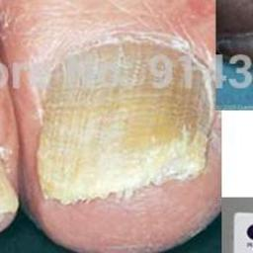 non-serious#1052 **Confidences:**normal = 0%; non-serious = 100%; warrants second opinion = 0%;   
The nail's condition is non-serious with confidence score of 100%. [image source](http://localhost:8080/ai/onyx/images/korean/onychomycosis/semisuper_1414_293_224_511_442_2-packs-nail-fungus-treatment-onychomycosis-paronychia-toe-nail-slits-infection-finger-ointment-chinese-herbal-products.jpg)×

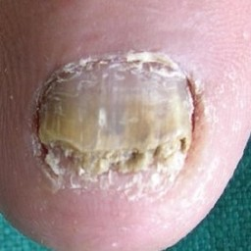 non-serious#1202 **Confidences:**normal = 0%; non-serious = 100%; warrants second opinion = 0%;   
The nail's condition is non-serious with confidence score of 100%. [image source](http://localhost:8080/ai/onyx/images/korean/onychomycosis/semisuper_1769_519_219_804_504_ijdvl_2012_78_5_620_100579_u4.jpg)×

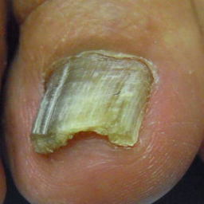 non-serious#1532 **Confidences:**normal = 0%; non-serious = 100%; warrants second opinion = 0%;   
The nail's condition is non-serious with confidence score of 100%. [image source](http://localhost:8080/ai/onyx/images/korean/onychomycosis/semisuper_jpn_539_33_26_412_405_tinea3.jpg)×

 non-serious#787 **Confidences:**normal = 0%; non-serious = 100%; warrants second opinion = 0%;   
The nail's condition is non-serious with confidence score of 100%. [image source](http://localhost:8080/ai/onyx/images/korean/L_NAIL_5nail_5nail2006_onychomycosis_onychomycosis.png#787)×

 non-serious#647 **Confidences:**normal = 0%; non-serious = 100%; warrants second opinion = 0%;   
The nail's condition is non-serious with confidence score of 100%. [image source](http://localhost:8080/ai/onyx/images/korean/L_NAIL_5nail_5nail2006_onychomycosis_onychomycosis.png#647)×

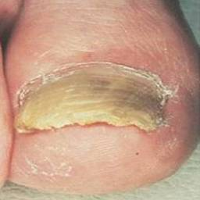 non-serious#1207 **Confidences:**normal = 0%; non-serious = 100%; warrants second opinion = 0%;   
The nail's condition is non-serious with confidence score of 100%. [image source](http://localhost:8080/ai/onyx/images/korean/onychomycosis/semisuper_1786_231_65_593_427_picture8.jpg)×

 non-serious#837 **Confidences:**normal = 0%; non-serious = 100%; warrants second opinion = 0%;   
The nail's condition is non-serious with confidence score of 100%. [image source](http://localhost:8080/ai/onyx/images/korean/L_NAIL_5nail_5nail2005_2_onychomycosis.png#837)×

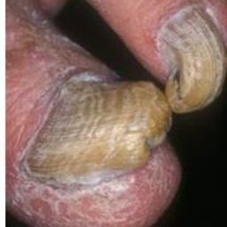 non-serious#1217 **Confidences:**normal = 0%; non-serious = 100%; warrants second opinion = 0%;   
The nail's condition is non-serious with confidence score of 100%. [image source](http://localhost:8080/ai/onyx/images/korean/onychomycosis/semisuper_1806_187_460_396_669_slide_8.jpg)×

 non-serious#427 **Confidences:**normal = 0%; non-serious = 100%; warrants second opinion = 0%;   
The nail's condition is non-serious with confidence score of 100%. [image source](http://localhost:8080/ai/onyx/images/korean/L_NAIL_5nailA2_scio_onychomycosis.png#427)×

 non-serious#642 **Confidences:**normal = 0%; non-serious = 100%; warrants second opinion = 0%;   
The nail's condition is non-serious with confidence score of 100%. [image source](http://localhost:8080/ai/onyx/images/korean/L_NAIL_5nail_5nail2006_onychomycosis_onychomycosis.png#642)×

 non-serious#682 **Confidences:**normal = 0%; non-serious = 100%; warrants second opinion = 0%;   
The nail's condition is non-serious with confidence score of 100%. [image source](http://localhost:8080/ai/onyx/images/korean/L_NAIL_5nail_5nail2006_onychomycosis_onychomycosis.png#682)×

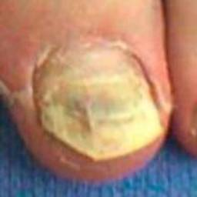 non-serious#1047 **Confidences:**normal = 0%; non-serious = 100%; warrants second opinion = 0%;   
The nail's condition is non-serious with confidence score of 100%. [image source](http://localhost:8080/ai/onyx/images/korean/onychomycosis/semisuper_1389_672_467_870_664_maxresdefault.jpg)×

 non-serious#467 **Confidences:**normal = 0%; non-serious = 100%; warrants second opinion = 0%;   
The nail's condition is non-serious with confidence score of 100%. [image source](http://localhost:8080/ai/onyx/images/korean/L_NAIL_5nailA2_scio_onychomycosis.png#467)×

 non-serious#472 **Confidences:**normal = 0%; non-serious = 100%; warrants second opinion = 0%;   
The nail's condition is non-serious with confidence score of 100%. [image source](http://localhost:8080/ai/onyx/images/korean/L_NAIL_5nailA2_scio_onychomycosis.png#472)×

 non-serious#677 **Confidences:**normal = 0%; non-serious = 100%; warrants second opinion = 0%;   
The nail's condition is non-serious with confidence score of 100%. [image source](http://localhost:8080/ai/onyx/images/korean/L_NAIL_5nail_5nail2006_onychomycosis_onychomycosis.png#677)×

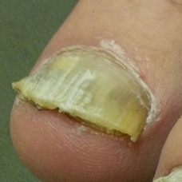 non-serious#1327 **Confidences:**normal = 0%; non-serious = 100%; warrants second opinion = 0%;   
The nail's condition is non-serious with confidence score of 100%. [image source](http://localhost:8080/ai/onyx/images/korean/onychomycosis/semisuper_378_46_29_334_316_Combo%20of%20problems.jpg)×

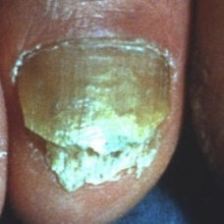 non-serious#1457 **Confidences:**normal = 0%; non-serious = 100%; warrants second opinion = 0%;   
The nail's condition is non-serious with confidence score of 100%. [image source](http://localhost:8080/ai/onyx/images/korean/onychomycosis/semisuper_864_15_76_302_395_subungual%20hyperkeratosis.jpg)×

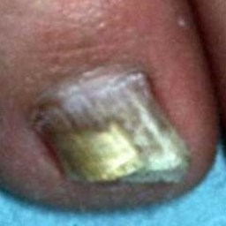 non-serious#1177 **Confidences:**normal = 0%; non-serious = 100%; warrants second opinion = 0%;   
The nail's condition is non-serious with confidence score of 100%. [image source](http://localhost:8080/ai/onyx/images/korean/onychomycosis/semisuper_1705_719_770_959_1010_036048HB.JPG)×

 non-serious#507 **Confidences:**normal = 0%; non-serious = 100%; warrants second opinion = 0%;   
The nail's condition is non-serious with confidence score of 100%. [image source](http://localhost:8080/ai/onyx/images/korean/L_NAIL_5nail_5nail2004_2_onychomycosis.png#507)×

 non-serious#562 **Confidences:**normal = 0%; non-serious = 100%; warrants second opinion = 0%;   
The nail's condition is non-serious with confidence score of 100%. [image source](http://localhost:8080/ai/onyx/images/korean/L_NAIL_5nail_5nail2004_2_onychomycosis.png#562)×

 non-serious#717 **Confidences:**normal = 0%; non-serious = 100%; warrants second opinion = 0%;   
The nail's condition is non-serious with confidence score of 100%. [image source](http://localhost:8080/ai/onyx/images/korean/L_NAIL_5nail_5nail2006_onychomycosis_onychomycosis.png#717)×

 non-serious#757 **Confidences:**normal = 0%; non-serious = 100%; warrants second opinion = 0%;   
The nail's condition is non-serious with confidence score of 100%. [image source](http://localhost:8080/ai/onyx/images/korean/L_NAIL_5nail_5nail2006_onychomycosis_onychomycosis.png#757)×

 non-serious#942 **Confidences:**normal = 0%; non-serious = 100%; warrants second opinion = 0%;   
The nail's condition is non-serious with confidence score of 100%. [image source](http://localhost:8080/ai/onyx/images/korean/L_NAIL_5nail_5nail2005_2_onychomycosis.png#942)×

 non-serious#1002 **Confidences:**normal = 0%; non-serious = 100%; warrants second opinion = 0%;   
The nail's condition is non-serious with confidence score of 100%. [image source](http://localhost:8080/ai/onyx/images/korean/L_NAIL_5nail_5nail2005_2_onychomycosis.png#1002)×

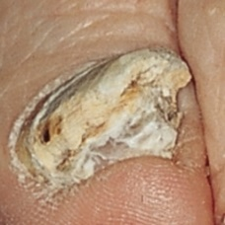 non-serious#1087 **Confidences:**normal = 0%; non-serious = 100%; warrants second opinion = 0%;   
The nail's condition is non-serious with confidence score of 100%. [image source](http://localhost:8080/ai/onyx/images/korean/onychomycosis/semisuper_1495_21_157_247_383_at021g39.jpg)×

 non-serious#747 **Confidences:**normal = 0%; non-serious = 100%; warrants second opinion = 0%;   
The nail's condition is non-serious with confidence score of 100%. [image source](http://localhost:8080/ai/onyx/images/korean/L_NAIL_5nail_5nail2006_onychomycosis_onychomycosis.png#747)×

 non-serious#767 **Confidences:**normal = 0%; non-serious = 100%; warrants second opinion = 0%;   
The nail's condition is non-serious with confidence score of 100%. [image source](http://localhost:8080/ai/onyx/images/korean/L_NAIL_5nail_5nail2006_onychomycosis_onychomycosis.png#767)×

 non-serious#917 **Confidences:**normal = 0%; non-serious = 100%; warrants second opinion = 0%;   
The nail's condition is non-serious with confidence score of 100%. [image source](http://localhost:8080/ai/onyx/images/korean/L_NAIL_5nail_5nail2005_2_onychomycosis.png#917)×

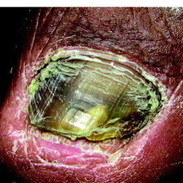 non-serious#1222 **Confidences:**normal = 0%; non-serious = 100%; warrants second opinion = 0%;   
The nail's condition is non-serious with confidence score of 100%. [image source](http://localhost:8080/ai/onyx/images/korean/onychomycosis/semisuper_1844_79_497_348_766_F1.large.jpg)×

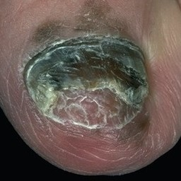 non-serious#1352 **Confidences:**normal = 0%; non-serious = 100%; warrants second opinion = 0%;   
The nail's condition is non-serious with confidence score of 100%. [image source](http://localhost:8080/ai/onyx/images/korean/onychomycosis/semisuper_485_83_285_358_559_hutchinson-sign-1.jpg)×

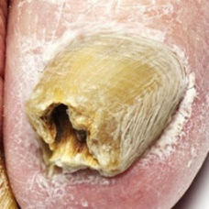 non-serious#1607 **Confidences:**normal = 0%; non-serious = 100%; warrants second opinion = 0%;   
The nail's condition is non-serious with confidence score of 100%. [image source](http://localhost:8080/ai/onyx/images/korean/onychomycosis/semisuper_kor_924_393_130_596_332_th_237F384957EDCC3C2BAB04.jpg)×

 warrants second opinion#68 **Confidences:**normal = 47%; non-serious = 11%; warrants second opinion = 42%;   
Not very sure whether the nail is OK or not. Sorry. [image source](http://localhost:8080/ai/onyx/images/korean/L_NAIL_5nailA2_lesion_melanonychia3_melanonychia.png#68)×

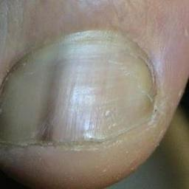 warrants second opinion#588 **Confidences:**normal = 33%; non-serious = 7%; warrants second opinion = 59%;   
Not very sure whether the nail is OK or not. Sorry. [image source](http://localhost:8080/ai/onyx/images/korean/melanonychia/semisuper_2267_201_119_501_418_00002330_standalone.jpg)×

 warrants second opinion#103 **Confidences:**normal = 36%; non-serious = 0%; warrants second opinion = 64%;   
It is most likely that the nail indicates something that warrants a second opinion and you should seek medical advice. (Confidence score is 64%) [image source](http://localhost:8080/ai/onyx/images/korean/L_NAIL_5nailA2_lesion_melanonychia3_melanonychia.png#103)×

 warrants second opinion#73 **Confidences:**normal = 27%; non-serious = 1%; warrants second opinion = 72%;   
It is most likely that the nail indicates something that warrants a second opinion and you should seek medical advice. (Confidence score is 72%) [image source](http://localhost:8080/ai/onyx/images/korean/L_NAIL_5nailA2_lesion_melanonychia3_melanonychia.png#73)×

 warrants second opinion#398 **Confidences:**normal = 1%; non-serious = 25%; warrants second opinion = 74%;   
It is most likely that the nail indicates something that warrants a second opinion and you should seek medical advice. (Confidence score is 74%) [image source](http://localhost:8080/ai/onyx/images/korean/L_NAIL_5nail_nail2005_2_melanonychia.png#398)×

 warrants second opinion#63 **Confidences:**normal = 3%; non-serious = 23%; warrants second opinion = 75%;   
It is most likely that the nail indicates something that warrants a second opinion and you should seek medical advice. (Confidence score is 75%) [image source](http://localhost:8080/ai/onyx/images/korean/L_NAIL_5nailA2_lesion_melanonychia3_melanonychia.png#63)×

 warrants second opinion#13 **Confidences:**normal = 25%; non-serious = 0%; warrants second opinion = 75%;   
It is most likely that the nail indicates something that warrants a second opinion and you should seek medical advice. (Confidence score is 75%) [image source](http://localhost:8080/ai/onyx/images/korean/L_NAIL_5nailA2_lesion_melanonychia3_melanonychia.png#13)×

 warrants second opinion#33 **Confidences:**normal = 3%; non-serious = 22%; warrants second opinion = 76%;   
It is most likely that the nail indicates something that warrants a second opinion and you should seek medical advice. (Confidence score is 76%) [image source](http://localhost:8080/ai/onyx/images/korean/L_NAIL_5nailA2_lesion_melanonychia3_melanonychia.png#33)×

 warrants second opinion#323 **Confidences:**normal = 1%; non-serious = 22%; warrants second opinion = 77%;   
It is most likely that the nail indicates something that warrants a second opinion and you should seek medical advice. (Confidence score is 77%) [image source](http://localhost:8080/ai/onyx/images/korean/L_NAIL_5nail_nail2005_2_melanonychia.png#323)×

 warrants second opinion#113 **Confidences:**normal = 0%; non-serious = 22%; warrants second opinion = 77%;   
It is most likely that the nail indicates something that warrants a second opinion and you should seek medical advice. (Confidence score is 77%) [image source](http://localhost:8080/ai/onyx/images/korean/L_NAIL_5nailA2_lesion_melanonychia3_melanonychia.png#113)×

 warrants second opinion#118 **Confidences:**normal = 21%; non-serious = 1%; warrants second opinion = 78%;   
It is most likely that the nail indicates something that warrants a second opinion and you should seek medical advice. (Confidence score is 78%) [image source](http://localhost:8080/ai/onyx/images/korean/L_NAIL_5nailA2_lesion_melanonychia3_melanonychia.png#118)×

 warrants second opinion#158 **Confidences:**normal = 14%; non-serious = 8%; warrants second opinion = 79%;   
It is most likely that the nail indicates something that warrants a second opinion and you should seek medical advice. (Confidence score is 79%) [image source](http://localhost:8080/ai/onyx/images/korean/L_NAIL_5nailA2_lesion_melanonychia3_melanonychia.png#158)×

 warrants second opinion#243 **Confidences:**normal = 21%; non-serious = 0%; warrants second opinion = 79%;   
It is most likely that the nail indicates something that warrants a second opinion and you should seek medical advice. (Confidence score is 79%) [image source](http://localhost:8080/ai/onyx/images/korean/L_NAIL_5nailA2_lesion_melanonychia3_melanonychia.png#243)×

 warrants second opinion#43 **Confidences:**normal = 14%; non-serious = 6%; warrants second opinion = 80%;   
It is most likely that the nail indicates something that warrants a second opinion and you should seek medical advice. (Confidence score is 80%) [image source](http://localhost:8080/ai/onyx/images/korean/L_NAIL_5nailA2_lesion_melanonychia3_melanonychia.png#43)×

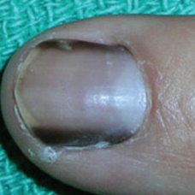 warrants second opinion#558 **Confidences:**normal = 7%; non-serious = 11%; warrants second opinion = 82%;   
It is most likely that the nail indicates something that warrants a second opinion and you should seek medical advice. (Confidence score is 82%) [image source](http://localhost:8080/ai/onyx/images/korean/melanonychia/semisuper_2194_243_430_429_615_m_usat2_c191f003.jpg)×

 warrants second opinion#213 **Confidences:**normal = 12%; non-serious = 6%; warrants second opinion = 82%;   
It is most likely that the nail indicates something that warrants a second opinion and you should seek medical advice. (Confidence score is 82%) [image source](http://localhost:8080/ai/onyx/images/korean/L_NAIL_5nailA2_lesion_melanonychia3_melanonychia.png#213)×

 warrants second opinion#223 **Confidences:**normal = 18%; non-serious = 0%; warrants second opinion = 82%;   
It is most likely that the nail indicates something that warrants a second opinion and you should seek medical advice. (Confidence score is 82%) [image source](http://localhost:8080/ai/onyx/images/korean/L_NAIL_5nailA2_lesion_melanonychia3_melanonychia.png#223)×

 warrants second opinion#78 **Confidences:**normal = 5%; non-serious = 12%; warrants second opinion = 83%;   
It is most likely that the nail indicates something that warrants a second opinion and you should seek medical advice. (Confidence score is 83%) [image source](http://localhost:8080/ai/onyx/images/korean/L_NAIL_5nailA2_lesion_melanonychia3_melanonychia.png#78)×

 warrants second opinion#58 **Confidences:**normal = 2%; non-serious = 15%; warrants second opinion = 83%;   
It is most likely that the nail indicates something that warrants a second opinion and you should seek medical advice. (Confidence score is 83%) [image source](http://localhost:8080/ai/onyx/images/korean/L_NAIL_5nailA2_lesion_melanonychia3_melanonychia.png#58)×

 warrants second opinion#383 **Confidences:**normal = 13%; non-serious = 4%; warrants second opinion = 83%;   
It is most likely that the nail indicates something that warrants a second opinion and you should seek medical advice. (Confidence score is 83%) [image source](http://localhost:8080/ai/onyx/images/korean/L_NAIL_5nail_nail2005_2_melanonychia.png#383)×

 warrants second opinion#498 **Confidences:**normal = 6%; non-serious = 10%; warrants second opinion = 84%;   
It is most likely that the nail indicates something that warrants a second opinion and you should seek medical advice. (Confidence score is 84%) [image source](http://localhost:8080/ai/onyx/images/korean/L_NAIL_5nail_5nail2004_2_melanonychia.png#498)×

 warrants second opinion#153 **Confidences:**normal = 15%; non-serious = 1%; warrants second opinion = 84%;   
It is most likely that the nail indicates something that warrants a second opinion and you should seek medical advice. (Confidence score is 84%) [image source](http://localhost:8080/ai/onyx/images/korean/L_NAIL_5nailA2_lesion_melanonychia3_melanonychia.png#153)×

 warrants second opinion#138 **Confidences:**normal = 13%; non-serious = 3%; warrants second opinion = 85%;   
It is most likely that the nail indicates something that warrants a second opinion and you should seek medical advice. (Confidence score is 85%) [image source](http://localhost:8080/ai/onyx/images/korean/L_NAIL_5nailA2_lesion_melanonychia3_melanonychia.png#138)×

 warrants second opinion#238 **Confidences:**normal = 1%; non-serious = 14%; warrants second opinion = 85%;   
It is most likely that the nail indicates something that warrants a second opinion and you should seek medical advice. (Confidence score is 85%) [image source](http://localhost:8080/ai/onyx/images/korean/L_NAIL_5nailA2_lesion_melanonychia3_melanonychia.png#238)×

 warrants second opinion#358 **Confidences:**normal = 10%; non-serious = 5%; warrants second opinion = 85%;   
It is most likely that the nail indicates something that warrants a second opinion and you should seek medical advice. (Confidence score is 85%) [image source](http://localhost:8080/ai/onyx/images/korean/L_NAIL_5nail_nail2005_2_melanonychia.png#358)×

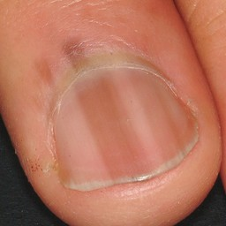 warrants second opinion#578 **Confidences:**normal = 6%; non-serious = 8%; warrants second opinion = 86%;   
It is most likely that the nail indicates something that warrants a second opinion and you should seek medical advice. (Confidence score is 86%) [image source](http://localhost:8080/ai/onyx/images/korean/melanonychia/semisuper_2246_1447_1014_2432_1999_0241902.jpg)×

 warrants second opinion#443 **Confidences:**normal = 5%; non-serious = 10%; warrants second opinion = 86%;   
It is most likely that the nail indicates something that warrants a second opinion and you should seek medical advice. (Confidence score is 86%) [image source](http://localhost:8080/ai/onyx/images/korean/L_NAIL_5nail_5nail2004_2_melanonychia.png#443)×

 warrants second opinion#38 **Confidences:**normal = 1%; non-serious = 12%; warrants second opinion = 87%;   
It is most likely that the nail indicates something that warrants a second opinion and you should seek medical advice. (Confidence score is 87%) [image source](http://localhost:8080/ai/onyx/images/korean/L_NAIL_5nailA2_lesion_melanonychia3_melanonychia.png#38)×

 warrants second opinion#413 **Confidences:**normal = 8%; non-serious = 5%; warrants second opinion = 87%;   
It is most likely that the nail indicates something that warrants a second opinion and you should seek medical advice. (Confidence score is 87%) [image source](http://localhost:8080/ai/onyx/images/korean/L_NAIL_5nail_nail2005_2_melanonychia.png#413)×

 warrants second opinion#173 **Confidences:**normal = 13%; non-serious = 1%; warrants second opinion = 87%;   
It is most likely that the nail indicates something that warrants a second opinion and you should seek medical advice. (Confidence score is 87%) [image source](http://localhost:8080/ai/onyx/images/korean/L_NAIL_5nailA2_lesion_melanonychia3_melanonychia.png#173)×

 warrants second opinion#318 **Confidences:**normal = 6%; non-serious = 7%; warrants second opinion = 87%;   
It is most likely that the nail indicates something that warrants a second opinion and you should seek medical advice. (Confidence score is 87%) [image source](http://localhost:8080/ai/onyx/images/korean/L_NAIL_5nail_nail2005_2_melanonychia.png#318)×

 warrants second opinion#53 **Confidences:**normal = 13%; non-serious = 0%; warrants second opinion = 87%;   
It is most likely that the nail indicates something that warrants a second opinion and you should seek medical advice. (Confidence score is 87%) [image source](http://localhost:8080/ai/onyx/images/korean/L_NAIL_5nailA2_lesion_melanonychia3_melanonychia.png#53)×

 warrants second opinion#363 **Confidences:**normal = 0%; non-serious = 12%; warrants second opinion = 88%;   
It is most likely that the nail indicates something that warrants a second opinion and you should seek medical advice. (Confidence score is 88%) [image source](http://localhost:8080/ai/onyx/images/korean/L_NAIL_5nail_nail2005_2_melanonychia.png#363)×

 warrants second opinion#233 **Confidences:**normal = 10%; non-serious = 2%; warrants second opinion = 88%;   
It is most likely that the nail indicates something that warrants a second opinion and you should seek medical advice. (Confidence score is 88%) [image source](http://localhost:8080/ai/onyx/images/korean/L_NAIL_5nailA2_lesion_melanonychia3_melanonychia.png#233)×

 warrants second opinion#143 **Confidences:**normal = 12%; non-serious = 0%; warrants second opinion = 88%;   
It is most likely that the nail indicates something that warrants a second opinion and you should seek medical advice. (Confidence score is 88%) [image source](http://localhost:8080/ai/onyx/images/korean/L_NAIL_5nailA2_lesion_melanonychia3_melanonychia.png#143)×

 warrants second opinion#513 **Confidences:**normal = 0%; non-serious = 11%; warrants second opinion = 88%;   
It is most likely that the nail indicates something that warrants a second opinion and you should seek medical advice. (Confidence score is 88%) [image source](http://localhost:8080/ai/onyx/images/korean/L_NAIL_5nail_5nail2004_2_melanonychia.png#513)×

 warrants second opinion#488 **Confidences:**normal = 5%; non-serious = 6%; warrants second opinion = 89%;   
It is most likely that the nail indicates something that warrants a second opinion and you should seek medical advice. (Confidence score is 89%) [image source](http://localhost:8080/ai/onyx/images/korean/L_NAIL_5nail_5nail2004_2_melanonychia.png#488)×

 warrants second opinion#93 **Confidences:**normal = 8%; non-serious = 2%; warrants second opinion = 89%;   
It is most likely that the nail indicates something that warrants a second opinion and you should seek medical advice. (Confidence score is 89%) [image source](http://localhost:8080/ai/onyx/images/korean/L_NAIL_5nailA2_lesion_melanonychia3_melanonychia.png#93)×

 warrants second opinion#348 **Confidences:**normal = 2%; non-serious = 9%; warrants second opinion = 89%;   
It is most likely that the nail indicates something that warrants a second opinion and you should seek medical advice. (Confidence score is 89%) [image source](http://localhost:8080/ai/onyx/images/korean/L_NAIL_5nail_nail2005_2_melanonychia.png#348)×

 warrants second opinion#178 **Confidences:**normal = 0%; non-serious = 11%; warrants second opinion = 89%;   
It is most likely that the nail indicates something that warrants a second opinion and you should seek medical advice. (Confidence score is 89%) [image source](http://localhost:8080/ai/onyx/images/korean/L_NAIL_5nailA2_lesion_melanonychia3_melanonychia.png#178)×

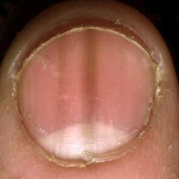 warrants second opinion#553 **Confidences:**normal = 9%; non-serious = 1%; warrants second opinion = 90%;   
It is most likely that the nail indicates something that warrants a second opinion and you should seek medical advice. (Confidence score is 90%) [image source](http://localhost:8080/ai/onyx/images/korean/melanonychia/semisuper_2185_38_26_509_497_melanonychia-pictures-4.jpg)×

 warrants second opinion#283 **Confidences:**normal = 0%; non-serious = 9%; warrants second opinion = 91%;   
It is most likely that the nail indicates something that warrants a second opinion and you should seek medical advice. (Confidence score is 91%) [image source](http://localhost:8080/ai/onyx/images/korean/L_NAIL_5nail_nail2005_2_melanonychia.png#283)×

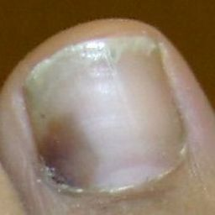 warrants second opinion#543 **Confidences:**normal = 8%; non-serious = 1%; warrants second opinion = 91%;   
It is most likely that the nail indicates something that warrants a second opinion and you should seek medical advice. (Confidence score is 91%) [image source](http://localhost:8080/ai/onyx/images/korean/melanonychia/semisuper_1171_146_14_414_274_440px-HEMORRHAGESUBUNG1.JPG)×

 warrants second opinion#378 **Confidences:**normal = 9%; non-serious = 0%; warrants second opinion = 91%;   
It is most likely that the nail indicates something that warrants a second opinion and you should seek medical advice. (Confidence score is 91%) [image source](http://localhost:8080/ai/onyx/images/korean/L_NAIL_5nail_nail2005_2_melanonychia.png#378)×

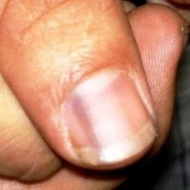 warrants second opinion#643 **Confidences:**normal = 8%; non-serious = 0%; warrants second opinion = 91%;   
It is most likely that the nail indicates something that warrants a second opinion and you should seek medical advice. (Confidence score is 91%) [image source](http://localhost:8080/ai/onyx/images/korean/melanonychia/semisuper_536_560_334_806_580_LM%201.jpg)×

 warrants second opinion#188 **Confidences:**normal = 8%; non-serious = 0%; warrants second opinion = 92%;   
It is most likely that the nail indicates something that warrants a second opinion and you should seek medical advice. (Confidence score is 92%) [image source](http://localhost:8080/ai/onyx/images/korean/L_NAIL_5nailA2_lesion_melanonychia3_melanonychia.png#188)×

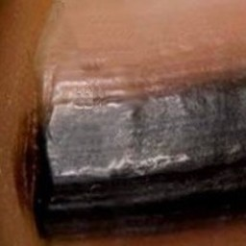 warrants second opinion#638 **Confidences:**normal = 0%; non-serious = 8%; warrants second opinion = 92%;   
It is most likely that the nail indicates something that warrants a second opinion and you should seek medical advice. (Confidence score is 92%) [image source](http://localhost:8080/ai/onyx/images/korean/melanonychia/semisuper_381_137_127_346_336_subunguaal-melanoom-4.jpg)×

 warrants second opinion#193 **Confidences:**normal = 7%; non-serious = 1%; warrants second opinion = 92%;   
It is most likely that the nail indicates something that warrants a second opinion and you should seek medical advice. (Confidence score is 92%) [image source](http://localhost:8080/ai/onyx/images/korean/L_NAIL_5nailA2_lesion_melanonychia3_melanonychia.png#193)×

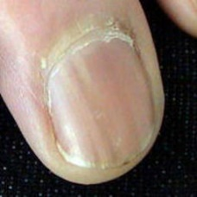 warrants second opinion#618 **Confidences:**normal = 3%; non-serious = 4%; warrants second opinion = 93%;   
It is most likely that the nail indicates something that warrants a second opinion and you should seek medical advice. (Confidence score is 93%) [image source](http://localhost:8080/ai/onyx/images/korean/melanonychia/semisuper_2348_302_141_500_339_00002227_standalone.jpg)×

 warrants second opinion#308 **Confidences:**normal = 0%; non-serious = 7%; warrants second opinion = 93%;   
It is most likely that the nail indicates something that warrants a second opinion and you should seek medical advice. (Confidence score is 93%) [image source](http://localhost:8080/ai/onyx/images/korean/L_NAIL_5nail_nail2005_2_melanonychia.png#308)×

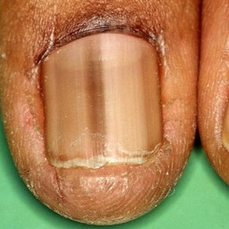 warrants second opinion#598 **Confidences:**normal = 0%; non-serious = 7%; warrants second opinion = 93%;   
It is most likely that the nail indicates something that warrants a second opinion and you should seek medical advice. (Confidence score is 93%) [image source](http://localhost:8080/ai/onyx/images/korean/melanonychia/semisuper_2298_31_107_603_710_melanonychia-longitudinalis-striata-1.jpg)×

 warrants second opinion#3 **Confidences:**normal = 4%; non-serious = 2%; warrants second opinion = 93%;   
It is most likely that the nail indicates something that warrants a second opinion and you should seek medical advice. (Confidence score is 93%) [image source](http://localhost:8080/ai/onyx/images/korean/L_NAIL_5nailA2_lesion_melanonychia3_melanonychia.png#3)×

 warrants second opinion#428 **Confidences:**normal = 0%; non-serious = 6%; warrants second opinion = 94%;   
It is most likely that the nail indicates something that warrants a second opinion and you should seek medical advice. (Confidence score is 94%) [image source](http://localhost:8080/ai/onyx/images/korean/L_NAIL_5nail_5nail2004_2_melanonychia.png#428)×

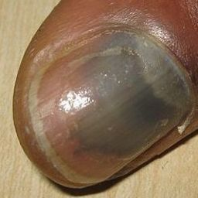 warrants second opinion#678 **Confidences:**normal = 1%; non-serious = 5%; warrants second opinion = 94%;   
It is most likely that the nail indicates something that warrants a second opinion and you should seek medical advice. (Confidence score is 94%) [image source](http://localhost:8080/ai/onyx/images/korean/melanonychia/semisuper_kor_801_65_190_310_435_th_273B244851FA360222B299.jpg)×

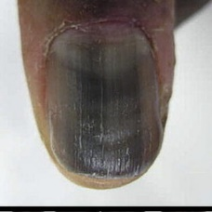 warrants second opinion#538 **Confidences:**normal = 3%; non-serious = 3%; warrants second opinion = 94%;   
It is most likely that the nail indicates something that warrants a second opinion and you should seek medical advice. (Confidence score is 94%) [image source](http://localhost:8080/ai/onyx/images/korean/melanonychia/semisuper_1105_57_91_355_389_melanonychia-medicatie-1.jpg)×

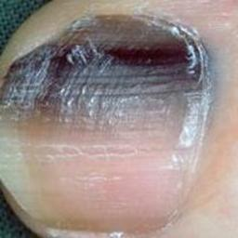 warrants second opinion#668 **Confidences:**normal = 0%; non-serious = 6%; warrants second opinion = 94%;   
It is most likely that the nail indicates something that warrants a second opinion and you should seek medical advice. (Confidence score is 94%) [image source](http://localhost:8080/ai/onyx/images/korean/melanonychia/semisuper_jpn_337_84_29_292_237_img0036.jpg)×

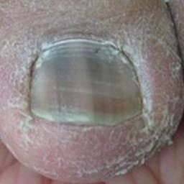 warrants second opinion#648 **Confidences:**normal = 5%; non-serious = 0%; warrants second opinion = 94%;   
It is most likely that the nail indicates something that warrants a second opinion and you should seek medical advice. (Confidence score is 94%) [image source](http://localhost:8080/ai/onyx/images/korean/melanonychia/semisuper_621_59_114_337_391_952186.fig.001.jpg)×

 warrants second opinion#198 **Confidences:**normal = 2%; non-serious = 4%; warrants second opinion = 95%;   
It is most likely that the nail indicates something that warrants a second opinion and you should seek medical advice. (Confidence score is 95%) [image source](http://localhost:8080/ai/onyx/images/korean/L_NAIL_5nailA2_lesion_melanonychia3_melanonychia.png#198)×

 warrants second opinion#8 **Confidences:**normal = 5%; non-serious = 0%; warrants second opinion = 95%;   
It is most likely that the nail indicates something that warrants a second opinion and you should seek medical advice. (Confidence score is 95%) [image source](http://localhost:8080/ai/onyx/images/korean/L_NAIL_5nailA2_lesion_melanonychia3_melanonychia.png#8)×

 warrants second opinion#468 **Confidences:**normal = 0%; non-serious = 5%; warrants second opinion = 95%;   
It is most likely that the nail indicates something that warrants a second opinion and you should seek medical advice. (Confidence score is 95%) [image source](http://localhost:8080/ai/onyx/images/korean/L_NAIL_5nail_5nail2004_2_melanonychia.png#468)×

 warrants second opinion#423 **Confidences:**normal = 3%; non-serious = 2%; warrants second opinion = 95%;   
It is most likely that the nail indicates something that warrants a second opinion and you should seek medical advice. (Confidence score is 95%) [image source](http://localhost:8080/ai/onyx/images/korean/L_NAIL_5nail_5nail2004_2_melanonychia.png#423)×

 warrants second opinion#483 **Confidences:**normal = 3%; non-serious = 1%; warrants second opinion = 95%;   
It is most likely that the nail indicates something that warrants a second opinion and you should seek medical advice. (Confidence score is 95%) [image source](http://localhost:8080/ai/onyx/images/korean/L_NAIL_5nail_5nail2004_2_melanonychia.png#483)×

 warrants second opinion#518 **Confidences:**normal = 3%; non-serious = 1%; warrants second opinion = 95%;   
It is most likely that the nail indicates something that warrants a second opinion and you should seek medical advice. (Confidence score is 95%) [image source](http://localhost:8080/ai/onyx/images/korean/L_NAIL_5nail_5nail2004_2_melanonychia.png#518)×

 warrants second opinion#128 **Confidences:**normal = 0%; non-serious = 4%; warrants second opinion = 95%;   
It is most likely that the nail indicates something that warrants a second opinion and you should seek medical advice. (Confidence score is 95%) [image source](http://localhost:8080/ai/onyx/images/korean/L_NAIL_5nailA2_lesion_melanonychia3_melanonychia.png#128)×

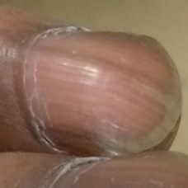 warrants second opinion#548 **Confidences:**normal = 4%; non-serious = 0%; warrants second opinion = 95%;   
It is most likely that the nail indicates something that warrants a second opinion and you should seek medical advice. (Confidence score is 95%) [image source](http://localhost:8080/ai/onyx/images/korean/melanonychia/semisuper_1910_547_219_801_472_20140620-182421-66261584.jpg)×

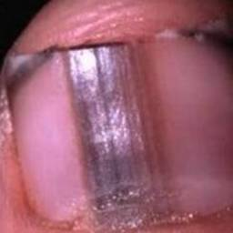 warrants second opinion#628 **Confidences:**normal = 0%; non-serious = 4%; warrants second opinion = 96%;   
It is most likely that the nail indicates something that warrants a second opinion and you should seek medical advice. (Confidence score is 96%) [image source](http://localhost:8080/ai/onyx/images/korean/melanonychia/semisuper_2375_13_14_256_270_sddefault.jpg)×

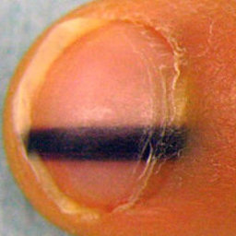 warrants second opinion#663 **Confidences:**normal = 4%; non-serious = 0%; warrants second opinion = 96%;   
It is most likely that the nail indicates something that warrants a second opinion and you should seek medical advice. (Confidence score is 96%) [image source](http://localhost:8080/ai/onyx/images/korean/melanonychia/semisuper_jpn_269_93_103_325_335_nail_b2_photo01.jpg)×

 warrants second opinion#273 **Confidences:**normal = 3%; non-serious = 2%; warrants second opinion = 96%;   
It is most likely that the nail indicates something that warrants a second opinion and you should seek medical advice. (Confidence score is 96%) [image source](http://localhost:8080/ai/onyx/images/korean/L_NAIL_5nail_nail2005_2_melanonychia.png#273)×

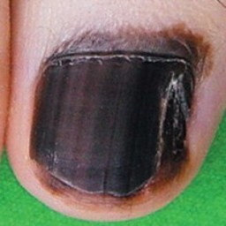 warrants second opinion#658 **Confidences:**normal = 3%; non-serious = 1%; warrants second opinion = 96%;   
It is most likely that the nail indicates something that warrants a second opinion and you should seek medical advice. (Confidence score is 96%) [image source](http://localhost:8080/ai/onyx/images/korean/melanonychia/semisuper_962_572_536_789_753_subunguaal-melanoom-6.jpg)×

 warrants second opinion#98 **Confidences:**normal = 3%; non-serious = 1%; warrants second opinion = 96%;   
It is most likely that the nail indicates something that warrants a second opinion and you should seek medical advice. (Confidence score is 96%) [image source](http://localhost:8080/ai/onyx/images/korean/L_NAIL_5nailA2_lesion_melanonychia3_melanonychia.png#98)×

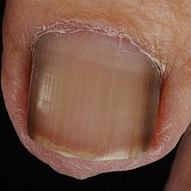 warrants second opinion#528 **Confidences:**normal = 1%; non-serious = 3%; warrants second opinion = 96%;   
It is most likely that the nail indicates something that warrants a second opinion and you should seek medical advice. (Confidence score is 96%) [image source](http://localhost:8080/ai/onyx/images/korean/melanonychia/semisuper_1089_556_322_954_721_melanonychia-longitudinalis-striata-2.jpg)×

 warrants second opinion#368 **Confidences:**normal = 4%; non-serious = 0%; warrants second opinion = 96%;   
It is most likely that the nail indicates something that warrants a second opinion and you should seek medical advice. (Confidence score is 96%) [image source](http://localhost:8080/ai/onyx/images/korean/L_NAIL_5nail_nail2005_2_melanonychia.png#368)×

 warrants second opinion#268 **Confidences:**normal = 0%; non-serious = 4%; warrants second opinion = 96%;   
It is most likely that the nail indicates something that warrants a second opinion and you should seek medical advice. (Confidence score is 96%) [image source](http://localhost:8080/ai/onyx/images/korean/L_NAIL_5nail_nail2005_2_melanonychia.png#268)×

 warrants second opinion#258 **Confidences:**normal = 2%; non-serious = 1%; warrants second opinion = 97%;   
It is most likely that the nail indicates something that warrants a second opinion and you should seek medical advice. (Confidence score is 97%) [image source](http://localhost:8080/ai/onyx/images/korean/L_NAIL_5nailA2_lesion_melanonychia3_melanonychia.png#258)×

 warrants second opinion#493 **Confidences:**normal = 0%; non-serious = 3%; warrants second opinion = 97%;   
It is most likely that the nail indicates something that warrants a second opinion and you should seek medical advice. (Confidence score is 97%) [image source](http://localhost:8080/ai/onyx/images/korean/L_NAIL_5nail_5nail2004_2_melanonychia.png#493)×

 warrants second opinion#83 **Confidences:**normal = 0%; non-serious = 3%; warrants second opinion = 97%;   
It is most likely that the nail indicates something that warrants a second opinion and you should seek medical advice. (Confidence score is 97%) [image source](http://localhost:8080/ai/onyx/images/korean/L_NAIL_5nailA2_lesion_melanonychia3_melanonychia.png#83)×

 warrants second opinion#88 **Confidences:**normal = 0%; non-serious = 3%; warrants second opinion = 97%;   
It is most likely that the nail indicates something that warrants a second opinion and you should seek medical advice. (Confidence score is 97%) [image source](http://localhost:8080/ai/onyx/images/korean/L_NAIL_5nailA2_lesion_melanonychia3_melanonychia.png#88)×

 warrants second opinion#508 **Confidences:**normal = 0%; non-serious = 3%; warrants second opinion = 97%;   
It is most likely that the nail indicates something that warrants a second opinion and you should seek medical advice. (Confidence score is 97%) [image source](http://localhost:8080/ai/onyx/images/korean/L_NAIL_5nail_5nail2004_2_melanonychia.png#508)×

 warrants second opinion#448 **Confidences:**normal = 3%; non-serious = 0%; warrants second opinion = 97%;   
It is most likely that the nail indicates something that warrants a second opinion and you should seek medical advice. (Confidence score is 97%) [image source](http://localhost:8080/ai/onyx/images/korean/L_NAIL_5nail_5nail2004_2_melanonychia.png#448)×

 warrants second opinion#478 **Confidences:**normal = 3%; non-serious = 0%; warrants second opinion = 97%;   
It is most likely that the nail indicates something that warrants a second opinion and you should seek medical advice. (Confidence score is 97%) [image source](http://localhost:8080/ai/onyx/images/korean/L_NAIL_5nail_5nail2004_2_melanonychia.png#478)×

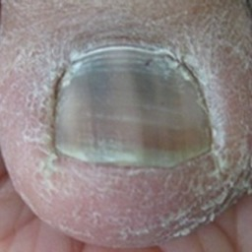 warrants second opinion#613 **Confidences:**normal = 2%; non-serious = 1%; warrants second opinion = 97%;   
It is most likely that the nail indicates something that warrants a second opinion and you should seek medical advice. (Confidence score is 97%) [image source](http://localhost:8080/ai/onyx/images/korean/melanonychia/semisuper_2334_46_123_317_395_Racial-melanonychia.jpg)×

 warrants second opinion#298 **Confidences:**normal = 1%; non-serious = 2%; warrants second opinion = 97%;   
It is most likely that the nail indicates something that warrants a second opinion and you should seek medical advice. (Confidence score is 97%) [image source](http://localhost:8080/ai/onyx/images/korean/L_NAIL_5nail_nail2005_2_melanonychia.png#298)×

 warrants second opinion#433 **Confidences:**normal = 3%; non-serious = 0%; warrants second opinion = 97%;   
It is most likely that the nail indicates something that warrants a second opinion and you should seek medical advice. (Confidence score is 97%) [image source](http://localhost:8080/ai/onyx/images/korean/L_NAIL_5nail_5nail2004_2_melanonychia.png#433)×

 warrants second opinion#463 **Confidences:**normal = 3%; non-serious = 0%; warrants second opinion = 97%;   
It is most likely that the nail indicates something that warrants a second opinion and you should seek medical advice. (Confidence score is 97%) [image source](http://localhost:8080/ai/onyx/images/korean/L_NAIL_5nail_5nail2004_2_melanonychia.png#463)×

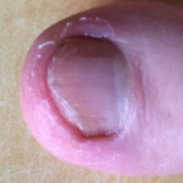 warrants second opinion#673 **Confidences:**normal = 3%; non-serious = 0%; warrants second opinion = 97%;   
It is most likely that the nail indicates something that warrants a second opinion and you should seek medical advice. (Confidence score is 97%) [image source](http://localhost:8080/ai/onyx/images/korean/melanonychia/semisuper_kor_238_292_138_474_320_P20140827_182108824_3D7FC128-AB11-46EB-99E4-A693C8158791.jpg)×

 warrants second opinion#403 **Confidences:**normal = 2%; non-serious = 1%; warrants second opinion = 97%;   
It is most likely that the nail indicates something that warrants a second opinion and you should seek medical advice. (Confidence score is 97%) [image source](http://localhost:8080/ai/onyx/images/korean/L_NAIL_5nail_nail2005_2_melanonychia.png#403)×

 warrants second opinion#393 **Confidences:**normal = 2%; non-serious = 1%; warrants second opinion = 97%;   
It is most likely that the nail indicates something that warrants a second opinion and you should seek medical advice. (Confidence score is 97%) [image source](http://localhost:8080/ai/onyx/images/korean/L_NAIL_5nail_nail2005_2_melanonychia.png#393)×

 warrants second opinion#438 **Confidences:**normal = 1%; non-serious = 2%; warrants second opinion = 97%;   
It is most likely that the nail indicates something that warrants a second opinion and you should seek medical advice. (Confidence score is 97%) [image source](http://localhost:8080/ai/onyx/images/korean/L_NAIL_5nail_5nail2004_2_melanonychia.png#438)×

 warrants second opinion#208 **Confidences:**normal = 1%; non-serious = 2%; warrants second opinion = 97%;   
It is most likely that the nail indicates something that warrants a second opinion and you should seek medical advice. (Confidence score is 97%) [image source](http://localhost:8080/ai/onyx/images/korean/L_NAIL_5nailA2_lesion_melanonychia3_melanonychia.png#208)×

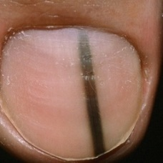 warrants second opinion#623 **Confidences:**normal = 0%; non-serious = 2%; warrants second opinion = 97%;   
It is most likely that the nail indicates something that warrants a second opinion and you should seek medical advice. (Confidence score is 97%) [image source](http://localhost:8080/ai/onyx/images/korean/melanonychia/semisuper_2362_478_273_947_742_MelanomaInSituMISNailD.jpg)×

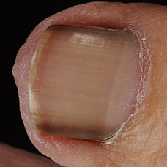 warrants second opinion#523 **Confidences:**normal = 1%; non-serious = 2%; warrants second opinion = 97%;   
It is most likely that the nail indicates something that warrants a second opinion and you should seek medical advice. (Confidence score is 97%) [image source](http://localhost:8080/ai/onyx/images/korean/melanonychia/semisuper_1075_68_819_573_1324_4072.jpg)×

 warrants second opinion#253 **Confidences:**normal = 2%; non-serious = 0%; warrants second opinion = 97%;   
It is most likely that the nail indicates something that warrants a second opinion and you should seek medical advice. (Confidence score is 97%) [image source](http://localhost:8080/ai/onyx/images/korean/L_NAIL_5nailA2_lesion_melanonychia3_melanonychia.png#253)×

 warrants second opinion#503 **Confidences:**normal = 2%; non-serious = 1%; warrants second opinion = 98%;   
It is most likely that the nail indicates something that warrants a second opinion and you should seek medical advice. (Confidence score is 98%) [image source](http://localhost:8080/ai/onyx/images/korean/L_NAIL_5nail_5nail2004_2_melanonychia.png#503)×

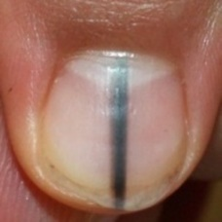 warrants second opinion#608 **Confidences:**normal = 2%; non-serious = 0%; warrants second opinion = 98%;   
It is most likely that the nail indicates something that warrants a second opinion and you should seek medical advice. (Confidence score is 98%) [image source](http://localhost:8080/ai/onyx/images/korean/melanonychia/semisuper_2324_245_361_447_564_image3.jpeg)×

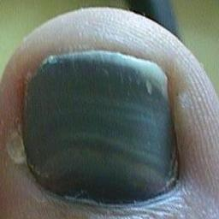 warrants second opinion#653 **Confidences:**normal = 0%; non-serious = 2%; warrants second opinion = 98%;   
It is most likely that the nail indicates something that warrants a second opinion and you should seek medical advice. (Confidence score is 98%) [image source](http://localhost:8080/ai/onyx/images/korean/melanonychia/semisuper_880_282_40_563_322_00001775_standalone.jpg)×

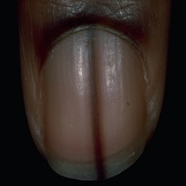 warrants second opinion#583 **Confidences:**normal = 2%; non-serious = 0%; warrants second opinion = 98%;   
It is most likely that the nail indicates something that warrants a second opinion and you should seek medical advice. (Confidence score is 98%) [image source](http://localhost:8080/ai/onyx/images/korean/melanonychia/semisuper_2259_60_237_480_657_img0084.jpg)×

 warrants second opinion#408 **Confidences:**normal = 2%; non-serious = 0%; warrants second opinion = 98%;   
It is most likely that the nail indicates something that warrants a second opinion and you should seek medical advice. (Confidence score is 98%) [image source](http://localhost:8080/ai/onyx/images/korean/L_NAIL_5nail_nail2005_2_melanonychia.png#408)×

 warrants second opinion#123 **Confidences:**normal = 2%; non-serious = 0%; warrants second opinion = 98%;   
It is most likely that the nail indicates something that warrants a second opinion and you should seek medical advice. (Confidence score is 98%) [image source](http://localhost:8080/ai/onyx/images/korean/L_NAIL_5nailA2_lesion_melanonychia3_melanonychia.png#123)×

 warrants second opinion#278 **Confidences:**normal = 2%; non-serious = 0%; warrants second opinion = 98%;   
It is most likely that the nail indicates something that warrants a second opinion and you should seek medical advice. (Confidence score is 98%) [image source](http://localhost:8080/ai/onyx/images/korean/L_NAIL_5nail_nail2005_2_melanonychia.png#278)×

 warrants second opinion#293 **Confidences:**normal = 0%; non-serious = 2%; warrants second opinion = 98%;   
It is most likely that the nail indicates something that warrants a second opinion and you should seek medical advice. (Confidence score is 98%) [image source](http://localhost:8080/ai/onyx/images/korean/L_NAIL_5nail_nail2005_2_melanonychia.png#293)×

 warrants second opinion#263 **Confidences:**normal = 0%; non-serious = 2%; warrants second opinion = 98%;   
It is most likely that the nail indicates something that warrants a second opinion and you should seek medical advice. (Confidence score is 98%) [image source](http://localhost:8080/ai/onyx/images/korean/L_NAIL_5nail_nail2005_2_melanonychia.png#263)×

 warrants second opinion#353 **Confidences:**normal = 0%; non-serious = 2%; warrants second opinion = 98%;   
It is most likely that the nail indicates something that warrants a second opinion and you should seek medical advice. (Confidence score is 98%) [image source](http://localhost:8080/ai/onyx/images/korean/L_NAIL_5nail_nail2005_2_melanonychia.png#353)×

 warrants second opinion#453 **Confidences:**normal = 1%; non-serious = 1%; warrants second opinion = 98%;   
It is most likely that the nail indicates something that warrants a second opinion and you should seek medical advice. (Confidence score is 98%) [image source](http://localhost:8080/ai/onyx/images/korean/L_NAIL_5nail_5nail2004_2_melanonychia.png#453)×

 warrants second opinion#458 **Confidences:**normal = 1%; non-serious = 1%; warrants second opinion = 98%;   
It is most likely that the nail indicates something that warrants a second opinion and you should seek medical advice. (Confidence score is 98%) [image source](http://localhost:8080/ai/onyx/images/korean/L_NAIL_5nail_5nail2004_2_melanonychia.png#458)×

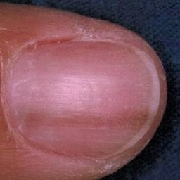 warrants second opinion#568 **Confidences:**normal = 2%; non-serious = 0%; warrants second opinion = 98%;   
It is most likely that the nail indicates something that warrants a second opinion and you should seek medical advice. (Confidence score is 98%) [image source](http://localhost:8080/ai/onyx/images/korean/melanonychia/semisuper_2222_611_22_878_289_JCutanAesthetSurg_2011_4_3_167_91247_f4.jpg)×

 warrants second opinion#633 **Confidences:**normal = 2%; non-serious = 0%; warrants second opinion = 98%;   
It is most likely that the nail indicates something that warrants a second opinion and you should seek medical advice. (Confidence score is 98%) [image source](http://localhost:8080/ai/onyx/images/korean/melanonychia/semisuper_308_611_22_878_289_JCutanAesthetSurg_2011_4_3_167_91247_f4.jpg)×

 warrants second opinion#388 **Confidences:**normal = 0%; non-serious = 2%; warrants second opinion = 98%;   
It is most likely that the nail indicates something that warrants a second opinion and you should seek medical advice. (Confidence score is 98%) [image source](http://localhost:8080/ai/onyx/images/korean/L_NAIL_5nail_nail2005_2_melanonychia.png#388)×

 warrants second opinion#18 **Confidences:**normal = 0%; non-serious = 2%; warrants second opinion = 98%;   
It is most likely that the nail indicates something that warrants a second opinion and you should seek medical advice. (Confidence score is 98%) [image source](http://localhost:8080/ai/onyx/images/korean/L_NAIL_5nailA2_lesion_melanonychia3_melanonychia.png#18)×

 warrants second opinion#473 **Confidences:**normal = 2%; non-serious = 0%; warrants second opinion = 98%;   
It is most likely that the nail indicates something that warrants a second opinion and you should seek medical advice. (Confidence score is 98%) [image source](http://localhost:8080/ai/onyx/images/korean/L_NAIL_5nail_5nail2004_2_melanonychia.png#473)×

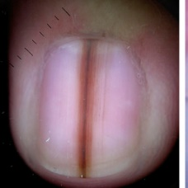 warrants second opinion#593 **Confidences:**normal = 2%; non-serious = 0%; warrants second opinion = 98%;   
It is most likely that the nail indicates something that warrants a second opinion and you should seek medical advice. (Confidence score is 98%) [image source](http://localhost:8080/ai/onyx/images/korean/melanonychia/semisuper_2281_592_87_1127_622_dst90037f3.jpg)×

 warrants second opinion#23 **Confidences:**normal = 1%; non-serious = 1%; warrants second opinion = 98%;   
It is most likely that the nail indicates something that warrants a second opinion and you should seek medical advice. (Confidence score is 98%) [image source](http://localhost:8080/ai/onyx/images/korean/L_NAIL_5nailA2_lesion_melanonychia3_melanonychia.png#23)×

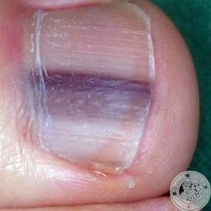 warrants second opinion#563 **Confidences:**normal = 0%; non-serious = 1%; warrants second opinion = 98%;   
It is most likely that the nail indicates something that warrants a second opinion and you should seek medical advice. (Confidence score is 98%) [image source](http://localhost:8080/ai/onyx/images/korean/melanonychia/semisuper_2204_135_88_529_491_img0051.jpg)×

 warrants second opinion#218 **Confidences:**normal = 0%; non-serious = 1%; warrants second opinion = 98%;   
It is most likely that the nail indicates something that warrants a second opinion and you should seek medical advice. (Confidence score is 98%) [image source](http://localhost:8080/ai/onyx/images/korean/L_NAIL_5nailA2_lesion_melanonychia3_melanonychia.png#218)×

 warrants second opinion#313 **Confidences:**normal = 1%; non-serious = 0%; warrants second opinion = 99%;   
It is most likely that the nail indicates something that warrants a second opinion and you should seek medical advice. (Confidence score is 99%) [image source](http://localhost:8080/ai/onyx/images/korean/L_NAIL_5nail_nail2005_2_melanonychia.png#313)×

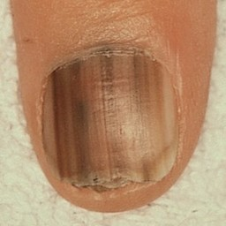 warrants second opinion#533 **Confidences:**normal = 1%; non-serious = 0%; warrants second opinion = 99%;   
It is most likely that the nail indicates something that warrants a second opinion and you should seek medical advice. (Confidence score is 99%) [image source](http://localhost:8080/ai/onyx/images/korean/melanonychia/semisuper_1096_155_107_461_413_melanonychia-pictures-2.jpg)×

 warrants second opinion#603 **Confidences:**normal = 1%; non-serious = 0%; warrants second opinion = 99%;   
It is most likely that the nail indicates something that warrants a second opinion and you should seek medical advice. (Confidence score is 99%) [image source](http://localhost:8080/ai/onyx/images/korean/melanonychia/semisuper_2304_155_107_461_413_melanonychia-pictures-2.jpg)×

 warrants second opinion#343 **Confidences:**normal = 1%; non-serious = 0%; warrants second opinion = 99%;   
It is most likely that the nail indicates something that warrants a second opinion and you should seek medical advice. (Confidence score is 99%) [image source](http://localhost:8080/ai/onyx/images/korean/L_NAIL_5nail_nail2005_2_melanonychia.png#343)×

 warrants second opinion#108 **Confidences:**normal = 1%; non-serious = 0%; warrants second opinion = 99%;   
It is most likely that the nail indicates something that warrants a second opinion and you should seek medical advice. (Confidence score is 99%) [image source](http://localhost:8080/ai/onyx/images/korean/L_NAIL_5nailA2_lesion_melanonychia3_melanonychia.png#108)×

 warrants second opinion#183 **Confidences:**normal = 0%; non-serious = 1%; warrants second opinion = 99%;   
It is most likely that the nail indicates something that warrants a second opinion and you should seek medical advice. (Confidence score is 99%) [image source](http://localhost:8080/ai/onyx/images/korean/L_NAIL_5nailA2_lesion_melanonychia3_melanonychia.png#183)×

 warrants second opinion#333 **Confidences:**normal = 0%; non-serious = 0%; warrants second opinion = 99%;   
It is most likely that the nail indicates something that warrants a second opinion and you should seek medical advice. (Confidence score is 99%) [image source](http://localhost:8080/ai/onyx/images/korean/L_NAIL_5nail_nail2005_2_melanonychia.png#333)×

 warrants second opinion#328 **Confidences:**normal = 0%; non-serious = 0%; warrants second opinion = 99%;   
It is most likely that the nail indicates something that warrants a second opinion and you should seek medical advice. (Confidence score is 99%) [image source](http://localhost:8080/ai/onyx/images/korean/L_NAIL_5nail_nail2005_2_melanonychia.png#328)×

 warrants second opinion#418 **Confidences:**normal = 0%; non-serious = 0%; warrants second opinion = 99%;   
It is most likely that the nail indicates something that warrants a second opinion and you should seek medical advice. (Confidence score is 99%) [image source](http://localhost:8080/ai/onyx/images/korean/L_NAIL_5nail_nail2005_2_melanonychia.png#418)×

 warrants second opinion#373 **Confidences:**normal = 0%; non-serious = 0%; warrants second opinion = 100%;   
It is most likely that the nail indicates something that warrants a second opinion and you should seek medical advice. (Confidence score is 100%) [image source](http://localhost:8080/ai/onyx/images/korean/L_NAIL_5nail_nail2005_2_melanonychia.png#373)×

 warrants second opinion#248 **Confidences:**normal = 0%; non-serious = 0%; warrants second opinion = 100%;   
It is most likely that the nail indicates something that warrants a second opinion and you should seek medical advice. (Confidence score is 100%) [image source](http://localhost:8080/ai/onyx/images/korean/L_NAIL_5nailA2_lesion_melanonychia3_melanonychia.png#248)×

 warrants second opinion#168 **Confidences:**normal = 0%; non-serious = 0%; warrants second opinion = 100%;   
It is most likely that the nail indicates something that warrants a second opinion and you should seek medical advice. (Confidence score is 100%) [image source](http://localhost:8080/ai/onyx/images/korean/L_NAIL_5nailA2_lesion_melanonychia3_melanonychia.png#168)×

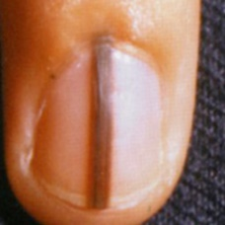 warrants second opinion#683 **Confidences:**normal = 0%; non-serious = 0%; warrants second opinion = 100%;   
It is most likely that the nail indicates something that warrants a second opinion and you should seek medical advice. (Confidence score is 100%) [image source](http://localhost:8080/ai/onyx/images/korean/melanonychia/semisuper_kor_845_416_304_655_543_U1422432619.jpg)×

 warrants second opinion#303 **Confidences:**normal = 0%; non-serious = 0%; warrants second opinion = 100%;   
It is most likely that the nail indicates something that warrants a second opinion and you should seek medical advice. (Confidence score is 100%) [image source](http://localhost:8080/ai/onyx/images/korean/L_NAIL_5nail_nail2005_2_melanonychia.png#303)×

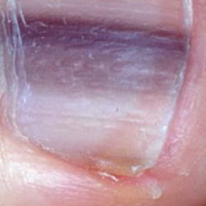 warrants second opinion#573 **Confidences:**normal = 0%; non-serious = 0%; warrants second opinion = 100%;   
It is most likely that the nail indicates something that warrants a second opinion and you should seek medical advice. (Confidence score is 100%) [image source](http://localhost:8080/ai/onyx/images/korean/melanonychia/semisuper_2238_175_167_422_474_melanonychia25.jpg)×

 warrants second opinion#203 **Confidences:**normal = 0%; non-serious = 0%; warrants second opinion = 100%;   
It is most likely that the nail indicates something that warrants a second opinion and you should seek medical advice. (Confidence score is 100%) [image source](http://localhost:8080/ai/onyx/images/korean/L_NAIL_5nailA2_lesion_melanonychia3_melanonychia.png#203)×

 warrants second opinion#288 **Confidences:**normal = 0%; non-serious = 0%; warrants second opinion = 100%;   
It is most likely that the nail indicates something that warrants a second opinion and you should seek medical advice. (Confidence score is 100%) [image source](http://localhost:8080/ai/onyx/images/korean/L_NAIL_5nail_nail2005_2_melanonychia.png#288)×

 warrants second opinion#133 **Confidences:**normal = 0%; non-serious = 0%; warrants second opinion = 100%;   
It is most likely that the nail indicates something that warrants a second opinion and you should seek medical advice. (Confidence score is 100%) [image source](http://localhost:8080/ai/onyx/images/korean/L_NAIL_5nailA2_lesion_melanonychia3_melanonychia.png#133)×

 warrants second opinion#148 **Confidences:**normal = 0%; non-serious = 0%; warrants second opinion = 100%;   
It is most likely that the nail indicates something that warrants a second opinion and you should seek medical advice. (Confidence score is 100%) [image source](http://localhost:8080/ai/onyx/images/korean/L_NAIL_5nailA2_lesion_melanonychia3_melanonychia.png#148)×

 warrants second opinion#338 **Confidences:**normal = 0%; non-serious = 0%; warrants second opinion = 100%;   
It is most likely that the nail indicates something that warrants a second opinion and you should seek medical advice. (Confidence score is 100%) [image source](http://localhost:8080/ai/onyx/images/korean/L_NAIL_5nail_nail2005_2_melanonychia.png#338)×

 warrants second opinion#163 **Confidences:**normal = 0%; non-serious = 0%; warrants second opinion = 100%;   
It is most likely that the nail indicates something that warrants a second opinion and you should seek medical advice. (Confidence score is 100%) [image source](http://localhost:8080/ai/onyx/images/korean/L_NAIL_5nailA2_lesion_melanonychia3_melanonychia.png#163)×

 warrants second opinion#228 **Confidences:**normal = 0%; non-serious = 0%; warrants second opinion = 100%;   
It is most likely that the nail indicates something that warrants a second opinion and you should seek medical advice. (Confidence score is 100%) [image source](http://localhost:8080/ai/onyx/images/korean/L_NAIL_5nailA2_lesion_melanonychia3_melanonychia.png#228)×

 warrants second opinion#28 **Confidences:**normal = 0%; non-serious = 0%; warrants second opinion = 100%;   
It is most likely that the nail indicates something that warrants a second opinion and you should seek medical advice. (Confidence score is 100%) [image source](http://localhost:8080/ai/onyx/images/korean/L_NAIL_5nailA2_lesion_melanonychia3_melanonychia.png#28)×

 warrants second opinion#48 **Confidences:**normal = 0%; non-serious = 0%; warrants second opinion = 100%;   
It is most likely that the nail indicates something that warrants a second opinion and you should seek medical advice. (Confidence score is 100%) [image source](http://localhost:8080/ai/onyx/images/korean/L_NAIL_5nailA2_lesion_melanonychia3_melanonychia.png#48)×